|  |  |
| --- | --- |
|  | **MINISTRY OF EDUCATION AND TRAINING** |

|  |
| --- |
| **FPT UNIVERSITY** |
| Capstone Project Document |
| **Gunpla World Application** |
|  |
| |  |  | | --- | --- | | **Group 15** | | | **Group Members** | Hoàng Ngô Minh Tùng – SE62231  Nguyễn Bảo Khánh – SE61978  Lê Nguyễn Ngọc Sang – SE61647 | | **Supervisor** | Phạm Công Thành | | **Ext Supervisor** | N/A | | **Capstone Project code** | gwa | |
| – Ho Chi Minh City, **09/2018** – |

# A. Report No.1: Introduction

## Project Information

* Project name: **Gunpla World Application**
* Project code: **gwa**
* Product Type: **Web app, Mobile app**
* Start Date: 10-Sep/2018
* End Date: 18-Dec/2018

## Introduction

In this document, we introduce a hangout place for Gunpla builders community and fans. Gundam models, as well as the hobby of assembling and painting them, is known in Japan as **Gunpla**, aportmanteau of "*Gun*dam *pla*stic model".

The number of people who take up Gunpla as a hobby is increasing rapidly day by day, as well as the hobby of assembling and painting plastic models. Based on our researches and analysis, we realized that it is inconvenient for users to find information about Gunpla or to search for already-built Gunpla model or a specific part from it, which have been built or painted by other Gunpla builders.

We build a system to make it easier and more convenient for people who want to purchase Gunpla from other hobbyist or to find useful information about Gunpla. We have searching mechanism to search for users who need to exchange their products within the required or nearest range, so that buyers can seek for sellers easier. We also create a playground for Gunpla builders to share their achievements as well as experience, provide information of the Gunpla world and especially attend events, contests, or even propose them. We believe this system will attract lots of Gunpla builders and bring them closer together.

This document contains our perspective in the system, requirement analysis, component design and detailed core workflow. Our hope is that the system will bring the Gunpla community and people looking into the hobby information and new experiences .

## Current Situation

People who have just taken up the hobby will have to search for information from many resources to resolve their questions about what Gunpla is, how to assemble or to paint them. They may also want to look for a particular Gunpla model's information, or guides and tutorial. Many Gunpla builders also look for forums to share their experience and events or contests to express their talents.

Gunpla owners may also want to exchange their models or parts with other people. There are few e-markets for exchanging Gunpla, the most popular one being Facebook groups.

## Problem Definition

Inconvenience in searching exchangeable Gunpla: when people wants to purchase certain Gunpla parts or a finished Gunpla model assembled by other builders, they will usually post their intentions on certain Facebook groups. The sellers will comment on that post and offer their price. The same situation will happen when people want to sell their products, with the buyer commenting on the sellers’ post. However, in the case of when there are a large number of posts, without searching mechanism using filters it maybe difficult for the buyers to search for what they want, this also could lead to spamming. This could leads to a lot of problems like misinformation or scam due to the way Facebook groups are moderated.

## Proposed Solution

We proposed a solution is to build a system named "Gunpla World Application" to resolve the current situation and also continue to develop the application, making it more convenient, improving user experience and satisfying the customers.

GWA includes a web application and a mobile application with following functions:

### 5.1 Feature functions

Web/Mobile Application:

* Manage and search for gundam information, get user’s review on gundam models
* Search for article, write article about gunpla tutorial, assembling or painting guide, sharing experience, hobby, lifestyle...
* Proposals to open events, join events , manage event/contests
* Exchange, trading, find nearby exchange, nearby events, get direction
* Evaluate with star ratings and comment
* Manage and get user’s information, statistic, exchange evaluation
* Manage system schedule
* Crawl data from Gundam corporations’ websites

### 5.2 Advantages and disadvantages

Advantages:

* It's now easier and more convenient for people who need to exchange Gunpla through the exchange forum when there are filters and nearby location.
* Gunpla fans can propose to open events, contests by their creative opinions.
* Provide integrated Gunpla information: each Gundam model may have guides and detailed information. This is convenient for newbies who have just taken up the hobby.

Disadvantages:

* Don’t have anti-spam mechanism

## Functional Requirements

1. **Gunpla model:**

User component:

* Search for gunpla model’s information
* Review with star rating and comment

Administrator component:

* Crawl data, review records, approve pending
* Manipulate gunpla model’s information

1. **Information article (tutorial, sharing experience):**

User component:

* Search for information article
* Manipulate the user’s own information article

Administrator component:

* Crawl data, review records, approve pending
* Manipulate information article
* Verify user’s pending article

1. **Event:**

User component:

* Search for events, find nearby events
* Proposals to open events
* Register events/contests
* Evaluate by star ratings & feedback for events

Administrator component:

* Get user’s proposal
* Manage events

1. **Exchange:**

User component:

* Post for exchange (buy/sell), request order
* Evaluate by star ratings & feedback for the exchange
* Manipulate user’s own exchange
* Search for exchange, find nearby exchange, get direction
* Report the exchange post

Administrator component:

* Verify user’s pending trade post request

1. **User:**

User component:

* Update profile, get user’s info with statistic
* Get notification
* Get exchange evaluation

Administrator component:

* Manage account, ban/unban account

1. **Report:**

* List gundam models, articles, events, exchange,crawl records and users with filters
* Count user’s proposals, exchange posts, rating evaluation
* Top 10 best rating user, Top 5 best rating model

## Role and Responsibility

|  |  |  |  |  |
| --- | --- | --- | --- | --- |
| No | Full Name | Role | Position | Contact |
| 1 | Phạm Công Thành | Project Manager | Supervisor | thanhpc3@fe.edu.vn |
| 2 | Hoàng Ngô Minh Tùng | Developer | Leader | tunghnmse62231@fpt.edu.vn |
| 3 | Nguyễn Bảo Khánh | Developer | Member | khanhnbse61978@fpt.edu.vn |
| 4 | Lê Nguyễn Ngọc Sang | Developer | Member | sanglnnse61647@fpt.edu.vn |

# B. Report No.2 Software Project Management Plan

## Problem Definition

### 1.1. Name of this Capstone Project

* Official name: Gunpla World Application
* Vietnamese name: Thế giới Gunpla
* Abbreviation: GWA

### 1.2. Problem Abstract

Currently in Vietnam, most people use Facebook as their primary form of communication with one another in the Gunpla community. While there are many Facebook groups that can act as a platform for trading, these “groups” are mostly moderated by volunteers. This can lead to many potential problems such as moderation quality, they might not have the skills or the tools to deal with complicated situations such as spamming or when there is a scammer.

We provide a software to act as a platform of information, hosting events and trading. We have many advanced features to heighten user experience, such as the accurate user location system we use in our trading platform. Our administrator site will also have many important feature to manage the entire system effectively.

### 1.3. Project Overview

#### 1.3.1. Current Situation

Below are the problems encountered in this project:

* **Security**: While spamming can be minimized with the use of filters and admin system, an attack can create many accounts to attack the sites with spam.
* **Legal issues:** There maybe legal issues regarding the information we use on our website.
* **Absence of team members**: team members can get sick or unexpected problems.

#### 1.3.2. The Proposed System

To help the administrator get hold of the latest and most accurate information and news, we get data from many popular and trusted sites and show them to the admin. This data includes individual Gunpla info and articles written from other websites. The admin can then use that information to help them write their articles and manage the current data.

Our website will have disclaimers about the validity of our articles and their sources to avoid any legal issues.

We also build a high available web server to maintain the main system to work 24/7 to make sure that if mobile applications need access to the information there will be always available.

We assign responsibility in vertical to make sure if any member in this problem cannot continue to work in our team there will be the least harmful to the project processes.

Our system includes three main subsystems: an administrator website to manage the system for the admins, the main web application that will be the final product, and a mobile application.

The website is the main platform of our system, it is used by the admin staffs and the users (customers). The website provides the following features:

* For user (customer):
* User can register a new account or get forgot password.
* User with an account can get any user’s info and exchange evaluation
* User can get Gundam info with user’s review evaluation.
* User can read any articles posted.
* User can read any events posted, join event
* User with an account can write an event proposal.
* User with an account can write new articles and post them, the article will need admin approval to be posted.
* User can get the exchange posts, request order.
* User with an account can post trade requests to buy or to sell on the market, the request will need admin approval to be posted.
* User can report an exchange post to the admin
* For administrator:
* Administrator can manipulate Gundam info
* Administrator can manipulate the crawling (gundam and article), approve pending crawl data, track crawl process
* Administrator can manipulate users.
* Administrator can manipulate article, verify user’ pending article
* Administrator can manipulate event, user’s proposal
* Administrator can verify exchange post request
* Administrator can manage schedule, track schedule progress

Besides above, the system can also get the location by address to search nearby exchange, events, send notification to user, execute schedule, send email with forgot password.

#### 1.3.3. Boundaries of the System

The system is designed to serve:

* Any Gunpla enthusiast with experience or just a newbie.
* Event hosting companies.
* Traders or any person who is looking for trading anything Gunpla related.

The system is designed with the following main functions:

* Compile Gunpla related news.
* Create a community to share knowledge, experience, tutorial or just to show off to one another.
* Let people propose events with their own ideas and let the host company review those ideas to host events.
* Create an environment to trade any Gunpla related goods.
* The system can search and suggest

The system is designed to run on these platforms:

* Devices with internet connection and internet browsers supporting HTML5, Javascript
* Devices running Android Ice Cream Sandwich or newer.

#### 1.3.4. Future Plans

Most event organizing model and trade markets for Gunpla players are primarily on Facebook, which has limited functionalities and not tailored for Gunpla players’ use. Our application was primarily built for Gunpla players and professionally tailored for their use.

* Gunpla players won’t have to go to different pages and groups to find information or to trade. With Gunpla World Application, everything is concentrated in one place. The user only needs to bookmark the website address or download the mobile application to access all the information and news they need on Gunpla, and all the functions they need to trade Gunpla with other players. Everything is combined on one application.
* Professional aspects:

+ Event host won’t have to worry about false information that may happen from spam or other kind of attacks. The system will have a fee system to defend against attacks, and it can provide important information like the number of attendees for an event so the company can manage that event effectively.

+ A registered user can propose an event from their idea and the host company can use that information to judge what is the best way to host an event.

+ A post about selling or trading have a locating function that accurately locates the user, the sellers can also enter the address by themselves if they choose to.

+ If you’re looking to buy something, the system can show the nearest sellers that are selling what you’re looking for based on your location.

+ We will use many online banking platform such as PayPal, Mastercard, Visa to process payment from the user

#### 1.3.5. Development Environment

##### 1.3.5.1. Hardware requirements

|  |  |  |
| --- | --- | --- |
| **Windows** | **Minimum requirements** | **Recommended** |
| **Internet connection** | Cable, Wi-Fi (8 Mbps) | Cable, Wi-Fi (20 Mbps) |
| **Operating system** | Window 7 | Window 10 |
| **Computer Processor** | Intel® Core™ i3 @ 2.0Ghz | Intel® Core™ i5 (4 CPUs) @ 2.5GHz |
| **Computer Memory** | 4GB RAM | 4GB RAM or more |

|  |  |  |
| --- | --- | --- |
| **Mobile** | **Minimum requirements** | **Recommended** |
| **Operating System** | Android 4.0.3 Ice Cream Sandwich | Android 6 Marshmallow or above |
| **Processor** | CPU dual core 1.4 GHz | CPU Quad core 2.0 GHz |
| **Memory** | 1GB RAM | 2GB RAM or above |

##### 1.3.5.2. Software requirements

|  |  |  |
| --- | --- | --- |
| **Software** | **Name and version** | **Description** |
| **Operating System** | Window 10 1803 | Operating system and platform for development |
| **Environment** | Java EE 8, Android SDK APIs level 15 or above | Specification for developing web and android application |
| **Modeling Tool** | StarUML 2.8.1 | Used to implement website and web service |
| **IDE** | IntelliJ IDEA 2018.2.3, Android Studio 3.1.3 | Programming tools |
| **DBMS** | MySQL 5.7.20, MySQL Workbench 6.3.9 CE | Used to create & manage the database for system |
| **Source control** | SourceTree 2.6.10 | Used for source control |
| **Web browser** | Chrome 62 or above | Testing browser |

## Project Organization

### 2.1. Software Process Model

This project is developed under waterfall model. It’s the most appropriate process model that ensure the success and quality of project organization. We use this process model because of the following reasons:

* The project requirements are very well documented, clear and fixed without ambigous.
* The project technology is static and well understood by all team members, the risk of changing algorithm is low.
* The whole development process needs to be departmentalized and controlled, divided into seperate phases sequentially. Each phase must be completed and has specific deliverables for the next phase to begin. This is easy to arrange and manage task due to the rigidity of the model and clearly defined stages.

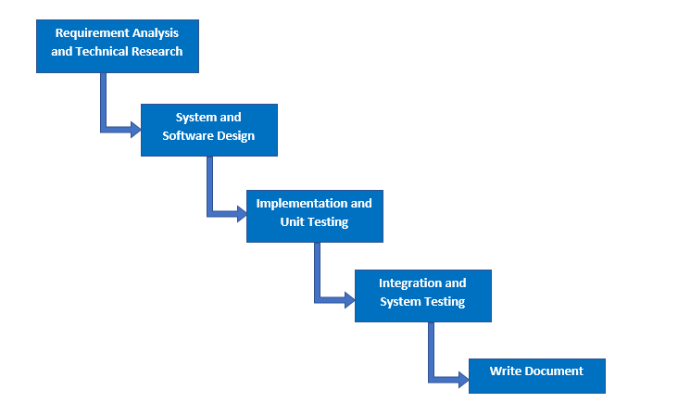

***Figure 1: Software Process Model***

### 2.2. Roles and responsibilities

|  |  |  |  |
| --- | --- | --- | --- |
| **No** | **Full name** | **Role in Group** | **Responsibilities** |
| **1** | Phạm Công Thành | Project Manager | * Specify user requirement * Control the development process * Give out technique and business analysis support |
| **2** | Hoàng Ngô Minh Tùng | Team Leader, QA, DEV, Tester | * Manage the process, quality, risk * GUI design * Design database * Clarify requirements * Prepare documents, reports * Arrange meeting * Design project architect * Coding * Testing |
| **3** | Nguyễn Bảo Khánh | Team Member, BA, DEV, Tester | * GUI design * Design database * Clarify requirements, analyze business * Design project architect * Coding * Testing |
| 4 | Lê Nguyễn Ngọc Sang | Team Member, QC, DEV, Tester | * Create test plan * GUI design * Design database * Clarify requirements, analyze business * Design project architect * Coding * Testing |

### 2.3. Tools and Techniques

|  |  |
| --- | --- |
| **Tool** | **Name and version** |
| IDE | * IntelliJ IDEA 2018.2.3 * Android Studio 3.1.3 |
| Source control | SourceTree 2.6.10 |
| Database Manager | MySQL Workbench 6.3.9 CE |

|  |  |
| --- | --- |
| **Technique** | **Name and version** |
| Front end | * HTML v5.0 * JQuery v3.2.1 * Bootstrap v3.3.7 * CSS * Javascript * Ajax |
| Back end | * Java EE 8 * Spring Boot v2.0.5 RELEASE * Hibernate v5.0.12 * RESTful Web Service |
| Google API libraries | * Google Maps API * Firebase Cloud Messaging |
| Web server | Apache Tomcat v8.5.15 |
| Database system | MySQL 5.7.20 |

## Project Management Plan

### 3.1. Software development life cycle

|  |  |  |  |  |  |
| --- | --- | --- | --- | --- | --- |
| **Phase** | **Description** | **Deliverables** | **Resource needed** | **Dependencies and Constraints** | **Risks** |
| **Requirement analysis and technical research** | **-** Identify and clarify requirements for system  - Research for google maps api and crawling technique (StAX), FCM (firebase cloud messaging) | - Software Requirement Specification  - Basic knowledge Google Maps API, FCM  - Understand about StAX technique  - Introduction document  - Project Management Plan  - Prototypes | 4 weeks | N/A | **-** Lack of member share of understand  - SRS does not match user requirement  - Misunderstanding of learning |
| **System and software design** | **-** Architect design for the system  - Detail design using top-down break down | - Software Design Description Document  - Base code structure  - Technology notes | 2 weeks | Depend on “Requirement Analysis and Technical Research” | **-** Lack of experience  - Diagrams don’t match SRS  - Not fulfil requirement |
| **Implementation and unit testing** | **-** Implement the system  - Crawling data  - Building mobile application  - Prepare test plan and test cases  - Unit testing of the code | **-** System Implementation and Test Document  - Programs (web and mobile app)  - Unit test cases and results | 4 weeks | Depend on “System and Software Design” | **-** Delay in implementation  - Inaccurate programming |
| **Integration and system testing** | **-** Perform functional and non functional testing  - Make sure the system meets the requirements | **-** Test report  - Defect report | 1 week | Depend on “Implementation and Unit Testing” | - Missing of functions that need to be tested |
| **Write document** | **-** Write “Software User’s Manual”  - Review all documents  - Write paper | **-** Software User’s Manual  - A paper | 3 weeks | Depend on “System Design” and “Implementation” | -Don’t have enough time to complete paper. |

***Table <number>: Software development life cycle***

### 3.2. Phase Detail

#### 3.2.1. Requirement Analysis and Technical Research

|  |  |  |
| --- | --- | --- |
| **Task** | **Description** | **Author** |
| **Identify and clarify functions** | Identify and clarify user requirements  Divide all functions into groups by concept | TungHNM, KhanhNB, SangLNN |
| **Research on Google Maps and Location, Firebase Cloud Messaging, Spring Boot email** | Research on google maps api  Research on HTML5 Location, Android Location  Research on Firebase Cloud Messaging, Spring Boot email  Research on StAX crawling technique | TungHNM, KhanhNB, SangLNN |
| **Design application** | Design GUI for web and mobile application base on main functions  Design Use Case Diagram | TungHNM, KhanhNB, SangLNN |
| **Write document** | Write Introduction document  Write Project Management Plan  Write Software Requirement Specification | TungHNM, KhanhNB, SangLNN |

#### 3.2.2. System and Software Design

|  |  |  |
| --- | --- | --- |
| **Task** | **Description** | **Author** |
| **Design ERD** | Design Entity Relationship Diagram for database | TungHNM, KhanhNB, SangLNN |
| **Design architect** | Design architect and main functions of application  Design Class Diagram, Interaction Diagram, Component Diagram | TungHNM, KhanhNB, SangLNN |
| **Write document** | Write Software Design Description | TungHNM, KhanhNB, SangLNN |

**3.2.3. Implementation and Unit Testing**

|  |  |  |
| --- | --- | --- |
| **Task** | **Description** | **Author** |
| **Implement Web Service** | Implement main functions  Implement REST api | TungHNM, KhanhNB, SangLNN |
| **Implement GUI** | Implement Web and Mobile UI | TungHNM, KhanhNB, SangLNN |
| **Implement Algorithms** | Implement nearby location, auto-complete address input  Implement pagination with sessionStorage  Implement data crawling  Implement as-you-type search with string comparison and localStorage  Implement schedule  Implement MD5 hash function for matching data | TungHNM, KhanhNB, SangLNN |
| **Unit testing** | Prepare test cases for all functions  Test each functions and provide check list of defects  Fix bugs base on the check list | TungHNM, KhanhNB, SangLNN |
| **Write document** | Write System Implementation and Test Document | TungHNM, KhanhNB, SangLNN |

**3.2.4. Integration and System Testing**

|  |  |  |
| --- | --- | --- |
| **Task** | **Description** | **Author** |
| **Prepare test plan** | Prepare overview plan for testing | TungHNM, KhanhNB, SangLNN |
| **Prepare test case** | Prepare test cases for the whole system base on user requirement | TungHNM, KhanhNB, SangLNN |
| **Integration and system test** | Perform all test cases | TungHNM, KhanhNB, SangLNN |

**3.2.5. Write document**

|  |  |  |
| --- | --- | --- |
| **Task** | **Description** | **Author** |
| **Write document** | Write Software User’s Manual Document | TungHNM, KhanhNB, SangLNN |
| **Review all documents** | Review 6 reports | TungHNM, KhanhNB, SangLNN |
| **Write paper** | Write abstract and introduction  Write about As-you-type search and pagination with sessionStorage  Write comparison  Write conclusion | TungHNM, KhanhNB, SangLNN |

### 3.3. All Meeting Minutes

All meeting minutes could be found at [here](https://drive.google.com/open?id=1ACCC2tjce8m-4AyyhLiwlV_43ZZlKM96).

1. **Coding Convention**

We use Java to develop the application. Here is our specified coding convention:

* Packaging Convention:
  + Divide application into layers: presentation layer, service layer, business layer, data access layer,...
* Code block Convention:
  + No line break before the opening brace.
  + Line break after the opening brace.
  + Line break before the closing brace.
  + Line break after the closing brace, only if that brace terminates a statement or terminates the body of a method, constructor, or named class.
* Naming Convention:
  + Package names are all lowercase, with consecutive words simply concatenated together (no underscores).
  + Class names are written in UpperCamelCase.
  + Constant names use CONSTANT_CASE: all uppercase letters, with words separated by underscores.
  + Use camel-case style for variables and functions name.
  + Names should reflect a business meaning or purpose.
* Commenting Convention:
  + Place the comment on a separate line, not at the end of a line of code.
  + Begin comment text with an uppercase letter.
* Log data Convention:
  + Log fatal errors, exception to file.
  + Log URL on console before sending request.
* Documentation Convention:
  + Add java docs at the top of the class describing the purpose of the class and the responsibility of it.
  + Add a description at the top of each method describing the business flow of the method, the input/output and the success/failure scenarios it handles.
  + Add business and meaningful comments for complex algorithms or blocks written by each member.

# C. Report No.3 Software Requirement Specification

## 1. User Requirement Specification

Our system is designed to act as a platform of information, hosting events and trading about Gunpla World. Users can use search system with nearby location through website and mobile. We also provide many advanced features to heighten user experience and make it more effective for administrator to manage the entire system. This software consists of three main user roles which are Member, Buyer/Seller and Admin with Admin are our employees.

### 1.1. Member Requirement

Member is a person who doesn’t have access to the system. Member can get gunpla’s information, publish articles, register for attending events, proposal to open events, contests, order the exchanges and evaluate. Below are functions of member:

* Register
* Login
* Search for models, get models’s detail, get review evaluation
* Search for articles, get articles’s information
* Manipulate article
* Search for events, get events’s detail
* Search for exchange, get exchange’s detail
* Register event
* Proposal to open events
* Order the exchanges
* Evaluate with rating and feedback

### 1.2. Buyer/Seller Requirement

Buyer/Seller is a role that is upgrade from Member, has all functions of Member and have more features about exchange, trading. Below are functions of this role which member doesn’t have:

* Post for exchange (for purchase or for sale)
* Manipulate the exchange
* Confirm about the transaction

### 1.3. Administrator Requirement

Administrator is a role as an employee who is responsible for managing the entire system such as manipulating account, manipulating models, articles, events, approving requests or manipulating the crawling, includes crawl models and crawl information articles. Administrator can do the following functions:

* Manage users
* Manage crawling, includes: crawl models and information articles
* Approve pending crawl records
* Manage gunpla model information system
* Manage article
* Approve requests to publish articles, and to post for exchange
* Manage events
* Manage schedule (crawling schedule, update event & update trade schedule)

### 1.4. Authenticated User Requirement

Authenticated user is a person who already logined into system. Authenticated user can do the following functions:

* Logout
* Edit profile
* Get profile (includes get exchange evaluation)
* Get notification

### 1.5. Handler Requirement

Handler is a kind of system role that run functions in the backend. Handler can do the following functions:

* Send notifications
* Auto disable error models (error loading 404 image)
* Authenticate and authorize
* Auto update event (which don’t have enough attendee after registration date)
* Auto update order request (which don’t have any responses from trade post owner in 2 days)

## 2. System Requirement Specification

### 2.1. External Interface Requirement

#### 2.1.1. User Interface

The user interface uses English for both web application and mobile application.

#### 2.1.2. Hardware Interface

* **Server:**
  + Ram: 4GB
  + Computer Processor: Intel® Core™ i5 (4 CPUs) @ 2.5GHz
  + Operating system: Windows 10
  + Internet connection: Cable, Wi-Fi (20 Mbps)
* **Mobile smartphone:**
  + Ram: 2GB
  + Processor: CPU Quad core 2.0 GHz
  + Operating system: Android 6 Marshmallow

#### 2.1.3. Software Interface

* Operating system: Window 10, Android 6 Marshmallow
* Environment: Java EE 8, Android SDK APIs level 15 or above
* IDE: IntelliJ IDEA 2018.2.3, Android Studio 3.1.3
* DBMS: MySQL 5.7.20, MySQL Workbench 6.3.9 CE
* Source control: SourceTree 2.6.10
* Web browser: Chrome 62 or above

#### 2.1.4. Communication Protocol

* Use HTTP protocol 1.1 for communication between:
  + Web application and web server
  + Mobile application and web server

### 2.2. System Overview Usecase

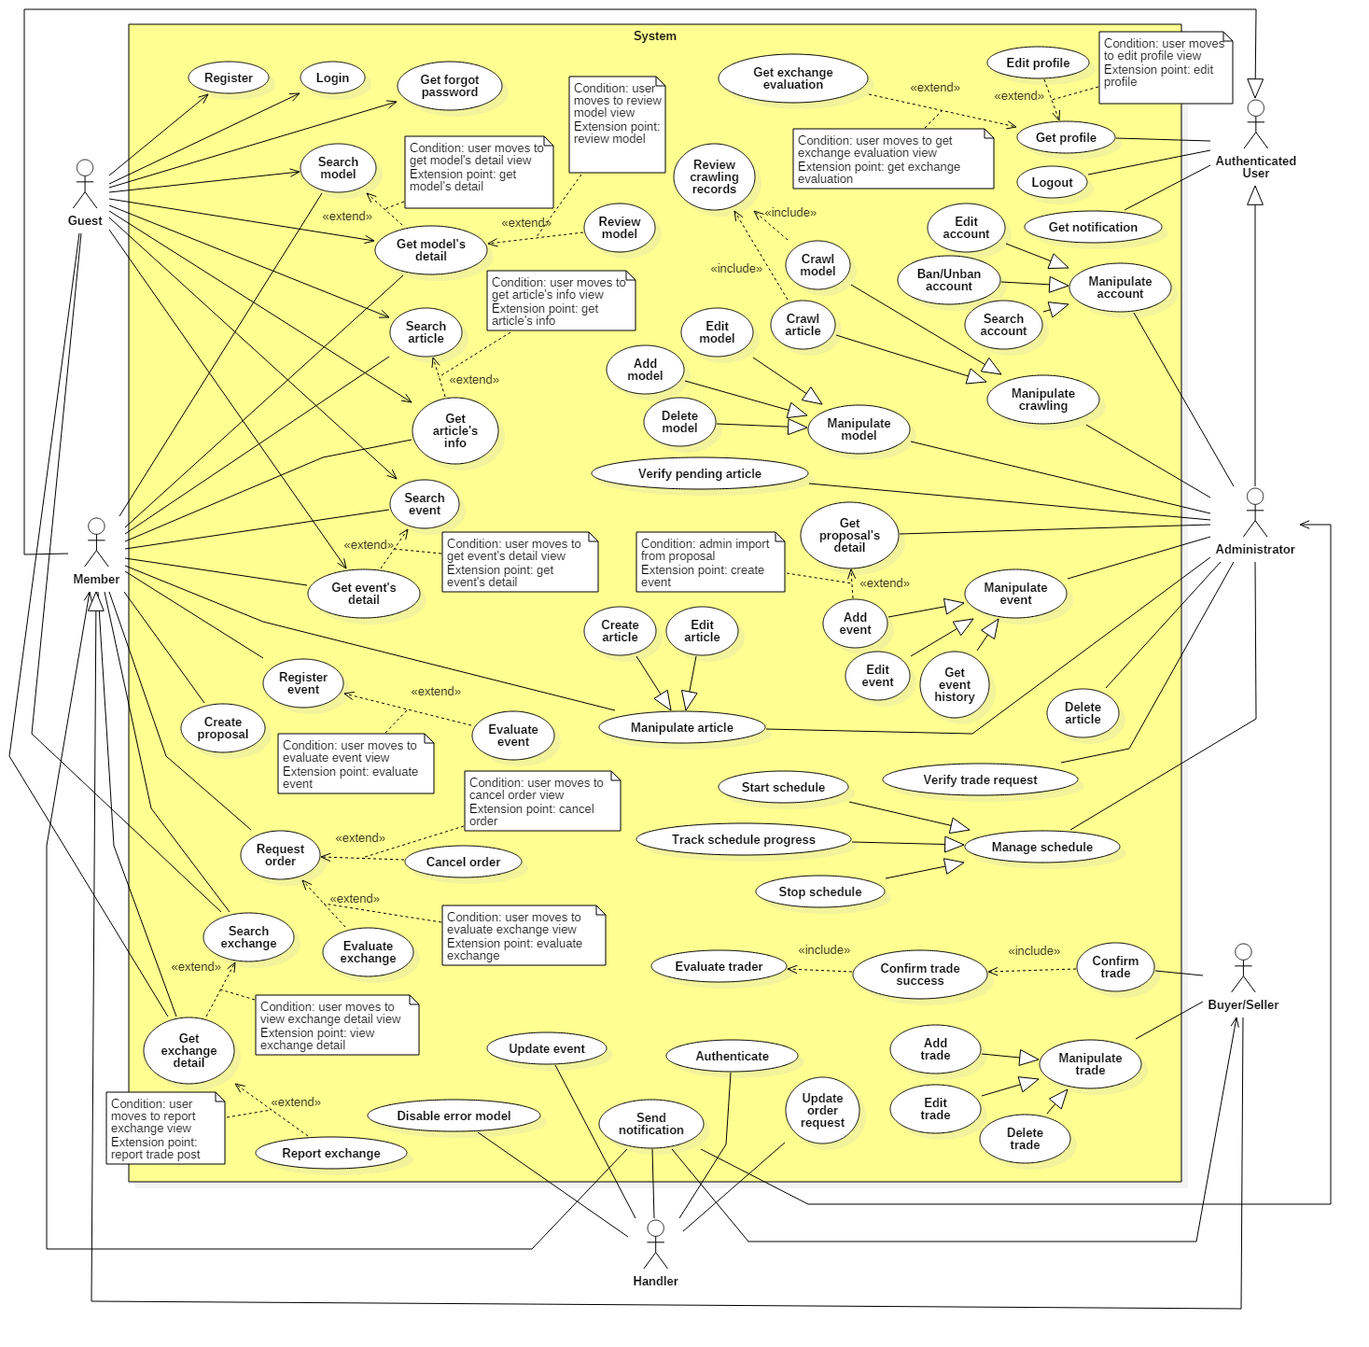

### 2.3. List of Usecase

#### 2.3.1. < Guest > Overview Usecase

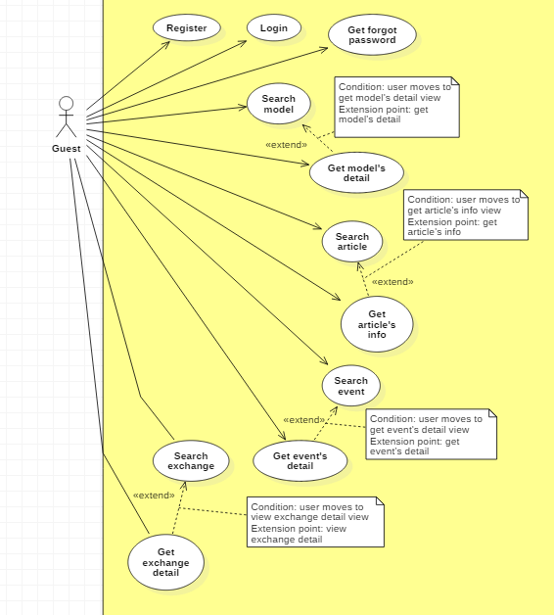

##### 2.3.1.1. < Guest > Register Usecase

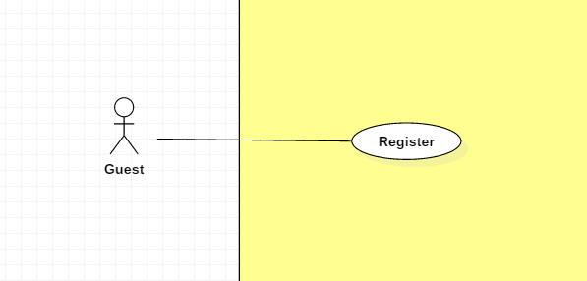

|  |  |  |  |
| --- | --- | --- | --- |
| **USE CASE – UC _Guest_01** | | | |
| **Usecase No.** | Guest_01 | **Usecase Version** | 1.0 |
| **Usecase Name** | Register | | |
| **Author** | TungHNM | | |
| **Date** | 03/10/2018 | **Priority** | Normal |
| **Actor:**   * Guest.   **Summary:**   * This use case allows guest to register to system.   **Goal:**   * System can recognize the new account. * User can login the system with role “Member”   **Triggers:**   * Guest sends register command to the system.   **Preconditions:**   * Register view is displayed.   **Post Conditions:**   * **Success**: New account is added to the system with role “Member”. * **Fail**: Show error message.   **Main Success Scenario:**   |  |  |  | | --- | --- | --- | | **Step** | **Actor Action** | **System Response** | | 1 | Guest goes to register view | Register view is shown with following labels and fields:   * Username: tex, required, max length: 50 * Email: text, required, max length: 50, match: /^([a-z0-9_\.-]+)@([\da-z\.-]+)\.([a-z\.]{2,6})$/ * Password: free text input, required, max length: 50 * Confirm password: free text input, required * First Name: text, max length: 50 * Last Name: text, max length: 50 | | 2 | Guest fills out the form |  | | 3 | Guest clicks on “SAVE” button | Validate data.  [Exception 1, 2, 3, 4, 5, 6]  New account is added to system.  System displays dialog with message: Register successfully ! |   **Alternative Scenario:** N/A  **Exceptions:**   |  |  |  | | --- | --- | --- | | **No** | **Cause** | **System Response** | | 1 | Entered email does not match the required format: /^([a-z0-9_\.-]+)@([\da-z\.-]+)\.([a-z\.]{2,6})$/ | System shows error message: Invalid email ! | | 2 | Entered email is duplicate in database | System shows error message: The email has been existed ! | | 3 | Missing of required fields | System shows error message to notify guest to input missing fields | | 4 | Password and Confirm password don’t match | System shows error message: The password and confirm password don’t match ! | | 5 | Length of field’s value is out of range | System shows message that notify guest which field’s value is out of range | | 6 | Entered username is duplicate in database | System shows error message: Username has been existed ! |   **Relationships:** N/A  **Business** **Rules**:   * The entered password and confirm password must match to each other. * Email and username must not be duplicate in database. * In case of success scenario, the account is created with default role: Member and status: Active | | | |

##### 2.3.1.2. < Guest > Get forgot password Usecase

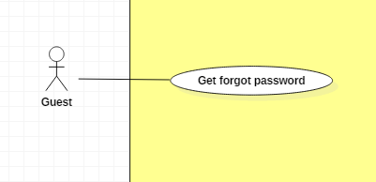

|  |  |  |  |
| --- | --- | --- | --- |
| **USE CASE – UC _Guest_02** | | | |
| **Usecase No.** | Guest_02 | **Usecase Version** | 1.0 |
| **Usecase Name** | Get forgot password | | |
| **Author** | TungHNM | | |
| **Date** | 03/10/2018 | **Priority** | Normal |
| **Actor:**   * Guest.   **Summary:**   * This use case allows guest who has already registered to get forgot password.   **Goal:**   * Registered user is able to get forgot password   **Triggers:**   * Guest sends get forgot password command to the system.   **Preconditions:**   * Get forgot password view is displayed.   **Post Conditions:**   * **Success**: Registered user receives email with their account’s password. * **Fail**: Show error message.   **Main Success Scenario:**   |  |  |  | | --- | --- | --- | | **Step** | **Actor Action** | **System Response** | | 1 | Guest input email and submit | Validate data.  [Exception 1]  Registered user receives email with his/her password  System displays message: “We have sent your password to your email. Please check it, thanks !”  [Alternative 1] |   **Alternative Scenario:**  **Alternative Scenario 1:** The input email does not exist   |  |  |  | | --- | --- | --- | | **Step** | **Actor Action** | **System Response** | | 1 | Guest input email and submit | System displays message: “This email does not exist” |   **Exceptions:**   |  |  |  | | --- | --- | --- | | **No** | **Cause** | **System Response** | | 1 | Entered email does not match the required format: /^([a-z0-9_\.-]+)@([\da-z\.-]+)\.([a-z\.]{2,6})$/ | System shows error message: Invalid email ! |   **Relationships:** N/A  **Business** **Rules**:   * In case of success scenario, system will send email with password to registered’s email | | | |

#### 2.3.2. < Member > Overview Usecase

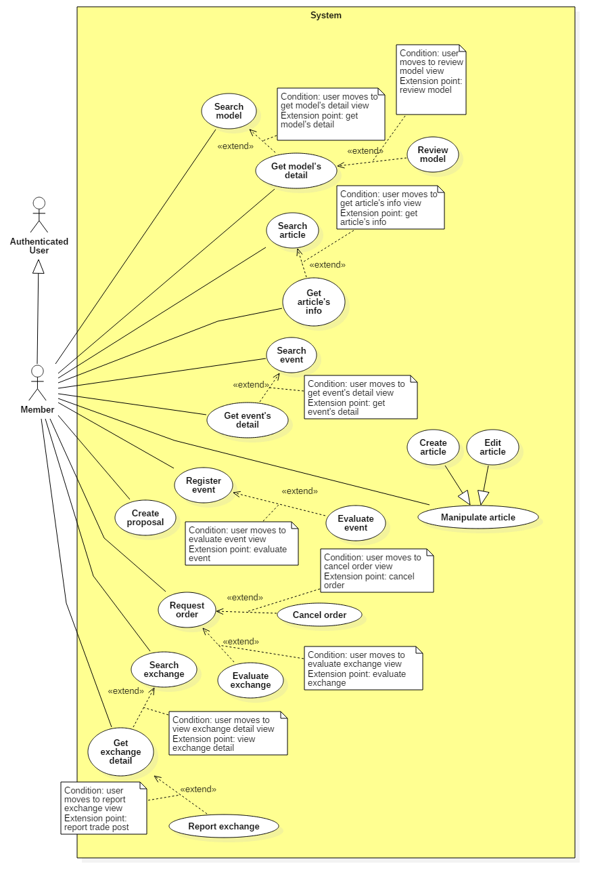

##### 2.3.2.1. < Member > Search model Usecase

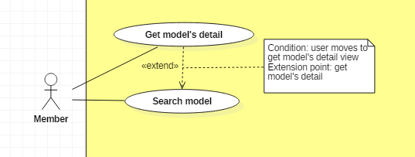

|  |  |  |  |
| --- | --- | --- | --- |
| **USE CASE – UC _Member_01** | | | |
| **Usecase No.** | Member_01 | **Usecase Version** | 1.0 |
| **Usecase Name** | Search model | | |
| **Author** | TungHNM | | |
| **Date** | 03/10/2018 | **Priority** | Normal |
| **Actor:**   * Member.   **Summary:**   * This use case allows member to search model.   **Goal:**   * Make it more convenient for members to seek for gunpla information.   **Triggers:**   * Member sends search model command to the system.   **Preconditions:**   * The search model page is displayed.   **Post Conditions:**   * **Success**: A list of matching records are shown with pagination and orderBy filter. * **Fail**: Show error message.   **Main Success Scenario:**   |  |  |  | | --- | --- | --- | | **Step** | **Actor Action** | **System Response** | | 1 | Member goes to search model view | System displays search model view with the following elements:   * Search navbar: free text input * Icon search: button * Filter series title: dropdown list * Filter product series: dropdown list * Filter manufacturer: dropdown list * Filter price: dropdown list, includes following values:   + All   + < 5000 yen   + 5000 yen to 10000 yen   + > 10000 yen   System displays all available gundam models in database with pagination and filter OrderBy    System loads all product series to filter product series, also include option “All”  System loads all series title to filter series title, also include option “All”  System loads all manufacturers to filter manufacturer, also include option “All” | | 2 | Member clicks on search navbar | An text input is displayed with border blue and placeholder: Please input keyword | | 3 | Member fills out the input text and filters form  [Alternative 1] | System will display a list with instant results which match or nearly match the input keyword, includes thumbImage of gundam model and name | | 4 | Member clicks on search icon button or press Enter | A list of matching gundam models by name, product series, series title, manufacturer, price based on the filters will be displayed on the view with pagination and sorting filter.  [Alternative 2] | | 5 | Member hovers on a record | Brief detail information will be displayed on the view | | 6 | Member clicks on More information button on each records | System redirects to the clicked gundam model’s detail page | | 7 | Member chooses an option in OrderBy dropdown list | System will sort the current matching records by OrderBy filter’s value (price, createdDate and rating) |   **Alternative Scenario:**  **Alternative Scenario 1: Click on an item in instant results list**   |  |  |  | | --- | --- | --- | | **Step** | **Actor Action** | **System Response** | | 1 | Member clicks on an item in instant results list | System redirects to the clicked gundam model’s detail page |   **Alternative Scenario 2: No matching records**   |  |  |  | | --- | --- | --- | | **Step** | **Actor Action** | **System Response** | | 1 | Member clicks on search icon button or press enter | There is no matching records and system displays message No matching records ! |   **Exceptions:** N/A  **Relationships:** N/A  **Business** **Rules**:   * When user input a keyword in search bar, system will display all the match or nearly match model’s name on the view with thumb image * When user goes to search page, all gundam model’s name and thumb image url in database response from server will be saved in localStorage with datetime * Every next time user goes to search page, system will check the datetime of the last saving in localStorage and compares to current datetime, if larger or equal to 4 days, then ajax will request to server and update data * Each page displays a maximum of 24 gundam records * When user clicks on a page, data of that page will be saved to sessionStorage, and also 2 pages next by * When user clicks on a page, system will check data of that page and also 2 pages nextby whether it is saved in sessionStorage or not, if saved then get it from sessionStorage and display to view, if not then request to server and get data | | | |

##### 2.3.2.2. < Member > Get model’s detail Usecase &

##### 2.3.2.3. < Member > Review model Usecase

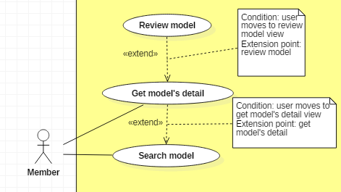

|  |  |  |  |
| --- | --- | --- | --- |
| **USE CASE – UC _Member_02, USE CASE – UC _Member_03** | | | |
| **Usecase No.** | Member_02, Member_03 | **Usecase Version** | 1.0 |
| **Usecase Name** | Get model’s detail, Review model | | |
| **Author** | TungHNM | | |
| **Date** | 03/10/2018 | **Priority** | Normal |
| **Actor:**   * Member.   **Summary:**   * This use case allows users to get model’s information detail.   **Goal:**   * Member can get information from models.   **Triggers:**   * Member sends get model’s detail command to the system.   **Preconditions:** N/A  **Post Conditions:**   * **Success**: Model’s detail page is shown with information. * **Fail**: Show error message.   **Main Success Scenario:**   |  |  |  | | --- | --- | --- | | **Step** | **Actor Action** | **System Response** | | 1 | Member clicks on a model and goes to model detail view | System displays the selected model’s detail page with the following labels and text:   * Big image: img * Manufacturer: text * Scale: text * Series: text * Released Date: text * Price: text * Rating: stars image * View review evaluation icon: button * Description: text * My rating: button   System displays a slideshow of images divided into following categories:   * Package * Item picture * Other picture * Contents * About item * Color * Assembly guide   System displays Top 5 rating gundam models on the right navbar  System displays gundam model’s related article and related trade post (exchange) on the right navbar | | 2 | Member clicks on view review evaluation icon button | System displays gundam model’s all user’s review evaluation with pagination by scrolling to bottom (each page has maximum 10 records) | | 3 | Member clicks on my rating button | System displays evaluation form with star ratings and review comment (required) | | 4 | Member fills out the form and click submit | Validate  [Exception 1]  System displays message “Submit successfully” and remove my rating button |   **Alternative Scenario:** N/A  **Exceptions:**   |  |  |  | | --- | --- | --- | | **No** | **Cause** | **System Response** | | 1 | Missing required fields | System display error message to the view for member to input required fields |   **Relationships:** Use case Get model’s detail extends to Get Search model use case, Use case Review model extends to Get model’s detail use case  **Business** **Rules**:   * Related article is found by matching article’s title to current model’s name * Related trade post is found by percentage string comparison between trade post’s model name and current model’s name which have to be larger than or equal to 70% * Pagination in list user’s review evaluation will be divided to maximum 10 records for each page and will continue to load if user scroll to bottom * Each member can only evaluate gundam model one time | | | |

##### 2.3.2.4. < Member > Search article Usecase

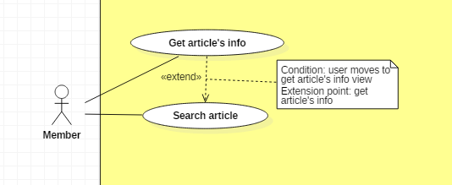

|  |  |  |  |
| --- | --- | --- | --- |
| **USE CASE – UC _Member_04** | | | |
| **Usecase No.** | Member_04 | **Usecase Version** | 1.0 |
| **Usecase Name** | Search article | | |
| **Author** | Khanhnb | | |
| **Date** | 03/10/2018 | **Priority** | Normal |
| **Actor:**   * Member.   **Summary:**   * This use case allows member to search articles.   **Goal:**   * Make it more convenient for guest to seek for article.   **Triggers:**   * Member sends search news command to the system.   **Preconditions:**   * The search article page is displayed.   **Post Conditions:**   * **Success**: A list of matching records are shown. * **Fail**: Show error message.   **Main Success Scenario:**   |  |  |  | | --- | --- | --- | | **Step** | **Actor Action** | **System Response** | | 1 | Member goes to search article view | System displays search article view with the following elements:   * Search bar: free text input * Dropdown list: select from a list of article’s category, default selection is “All category” * Dropdown list: select sort by newest or oldest articles * SEARCH BY: article’s title | | 2 | Member fills out the input text, select category and sort type |  | | 3 | Member clicks on “SEARCH” button or press Enter | A list of articles with matching titles is shown |   **Alternative Scenario:** N/A  **Exceptions:** N/A  **Relationships:** N/A  **Business** **Rules**:   * System search article by title matching with the keyword input from guest * A list of records will go with pagination and sorting filters | | | |

##### 2.3.2.5. < Member > Get article’s info Usecase



|  |  |  |  |
| --- | --- | --- | --- |
| **USE CASE – UC _Member_05** | | | |
| **Usecase No.** | Member_05 | **Usecase Version** | 1.0 |
| **Usecase Name** | Get article’s info | | |
| **Author** | Khanhnb | | |
| **Date** | 03/10/2018 | **Priority** | Normal |
| **Actor:**   * Member.   **Summary:**   * This use case allows emberto get an article’s info.   **Goal:**   * Display an article’s content   **Triggers:**   * Member sends get news’s detail command to the system.   **Preconditions:**   * Member select a article from the list of articles.   **Post Conditions:**   * **Success**: The matching record is shown. * **Fail**: Show error message.   **Main Success Scenario:**   |  |  |  | | --- | --- | --- | | **Step** | **Actor Action** | **System Response** | | 1 | Member clicks on an article and goes to article detail view | System displays news’s detail view with the following elements:   * The title of the article: text * The date the article was posted on * The username of the article’s author * The article’s content * (if the member posted this article) “Edit article” button |   **Alternative Scenario:** N/A  **Exceptions:** N/A  **Relationships:** N/A  **Business** **Rules**: N/A | | | |

##### 2.3.2.6. < Member > Create article Usecase

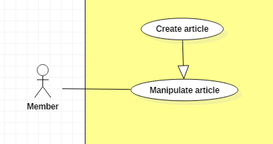

|  |  |  |  |
| --- | --- | --- | --- |
| **USE CASE – UC _Member_06** | | | |
| **Usecase No.** | Member_06 | **Usecase Version** | 1.0 |
| **Usecase Name** | Create article | | |
| **Author** | KhanhNB | | |
| **Date** | 25/09/2018 | **Priority** | Normal |
| **Actor:**   * Member   **Summary:**   * This use case allows user to create a new article.   **Goal:**   * A new article added to the database system.   **Triggers:**   * Member write an articles and submit it.   **Preconditions:**   * User must login into system with role Member.   **Post Conditions:**   * **Success**: New article is added to the database system. * **Fail**: Show error message.   **Main Success Scenario:**   |  |  |  | | --- | --- | --- | | **Step** | **Actor Action** | **System Response** | | 1 | Member go to “Create a new article” page | “Create new article” view is shown with following labels and fields:   * Input field for article’s Title * Dropdown list to select article’s category * A textarea for the article’s description * An image upload button to upload the article’s thumbnail * An empty image to preview the thumbnail * A textarea using CKEditor library for the article’s content * Submit button | | 2 | Member fills out the form. |  | | 3 | Member submit article. | Add new article the database.  System shows message saying “Article submitted! Please wait for admin’s approval!”. |   **Alternative Scenario:**  N/A  **Exceptions:**   |  |  |  | | --- | --- | --- | | **No** | **Cause** | **System Response** | | 1 | Member submit article with empty title | System shows error message to ask the member to enters missing required fields. | | 2 | Member submit article with empty description | System shows error message to ask the member to enters missing required fields. | | 3 | Member submit article with no thumbnail uploaded | System shows error message to ask the member to enters missing required fields. | | 4 | Member submit article with empty content | System shows error message to ask the member to enters missing required fields. | | 5 | Member upload file too large. | System shows error message to ask the member to enters missing required fields. |   **Relationships:** N/A  **Business** **Rules**:   * In case of success scenarios, a new article would be posted to the database. The article’s status will be “Pending”. * Article id is automatically initialized by the system. File upload must be file type of images: *.jpeg, *.jpg, *.png, *.gif. | | | |

##### 2.3.2.7. < Member > Edit article Usecase

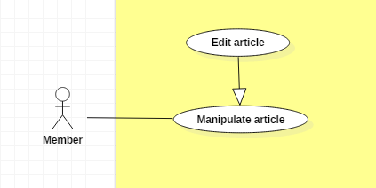

|  |  |  |  |
| --- | --- | --- | --- |
| **USE CASE – UC _Member_07** | | | |
| **Usecase No.** | Member_07 | **Usecase Version** | 1.0 |
| **Usecase Name** | Edit article | | |
| **Author** | KhanhNB | | |
| **Date** | 25/09/2018 | **Priority** | Normal |
| **Actor:**   * Member   **Summary:**   * This use case allows member to edit an article.   **Goal:**   * The articles is updated in database   **Triggers:**   * Member edit an article and submit it.   **Preconditions:**   * User must login into system with role Member. * Member viewing an article that they posted * Member selects “Edit article”   **Post Conditions:**   * **Success**: New article is updated in the database system. * **Fail**: Show error message.   **Main Success Scenario:**   |  |  |  | | --- | --- | --- | | **Step** | **Actor Action** | **System Response** | | 1 | Member go to “Edit article” page | * Input field for article’s Title * Dropdown list to select article’s category * A textarea for the article’s description * An image upload button to upload the article’s thumbnail * An empty image to preview the thumbnail * A textarea using CKEditor library for the article’s content * Submit button | | 2 | Member fills out the form. |  | | 3 | Member submit article. | System update the article in the database |   **Alternative Scenario:**  N/A  **Exceptions:**   |  |  |  | | --- | --- | --- | | **No** | **Cause** | **System Response** | | 1 | Member submit article with empty title | System shows error message to ask the member to enters missing required fields. | | 2 | Member submit article with empty description | System shows error message to ask the member to enters missing required fields. | | 3 | Member submit article with no thumbnail uploaded | System shows error message to ask the member to enters missing required fields. | | 4 | Member submit article with empty content | System shows error message to ask the member to enters missing required fields. | | 5 | Member upload file too large. | System shows error message to ask the member to enters missing required fields. |   **Relationships:** N/A  **Business** **Rules**:   * In case of success scenarios, the article would be updated in the database. * Article id is automatically initialized by the system. File upload must be file type of images: *.jpeg, *.jpg, *.png, *.gif. * Member can only edit articles they posted | | | |

##### 2.3.2.8. < Member > Search event Usecase

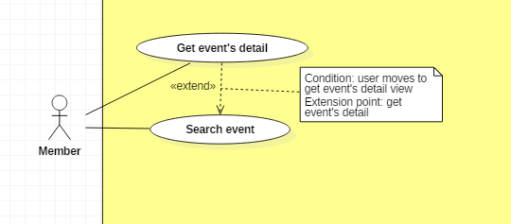

|  |  |  |  |
| --- | --- | --- | --- |
| **USE CASE – UC _Member_08** | | | |
| **Usecase No.** | Member_08 | **Usecase Version** | 1.0 |
| **Usecase Name** | Search event | | |
| **Author** | Khanhnb | | |
| **Date** | 03/10/2018 | **Priority** | Normal |
| **Actor:**   * Member..   **Summary:**   * This use case allows member to search events.   **Goal:**   * Make it more convenient for member to seek for events.   **Triggers:**   * Member sends search event command to the system.   **Preconditions:**   * The search event page is displayed.   **Post Conditions:**   * **Success**: A list of matching records are shown. * **Fail**: Show error message.   **Main Success Scenario:**   |  |  |  | | --- | --- | --- | | **Step** | **Actor Action** | **System Response** | | 1 | Member goes to search event view  [Alternative scenario 1] | System displays search article view with the following elements:   * Search bar: free text input * Dropdown list: select sort by newest or oldest events, default * SEARCH BY: event’s title | | 2 | Member fills out the input text, select sort type |  | | 3 | Memberclicks on “SEARCH” button or press Enter | A list of events with matching titles is shown |   **Alternative Scenario:**   |  |  |  | | --- | --- | --- | | **Step** | **Actor Action** | **System Response** | | 1 | Member select “Show nearby events” button | A list of events located within 10km of the user’s current location is shown |   **Exceptions:** N/A  **Relationships:** N/A  **Business** **Rules**:   * System search events by title matching with the keyword input from guest * A list of records will go with pagination and sorting filters * System search nearby events using Haversine algorithm to calculate the distance between the user and each event | | | |

##### 2.3.2.9. < Member > Get event’s detail Usecase

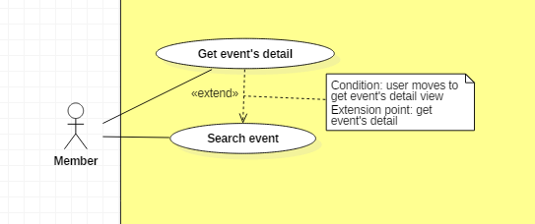

|  |  |  |  |
| --- | --- | --- | --- |
| **USE CASE – UC _Member_09** | | | |
| **Usecase No.** | Member_09 | **Usecase Version** | 1.0 |
| **Usecase Name** | Get event’s info | | |
| **Author** | Khanhnb | | |
| **Date** | 03/10/2018 | **Priority** | Normal |
| **Actor:**   * Member.   **Summary:**   * This use case allows member to get an event’s info.   **Goal:**   * Display an event’s content   **Triggers:**   * Member sends get news’s detail command to the system.   **Preconditions:**   * Member select a event from the list of event.   **Post Conditions:**   * **Success**: The matching record is shown. * **Fail**: Show error message.   **Main Success Scenario:**   |  |  |  | | --- | --- | --- | | **Step** | **Actor Action** | **System Response** | | 1 | Member clicks on an event and goes to event detail view | System displays event’s detail view with the following elements:   * The title of the event: text * The date when the event starts and ends * The date then registration starts and ends * The location of the event * The number of people registered for this event * The event’s content * (if available) The event’s rating and feedback by its attendees * (if the event’s status is “Finished”) Text line saying “This event has finished” * (if the event’s status is “Cancelled”) Text line saying “This event was cancelled”) * (if today is within the registration period) Register button   If the current user has registered to this event, system display the following elements:   * The username of the user * The date when the user registered on * The amount of tickets the user bought * A star rating area to rate the event * A textarea for the feedback * A submit feedback button   If the current user has sent feedback to htis event then system display the following elements:   * The star rating with the user’s rating * A textarea showing the user’s written feedback |   **Alternative Scenario:** N/A  **Exceptions:** N/A  **Relationships:** N/A  **Business** **Rules**: N/A | | | |

##### 2.3.2.10. < Member > Register event Usecase

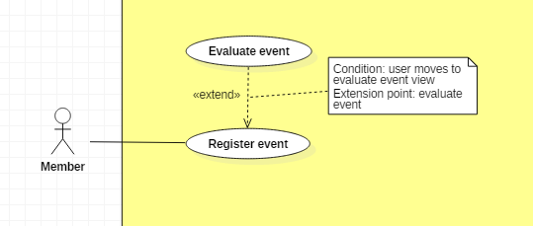

|  |  |  |  |
| --- | --- | --- | --- |
| **USE CASE – UC _Member_10** | | | |
| **Usecase No.** | Member_10 | **Usecase Version** | 1.0 |
| **Usecase Name** | Register event | | |
| **Author** | Khanhnb | | |
| **Date** | 03/10/2018 | **Priority** | Normal |
| **Actor:**   * Member .   **Summary:**   * This use case allows Member to register to an event   **Goal:**   * The member is added to the event’s attendee list   **Triggers:**   * Member send register event command to the system   **Preconditions:**   * Member is viewing an event’s detail, the current date is within registration time   **Post Conditions:**   * **Success**: Member successfully register to an event, member’s id is added to the list of attendees * **Fail**: Show error message.   **Main Success Scenario:**   |  |  |  | | --- | --- | --- | | **Step** | **Actor Action** | **System Response** | | 1 | Member select “Register” when in event detail view | A new dialog is shown with following labels and fields:   * The member’s username * Today’s date * Number of remaining tickets * Number of tickets text input * Register button | | 2 | Member fill all required form |  | | 3 | Member click “Register” | System add member to the list of attendees  A message saying “Registered successful!” shows. |   **Alternative Scenario:**  **Exceptions:**   |  |  |  | | --- | --- | --- | | **No** | **Cause** | **System Response** | | 1 | Number of tickets the user entered exceeds the amount of remaining tickets for that event | A message saying “The number of tickets you’ve entered exceeds the remaining tickets amount!” shows. |   **Relationships:** N/A  **Business** **Rules**: The number of tickets the user enter must be lower or equal with the remaining number of tickets the event has | | | |

##### 2.3.2.11. < Member > Create proposal Usecase

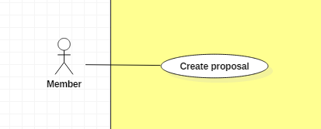

|  |  |  |  |
| --- | --- | --- | --- |
| **USE CASE – UC _Member_11** | | | |
| **Usecase No.** | Member_11 | **Usecase Version** | 1.0 |
| **Usecase Name** | Evaluate event | | |
| **Author** | Khanhnb | | |
| **Date** | 03/10/2018 | **Priority** | Normal |
| **Actor:**   * Member .   **Summary:**   * This use case allows Member to create an event proposal   **Goal:**   * The member can send the admin a proposal idea for an event   **Triggers:**   * Member submit the proposal information   **Preconditions:**   * User is logged in with the role “Member”   **Post Conditions:**   * **Success**: Member successfully send the proposal, proposal is saved to the database * **Fail**: Show error message.   **Main Success Scenario:**   |  |  |  | | --- | --- | --- | | **Step** | **Actor Action** | **System Response** | | 1 | Member go to “Create a new proposal” page | “Create new proposal” view is shown with following labels and fields:   * Input field for event’s title * Textarea for a short description of the event * Input field for the location of the event * A textarea using CKEditor library for the event’s content * Submit button | | 2 | Member fills out the form. |  | | 3 | Member submit article. | Add new article the database.  System shows message saying “Proposal sent! Thank you for your time”. |   **Alternative Scenario:** N/A  **Exceptions:** N/A  **Relationships:** N/A  **Business** **Rules**:N/A | | | |

##### 2.3.2.12. < Member > Search exchange Usecase

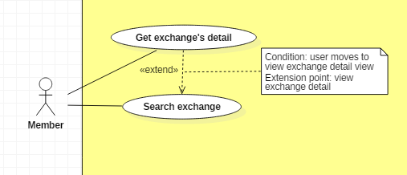

|  |  |  |  |
| --- | --- | --- | --- |
| **USE CASE – UC _Member_12** | | | |
| **Usecase No.** | Member_12 | **Usecase Version** | 1.0 |
| **Usecase Name** | Search exchange | | |
| **Author** | SangLNN | | |
| **Date** | 26/09/2018 | **Priority** | Normal |
| **Actor:**   * Member.   **Summary:**   * This use case allows member search exchange by keyword (title,brand,model) or location and range.   **Goal:**   * System create view to show search result.   **Triggers:**   * User sends search a trade post command with keyword, location and range to the system.   **Preconditions:**   * User must on website page.   **Post Conditions:**   * **Success**: System create view to show all result matching keyword and range with location. * **Fail**: Show error message.   **Main Success Scenario:**   |  |  |  | | --- | --- | --- | | **Step** | **Actor Action** | **System Response** | | 1 | Member click on “Trade market” link from header navbar or “Trade listing” on trade market page to send list all trade command. | System create a view show search form with following fields:   * Search input: text input , required. * “More” button   [Alternative Scenario 1] | | 2 | Member type keyword and press enter to send search command. | [Exception 1]  - System create a view show all result.  - Filter  [Alternative Scenario 2]  - Group by  [Alternative Scenario 3] |   **Alternative Scenario:**  Alternative Scenario 1: Search with location and range   |  |  |  | | --- | --- | --- | | **Step** | **Actor Action** | **System Response** | | 1 | Member click on “more” button. | System will show additional search form with following labels and fields:   * Search with location and form: radio button. * Location: text input, readonly. * Change your location: button. * Range: range input, required, min value: 500, max value: 20000. | | 2 | Member fills out the form. |  | | 3 | Member type keyword and press enter to send search command. | [Exception 1]  - System create a view show all result.  - Filter  [Alternative Scenario 2]  - Group by  [Alternative Scenario 3] |   Alternative Scenario 2 : Filter Scenario.   |  |  |  | | --- | --- | --- | | **Step** | **Actor Action** | **System Response** | | 1 | Member select on filter option send filter command. | System will list trade post sorting by user selected option. |   Alternative Scenario 3 : Group by Scenario.   |  |  |  | | --- | --- | --- | | **Step** | **Actor Action** | **System Response** | | 1 | Member select on tab group option send group by command. | System will list trade post group by user selected option. |   **Exceptions:**   |  |  |  | | --- | --- | --- | | **No** | **Cause** | **System Response** | | 1 | No result found. | System shows message no result found. |   **Relationships:** N/A  **Business** **Rules**:   * Short information per post contains: Cover image, title, condition, trade type, price, brand, model. * Result list will show in pagination with 8 trade post per page. * Have 3 grouping tab: All, Selling , Buying. * Have 4 filter: Date descending, Date ascending, Price descending, price ascending. | | | |

##### 2.3.2.13. < Member > Get exchange detail Usecase



|  |  |  |  |
| --- | --- | --- | --- |
| **USE CASE – UC _Member_13** | | | |
| **Usecase No.** | Member_13 | **Usecase Version** | 1.0 |
| **Usecase Name** | Get exchange’s detail | | |
| **Author** | SangLNN | | |
| **Date** | 26/09/2018 | **Priority** | Normal |
| **Actor:**   * Member.   **Summary:**   * This use case allows member view exchange details.   **Goal:**   * System create view to show all information about exchange.   **Triggers:**   * User sends view trade command with trade post id to the system.   **Preconditions:**   * User must on website page.   **Post Conditions:**   * **Success**: System create view to show all information for trade post. * **Fail**: Show error message.   **Main Success Scenario:**   |  |  |  | | --- | --- | --- | | **Step** | **Actor Action** | **System Response** | | 1 | Member click on trade post link from trade post list to send view trade details command. | System get all information from database and create a view show information in 3 section:  Product information section:   * Photo slideshow * Price * Title * Trade id * Date posted * Location * Type of trade * Brand * Model * Quantity * Rating * “Send order” button.   Trader information section:   * Delivery * Report this trade   Description section:   * Description |   **Alternative Scenario:** N/A  **Exceptions:** N/A  **Relationships:** N/A  **Business** **Rules**: N/A | | | |

##### 2.3.2.14. < Member > Request order Usecase

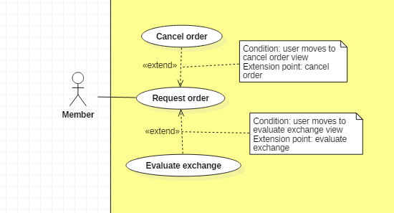

|  |  |  |  |
| --- | --- | --- | --- |
| **USE CASE – UC _Member_14** | | | |
| **Usecase No.** | Member_14 | **Usecase Version** | 1.0 |
| **Usecase Name** | Request order | | |
| **Author** | SangLNN | | |
| **Date** | 26/09/2018 | **Priority** | Normal |
| **Actor:**   * Member.   **Summary:**   * This use case allows member to order a trade.   **Goal:**   * User can get request order to trade post owner and waiting them to accept request.   **Triggers:**   * User sends order trade command with trade post id to the system.   **Preconditions:**   * User must login into system with role Member.   **Post Conditions:**   * **Success**: System notify to trade post owner the request order. * **Fail**: Show error message.   **Main Success Scenario:**   |  |  |  | | --- | --- | --- | | **Step** | **Actor Action** | **System Response** | | 1 | User click “Send order” button on trade post detail view. | System create view show a order form with following labels and fields:   * Quantity: Number, required, positive integer and below than stock quantity.   Trader information:   * Full name: Text input, readonly. * Email: Text input, readonly. * Phone: Text input, readonly. * Address: Text input, readonly. * Select address: button. [Alternative Scenario 1] * Auto get location: button. [Alternative Scenario 2] | | 2 | User click “Send order” button. | Validate data.  [Exception 1]  System save order data to database and send notification to buyer/seller. |   **Alternative Scenario:**  Alternative Scenario 1: Select address Scenario.   |  |  |  | | --- | --- | --- | | **Step** | **Actor Action** | **System Response** | | 1 | User click “Change your location” button. | System create and show modal with following labels and fields:   * Province/City: select option, required. * District: select option, required. * Ward: select option, required. * Street name: text input, required, length 3 - 50. * Apartment number: text input, required, length 3 – 50. * Your full address: text input, readonly.   And “submit” modal button. | | 2 | User fills out the form. |  | | 3 | User click “submit” button. | System close modal and get text data from “Your full address” field and fill into “Address” field from trader information form. |   Alternative Scenario 2: Auto get your location Scenario.   |  |  |  | | --- | --- | --- | | **Step** | **Actor Action** | **System Response** | | 1 | User click “Auto get your location” button to send get your location command. | [Exception 2]  System auto get your location and generated to text address then autoform to address field. |   **Exceptions:**   |  |  |  | | --- | --- | --- | | **No** | **Cause** | **System Response** | | 1 | User input quantity is not validate. | System shows error message to ask member enters validate quantity. | | 2 | User do not allows location permission. | System shows error message to ask member provide required permission. |   **Relationships:** N/A  **Business** **Rules**:   * System auto fill billing information from profile database. * Order quantity must be lower or equal stock quantity. * Order id is automatic initialized by the system. | | | |

#### 2.3.3. < Authenticated User > Overview Usecase

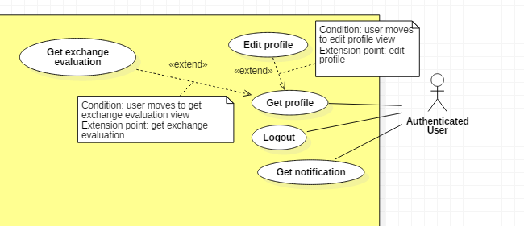

##### 2.3.3.1. < Authenticated User > Get profile Usecase

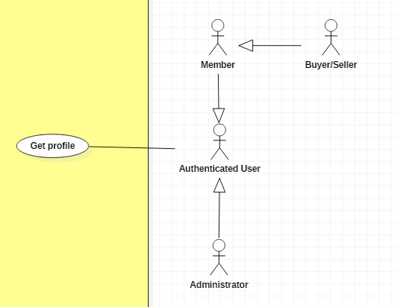

|  |  |  |  |
| --- | --- | --- | --- |
| **USE CASE – UC _AuthenticatedUser_01** | | | |
| **Usecase No.** | AuthenticatedUser_01 | **Usecase Version** | 1.0 |
| **Usecase Name** | Get profile | | |
| **Author** | TungHNM | | |
| **Date** | 03/10/2018 | **Priority** | Normal |
| **Actor:**   * Authenticated User.   **Summary:**   * This use case allows authenticated user to get his/her or other’s profile’s detail.   **Goal:**   * Authenticated user can get information from his/her or other’s profile’s detail.   **Triggers:**   * Authenticated user sends get profile command to the system.   **Preconditions:**   * User must login into the system.   **Post Conditions:**   * **Success**: User’s profile page is shown with information. * **Fail**: Show error message.   **Main Success Scenario:**   |  |  |  | | --- | --- | --- | | **Step** | **Actor Action** | **System Response** | | 1 | Authenticated user clicks on other user’s name  [Alternative 1] | System displays the selected user’s profile page with the following labels and text:   * Avatar: img * Email: text * Fullname: text * Role: text * Tel: text * Address: text * Birthday: text * Status: text   System displays statistic on the left side and TOP 10 ranking user on the right side, icon show exchange evaluation button to show other user’s exchange evaluation |   **Alternative Scenario:**  **Alternative Scenario 1:** Authenticated User gets his/her own profile   |  |  |  | | --- | --- | --- | | **Step** | **Actor Action** | **System Response** | | 1 | Authenticated user clicks on his/her own profile | System displays his/her own profile view with the following labels and text:   * Avatar: img * Email: input text * Firstname: input text * Middlename: input text * Lastname: input text * Role: input text, disabled * Tel: input text * Address: input text * Birthday: DateTimePicker * Status: input text, disabled   System also displays EDIT button and icon get exchange evaluation button to show other user’s exchange evaluation if any |   **Exceptions:** N/A  **Relationships:** N/A  **Business** **Rules**:N/A | | | |

##### 2.3.3.2. < Authenticated User > Edit profile Usecase

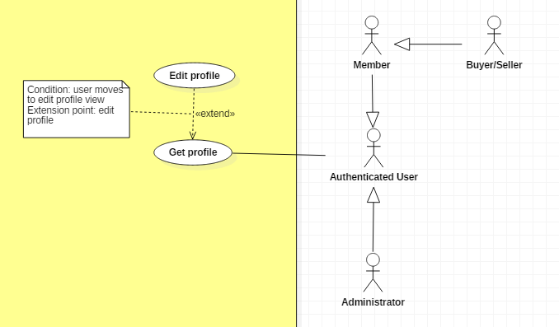

|  |  |  |  |
| --- | --- | --- | --- |
| **USE CASE – UC _AuthenticatedUser_02** | | | |
| **Usecase No.** | AuthenticatedUser_02 | **Usecase Version** | 1.0 |
| **Usecase Name** | Edit profile | | |
| **Author** | TungHNM | | |
| **Date** | 03/10/2018 | **Priority** | Normal |
| **Actor:**   * Authenticated User.   **Summary:**   * This use case allows authenticated user to update his/her profile information.   **Goal:**   * Authenticated User can edit his/her profile.   **Triggers:**   * Authenticated User sends edit profile command to the system.   **Preconditions:**   * User must login into system. * User’s own profile view is displayed.   **Post Conditions:**   * **Success**: User’s information is updated. * **Fail**: Show error message.   **Main Success Scenario:**   |  |  |  | | --- | --- | --- | | **Step** | **Actor Action** | **System Response** | | 1 | Authenticated User clicks on “EDIT” button | Edit Profile page is shown with following labels and fields:   * Email: text, required, max length: 50, RegEx: /^([a-z0-9_\.-]+)@([\da-z\.-]+)\.([a-z\.]{2,6})$/ * First Name: text, max length: 50 * Middle Name: text, max length: 50 * Last Name: text, max length: 50 * Tel: text, length: 10-11 * Address: text, max length: 250 * Birthday: DateTimePicker * Password: text, disabled * Status: text, disabled * Change image: button, icon   System automatically fills out the form with information of the selected user’s profile in database . | | 2 | User fills out the form  [Alternative 1] |  | | 4 | User clicks on “SAVE” button  [Alternative 2] | Validate data.  [Exception 1, 2, 3, 4, 5]  Update account information to database  System displays Profile page with updated information. |   **Alternative Scenario:**  **Alternative Scenario 1:** Authenticated Userclicks on change image icon button   |  |  |  | | --- | --- | --- | | **Step** | **Actor Action** | **System Response** | | 1 | Authenticated User clicks on change image icon button | System displays choose files dialog for user to choose | | 2 | Authenticated User choose files | Validate file type.  [Exception 6]  System displays the selected image on the view |   **Exceptions:**   |  |  |  | | --- | --- | --- | | **No** | **Cause** | **System Response** | | 1 | Email does not match the required format: /^([a-z0-9_\.-]+)@([\da-z\.-]+)\.([a-z\.]{2,6})$/ | System shows error message: Invalid email ! | | 2 | Phone number is not string of number | System shows error message: Invalid phone number ! | | 3 | Email is duplicate in database | System shows error message: The email has been existed ! | | 4 | Missing of required fields | System shows message that notify user to input the missed fields | | 5 | Length of field’s value is out of range | System shows message that notify user which field’s value is out of range | | 6 | Invalid image type | System shows message that notify user the selected file is not type of image |   **Relationships:** Extends to Get Profile use case  **Business** **Rules**:   * User’s profile will be automatically filled out when Edit Account page is loaded or whenever an exception occurs. * The selected avatar from choose file dialog must be type of *.jpeg/*.png/*.jpg/*.gif * In case of success scenarios, account’s information would be updated to the database and displays the profile page with updated information. * System will saved user’s avatar with file name: username.filetype * Email must not be duplicate in database. | | | |

#### 2.3.4. < Administrator > Overview Usecase

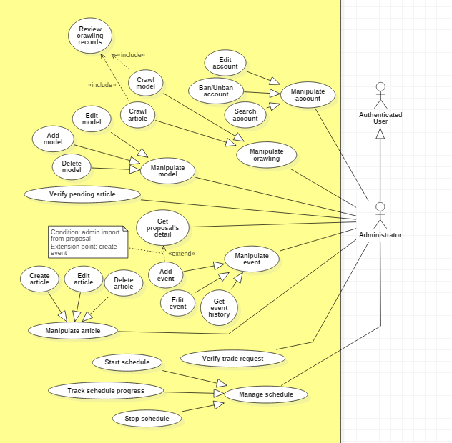

##### 2.3.4.1. < Administrator > Crawl model Usecase

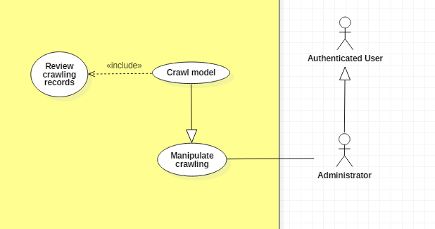

|  |  |  |  |
| --- | --- | --- | --- |
| **USE CASE – UC _Admin_01** | | | |
| **Usecase No.** | Admin_01 | **Usecase Version** | 1.0 |
| **Usecase Name** | Crawl model | | |
| **Author** | TungHNM | | |
| **Date** | 28/09/2018 | **Priority** | Normal |
| **Actor:**   * Administrator.   **Summary:**   * This use case allows administrator to crawl model from high domain: https://www.1999.co.jp/eng/gundam.   **Goal:**   * Information about models will be crawled and saved to database with status “crawlpending”.   **Triggers:**   * Administrator sends crawl models command to the system.   **Preconditions:**   * User must login into system with role Administrator. * Crawl model page is displayed.   **Post Conditions:**   * **Success**: The crawl is running with counting records and new records. Models’s crawling records will be saved to database with status “crawlpending” and will display on pending model page for administrator to review. * **Fail**: Show error message.   **Main Success Scenario:**   |  |  |  | | --- | --- | --- | | **Step** | **Actor Action** | **System Response** | | 1 | Administrator goes to crawl model view | System displays the following items:   * CRAWL button * List of crawl history records in log “crawlmodel.dat” | | 2 | Administrator clicks on “CRAWL” button | System displays messages: “System is crawling successfully”.  System displays icon “Track crawling process” button  Save new models to database, log file. | | 3 | Administrator switchs on “Track crawling process” button  [Alternative 1] | System shows counting number of crawl records & number of new records. |   **Alternative Scenario:**  **Alternative Scenario 1: Switch off “Track crawling process” button**   |  |  |  | | --- | --- | --- | | **Step** | **Actor Action** | **System Response** | | 1 | Administrator switchs off “Track crawling process” button | System hide number of crawl records and number of new records. |   **Relationships:** N/A  **Business** **Rules**:   * In case of success scenarios, new model crawling data would be saved to database with status “crawlpending”. * All crawling records are matching with data in database using MD5 hash function (name + product series + series title + manufacturer) * System log to file “crawlmodel.dat” when start crawl with status “Crawling” and update to “Done” when finish | | | |

##### 2.3.4.2. < Administrator > Crawl article Usecase

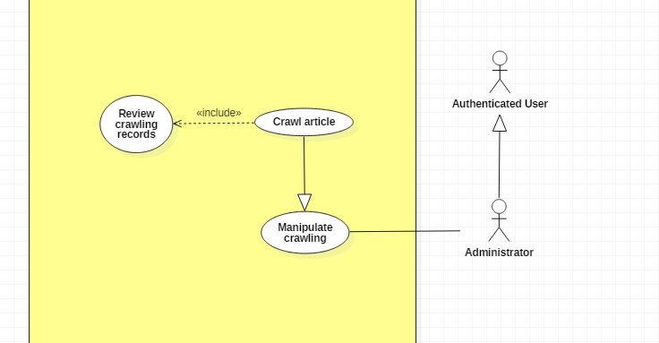

|  |  |  |  |
| --- | --- | --- | --- |
| **USE CASE – UC _Admin_02** | | | |
| **Usecase No.** | Admin_02 | **Usecase Version** | 1.0 |
| **Usecase Name** | Crawl article | | |
| **Author** | TungHNM | | |
| **Date** | 28/09/2018 | **Priority** | Normal |
| **Actor:**   * Administrator.   **Summary:**   * This use case allows administrator to crawl article from high domain: https://www.gunpla101.com   **Goal:**   * Information about article will be crawled and saved to database with status “crawlpending”.   **Triggers:**   * Administrator sends crawl article command to the system.   **Preconditions:**   * User must login into system with role Administrator. * Crawl article page is displayed.   **Post Conditions:**   * **Success**: The crawl is running with counting records and new records. Article’s crawling records will be saved to database with status “crawlpending” and will display on pending article page for administrator to review. * **Fail**: Show error message.   **Main Success Scenario:**   |  |  |  | | --- | --- | --- | | **Step** | **Actor Action** | **System Response** | | 1 | Administrator goes to crawl model view | System displays the following items:   * CRAWL button * List of crawl history records in log “crawlarticle.dat” | | 2 | Administrator clicks on “CRAWL” button | System display messages: “System is crawling successfully”.  System matches crawl article records with existed data in database.  Save new articles to database, log file. | | 3 | Administrator switchs on “Track crawling process” button  [Alternative 1] | System shows counting number of crawl records & number of new records. |   **Alternative Scenario:**  **Alternative Scenario 1: Switch off “Track crawling process” button**   |  |  |  | | --- | --- | --- | | **Step** | **Actor Action** | **System Response** | | 1 | Administrator switchs off “Track crawling process” button | System hide number of crawl records and number of new records. |   **Relationships:** N/A  **Business** **Rules**:   * In case of success scenarios, new article crawling data would be saved to database with status “crawlpending”. * System log to file “crawlarticle.dat” when start crawl with status “Crawling” and update to “Done” when finish | | | |

##### 2.3.1.3. < Administrator > Add new model Usecase

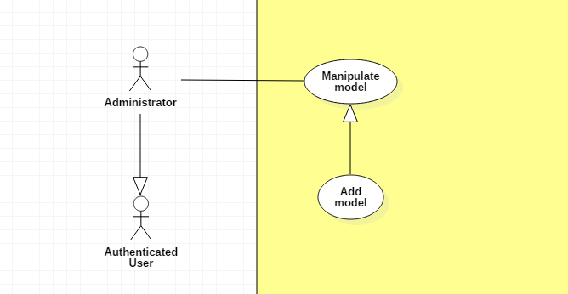

|  |  |  |  |
| --- | --- | --- | --- |
| **USE CASE – UC _Admin_03** | | | |
| **Usecase No.** | Admin_03 | **Usecase Version** | 1.0 |
| **Usecase Name** | Add new model | | |
| **Author** | TungHNM | | |
| **Date** | 30/09/2018 | **Priority** | Normal |
| **Actor:**   * Administrator.   **Summary:**   * This use case allows administrator to create a new model.   **Goal:**   * To add new model to system.   **Triggers:**   * Administrator sends add new model command to the system.   **Preconditions:**   * User must login into system with role Administrator. * The create new model page is displayed.   **Post Conditions:**   * **Success**: A model with information is created and saved to database successfully. * **Fail**: Show error message.   **Main Success Scenario:**   |  |  |  | | --- | --- | --- | | **Step** | **Actor Action** | **System Response** | | 1 | Administrator goes to create new model view | An add new model form is shown with following labels and fields:   * Code: text, required with regEx: /^[A-z]+$/ * Name: text, required, max length: 50 * Product Series: dropdown list, editable * Series Title: dropdown list, editable * Manufacturer: dropdown list, editable * Price: free text input * Released Date: DateTimePicker * Description: free text input, max length: 350 * Import image: input type file * Image type: dropdown list | | 2 | Administrator fills out the form  [Alternative 1] |  | | 3 | Administrator clicks on “CREATE” button | Validate data  [Exception 1, 2, 3, 5]  New model is created and saved to database.  Model’s images are saved to database and to folder “uploads”  System displays message Model {code} is saved successfully! |   **Alternative Scenario:**  **Alternative Scenario 1: Click on “Add images” button**   |  |  |  | | --- | --- | --- | | **Step** | **Actor Action** | **System Response** | | 1 | Administrator clicks on “Import image” button | System shows dialog for administrator to choose local image | | 2 | Administrator chooses an image or multi images | Validate file type  [Exception 4]  System shows the selected image on the view with following data: thumb image, image name with image type, image size, image type dropdown list, cancel button and checkbox (to delete multi images) | | 3 | Administrator delete an image or multi images | System deletes images on the view. |   **Exceptions:**   |  |  |  | | --- | --- | --- | | **No** | **Cause** | **System Response** | | 1 | Administrator does not input all the required fields | System shows error message to ask administrator to fill all the required fields | | 2 | Administrator inputs the invalid code. | System shows error message: Invalid format of code ! | | 3 | The model’s code input from administrator is duplicate | System shows error message: This code is already existed ! | | 4 | File which is imported by administrator is not type of image | System shows error message: Invalid file, please select file image only ! | | 5 | Length of field’s value is out of range | System shows error message that notify administrator which field’s value is out of range. |   **Relationships:** N/A  **Business** **Rules**:   * Model’s code must be characters and must not be duplicated in database. * Each of local image which is imported by administrator must go with an image type * File which is imported by administrator must be type of images: *.jpeg, *.jpg, *.png, *.gif. * Input product series, series title and manufacturer are match with records in database. If new, then save to database * Model’s images is saved in folder “uploads” with file name of model’s name go with auto generated id | | | |

##### 2.3.4.4. < Administrator > Edit model Usecase

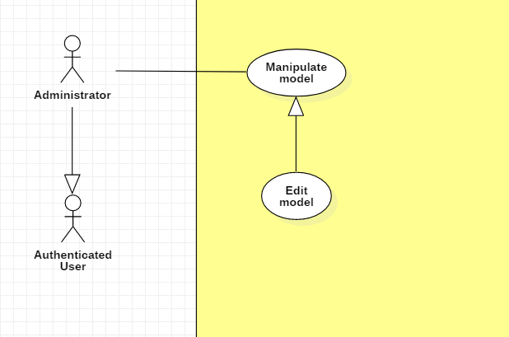

|  |  |  |  |
| --- | --- | --- | --- |
| **USE CASE – UC _Admin_04** | | | |
| **Usecase No.** | Admin_04 | **Usecase Version** | 1.0 |
| **Usecase Name** | Edit a model | | |
| **Author** | TungHNM | | |
| **Date** | 30/09/2018 | **Priority** | Normal |
| **Actor:**   * Administrator.   **Summary:**   * This use case allows administrator to edit a gunpla model’s information.   **Goal:**   * Information about gunpla models will be customized to be more reasonable.   **Triggers:**   * Administrator sends edit model command to the system.   **Preconditions:**   * User must login into system with role Administrator. * The detail page of the model which will be edited is displayed.   **Post Conditions:**   * **Success**: Information of the selected gunpla model is updated and saved to database successfully. * **Fail**: Show error message.   **Main Success Scenario:**   |  |  |  | | --- | --- | --- | | **Step** | **Actor Action** | **System Response** | | 1 | Administrator clicks on “Edit” button on the detail page | System displays Edit Model page and a form with following labels and fields:   * Code: text, required with regEx: /^[A-z]+$/ * Name: text, required, max length: 50 * Product Series: dropdown list, editable * Series Title: dropdown list, editable * Manufacturer: dropdown list, editable * Price: free text input * Released Date: DateTimePicker * Description: free text input, max length: 350 * Import image: input type file * Image type: dropdown list   System automatically loads the selected gundam model’s information to the form.  System loads selected model’s images with following labels for each image:   * Image: img * Image’s name: label * Image’s type: dropdown list * “Cancel”: button | | 2 | Administrator fills out the form  [Alternative 1] |  | | 3 | Administrator clicks on “SAVE” button | Validate data  [Exception 1, 2, 3, 5]  Model’s information is updated and saved to database.  Model’s images are updated in database and in “uploads” folder at server.  System displays message: Model {code} is updated successfully! |   **Alternative Scenario:**  **Alternative Scenario 1: Click on “Import image” button**   |  |  |  | | --- | --- | --- | | **Step** | **Actor Action** | **System Response** | | 1 | Administrator clicks on “Import image” button | System shows dialog for administrator to choose local image | | 2 | Administrator chooses an image or multi images | Validate file type  [Exception 4]  System shows the selected image on the view with following data: thumb image, image name with image type, image size, image type dropdown list, cancel button and checkbox | | 3 | Administrator delete an image or multi images | System will delete images on the view |   **Exceptions:**   |  |  |  | | --- | --- | --- | | **No** | **Cause** | **System Response** | | 1 | Administrator does not input all the required fields | System shows error message to ask administrator to fill all the required fields | | 2 | Administrator inputs the invalid code. | System shows error message: Invalid format of code ! | | 3 | The model’s code input from administrator is duplicate | System shows error message: This code is already existed ! | | 4 | File which is imported by administrator is not type of image | System shows error message: Invalid file, please select file image only ! | | 5 | Length of field’s value is out of range | System shows error message that notify administrator which field’s value is out of range |   **Relationships:** N/A  **Business** **Rules**:   * Model’s code must be characters and not duplicated in database. * Each of local image which is imported by administrator goes with an image type: dropdown list, image name with type, image size, cancel button at the same time * File which is imported by administrator must be type of images: *.jpeg, *.jpg, *.png, *.gif. * In case of success scenario, the selected model will be updated. System will create new images record in database and also in “uploads” folder if any, system will update the existed image if any (update image type) and system will delete images in database as well as “uploads” folder if any. * Input product series, series title and manufacturer are match with records in database. If new, then save to database * Model’s images is saved in folder “uploads” with file name of model’s name go with auto generated id | | | |

##### 2.3.4.5. < Administrator > Delete model Usecase

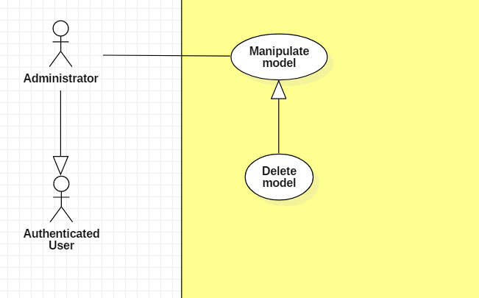

|  |  |  |  |
| --- | --- | --- | --- |
| **USE CASE – UC _Admin_05** | | | |
| **Usecase No.** | Admin_05 | **Usecase Version** | 1.0 |
| **Usecase Name** | Delete a model | | |
| **Author** | TungHNM | | |
| **Date** | 30/09/2018 | **Priority** | Normal |
| **Actor:**   * Administrator.   **Summary:**   * This use case allows administrator to delete a gundam model.   **Goal:**   * Models which are no longer available will be removed from system and will not be displayed on the user view.   **Triggers:**   * Administrator sends delete model command to the system.   **Preconditions:**   * User must login into system with role Administrator. * The detail page of the model which will be deleted is displayed.   **Post Conditions:**   * **Success**: Model and its information are deleted from the system. * **Fail**: Show error message.   **Main Success Scenario:**   |  |  |  | | --- | --- | --- | | **Step** | **Actor Action** | **System Response** | | 1 | Administrator clicks on “Delete” button on the detail page | System displays a dialog for administrator to confirm, the dialog is displayed with message: Are you sure ?, with 2 buttons:   * Yes * No | | 2 | Administrator clicks on “Yes” button  [Alternative 1] | Model information is deleted in database.  Model’s images are deleted in folder “uploads”  System displays message: Model {code} is removed from system successfully ! |   **Alternative Scenario:**  **Alternative Scenario 1: Clicks on “No” button**   |  |  |  | | --- | --- | --- | | **Step** | **Actor Action** | **System Response** | | 1 | Administrator clicks on “No” button | The dialog disappears and system views detail page of the selected gunpla model, automatically fills out all fields. |   **Exceptions:** N/A  **Relationships:** N/A  **Business** **Rules**: N/A | | | |

##### 2.3.4.6. < Administrator > Start/Stop schedule Usecase

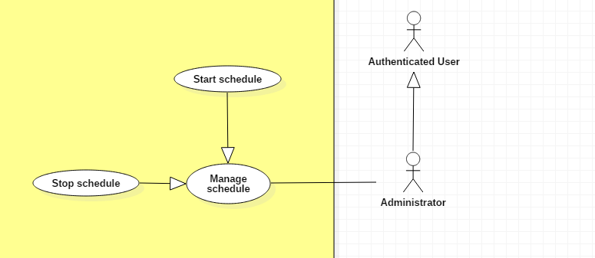

|  |  |  |  |
| --- | --- | --- | --- |
| **USE CASE – UC _Admin_06** | | | |
| **Usecase No.** | Admin_06 | **Usecase Version** | 1.0 |
| **Usecase Name** | Start/Stop schedule | | |
| **Author** | TungHNM | | |
| **Date** | 30/09/2018 | **Priority** | Normal |
| **Actor:**   * Administrator.   **Summary:**   * This use case allows administrator to start/stop schedule. There are 3 types of schedules: schedule auto crawl model and article, schedule disable events which don’t have enough attendee after end registration date and schedule reject all order requests which don’t have any responses from trade post owner in 2 days.   **Goal:**   * Administrator is able to control the schedule with input cycle and schedule will auto update system data after the input interval.   **Triggers:**   * Administrator sends start/stop schedule command to the system.   **Preconditions:**   * User must login into system with role Administrator. * The manage schedule page is displayed.   **Post Conditions:**   * **Success**: The selected schedule will start with input cycle (hours) or stop * **Fail**: Show error message.   **Main Success Scenario:**   |  |  |  | | --- | --- | --- | | **Step** | **Actor Action** | **System Response** | | 1 | Administrator clicks on start button | A dialog is displayed with following item:   * Cycle: text input, required | | 2 | Administrator input cycle hour with type of Integer | Validate.  [Exception 1, 2, 3]  System displays a dialog for administrator to confirm, the dialog is displayed with message: Are you sure ?, with 2 buttons:   * Yes * No | | 3 | Administrator clicks on “Yes” button  [Alternative 1] | The selected schedule will start to run at server with the input cycle!  System displays message: “Schedule {schedule name} is running successfully” | | 4 | Administrator clicks “Stop” button | System displays a dialog for administrator to confirm, the dialog is displayed with message: Are you sure ?, with 2 buttons:   * Yes * No | | 5 | Administrator clicks on “Yes” button  [Alternative 1] | The selected schedule is interrupted.  System displays message: “Schedule {schedule name} is stopped successfully” |   **Alternative Scenario:**  **Alternative Scenario 1: Clicks on “No” button**   |  |  |  | | --- | --- | --- | | **Step** | **Actor Action** | **System Response** | | 1 | Administrator clicks on “No” button | The dialog disappears and system views the manage schedule page |   **Exceptions:**   |  |  |  | | --- | --- | --- | | **No** | **Cause** | **System Response** | | 1 | Out of range input cycle | System display error message to the view | | 2 | Is not integer | System display error message to the view | | 3 | Missing required field | System display error message to the view |   **Relationships:** N/A  **Business** **Rules**:   * Schedule will start with thread and auto run on the server with the infinity loop, sleep for input interval (cycle) from administrators before execute update process and will be stopped when admin stops. * Cycle must be larger than 0 and lower than 480 (480 minutes = 20 days) | | | |

##### 2.3.4.7. < Administrator > Track schedule progress Usecase

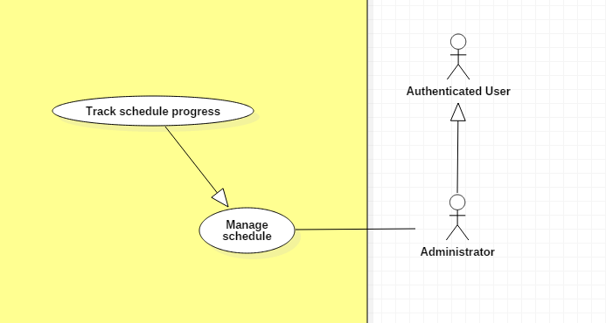

|  |  |  |  |
| --- | --- | --- | --- |
| **USE CASE – UC _Admin_07** | | | |
| **Usecase No.** | Admin_07 | **Usecase Version** | 1.0 |
| **Usecase Name** | Track schedule progress | | |
| **Author** | TungHNM | | |
| **Date** | 30/09/2018 | **Priority** | Normal |
| **Actor:**   * Administrator.   **Summary:**   * This use case allows administrator to track the schedules progress with countdown time and data in log file.   **Goal:**   * Administrator is able to track the schedule, the exact time that each schedule executes update process.   **Triggers:**   * Administrator goes to manage schedule view.   **Preconditions:**   * User must login into system with role Administrator. * The manage schedule page is displayed.   **Post Conditions:**   * **Success**: If the schedule is running, then system will display countdown time with data in log file and schedule’s status * **Fail**: Show error message.   **Main Success Scenario:**   |  |  |  | | --- | --- | --- | | **Step** | **Actor Action** | **System Response** | | 1 | Administrator goes to manage schedule view | System displays schedule name, status, and data in log file  If the schedule is running, countdown time will display |   **Exceptions:** N/A  **Relationships:** N/A  **Business** **Rules**:   * Countdown time will reset to the last input cycle of administrator after countdown finishes. | | | |

##### 2.3.4.8. < Administrator > Create new event Usecase

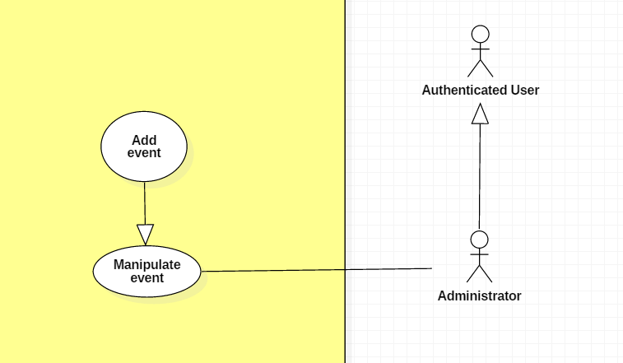

|  |  |  |  |
| --- | --- | --- | --- |
| **USE CASE – UC _Admin_08** | | | |
| **Usecase No.** | Admin_08 | **Usecase Version** | 1.0 |
| **Usecase Name** | Create new event | | |
| **Author** | KhanhNB | | |
| **Date** | 25/09/2018 | **Priority** | Normal |
| **Actor:**   * Administrator   **Summary:**   * This use case allows admin to post a new event   **Goal:**   * The event is posted on the website   **Triggers:**   * Admin fill in the event’s info and submit   **Preconditions:**   * User must login into system with role Administrator.   **Post Conditions:**   * **Success**: The event is added to the database * **Fail**: Show error message.   **Main Success Scenario:**   |  |  |  | | --- | --- | --- | | **Step** | **Actor Action** | **System Response** | | 1 | Admin go to “Create new event” page | “Create new event” view is shown with following labels and fields:   * Input field for the event’s Title * Input field for the event’s location * A textarea for the event’s description * Input image for the thumbnail * Input field for the event’s start date * Input field for the event’s end date * Input field for the event’s registration start date * Input field for the event’s registration end date * Input field for the event’s ticket price * A textarea using CKEditor library for the event’s content * Dropdown list for the event’s status, values “Active”, “Inactive”, “Finished” * Submit button | | 2 | Admin fill out form |  | | 3 | Admin submit | System add the event to the database, the event is now posted on the website |   **Alternative Scenario:**  N/A  **Exceptions:**   |  |  |  | | --- | --- | --- | | **No** | **Cause** | **System Response** | | 1 | Admin submit with empty title | System shows error message to ask the admin to enters missing required fields. | | 2 | Admin submit with empty location | System shows error message to ask the admin to enters missing required fields. | | 3 | Admin submit with empty description | System shows error message to ask the admin to enters missing required fields. | | 4 | Admin submit with empty max attendee | System shows error message to ask the admin to enters missing required fields. | | 5 | Admin submit with empty min attendee | System shows error message to ask the admin to enters missing required fields. | | 6 | Admin submit with empty content | System shows error message to ask the admin to enters missing required fields. | | 7 | Admin submit with no thumbnail uploaded | System shows error message to ask the admin to enters missing required fields. | | 8 | Admin upload file too large. | System shows error message to ask the admin to upload correct required file size. |   **Relationships:** N/A  **Business** **Rules**:   * In case of success scenarios, the event would be updated in the database. * Article id is automatically initialized by the system. File upload must be file type of images: *.jpeg, *.jpg, *.png, *.gif. * The registration dates validation formula:   Registration start date < Registration end date < Event start date < Event end date | | | |

##### 2.3.4.9. < Administrator > Edit event Usecase

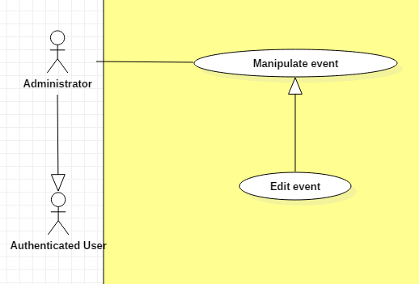

|  |  |  |  |
| --- | --- | --- | --- |
| **USE CASE – UC _Admin_09** | | | |
| **Usecase No.** | Admin_09 | **Usecase Version** | 1.0 |
| **Usecase Name** | Update event | | |
| **Author** | KhanhNB | | |
| **Date** | 25/09/2018 | **Priority** | Normal |
| **Actor:**   * Administrator   **Summary:**   * This use case allows admin to update an event’s info.   **Goal:**   * The event is updated in database   **Triggers:**   * Admin edit an event and submit it.   **Preconditions:**   * User must login into system with role Administrator.   **Post Conditions:**   * **Success**: The event is updated in the database system. * **Fail**: Show error message.   **Main Success Scenario:**   |  |  |  | | --- | --- | --- | | **Step** | **Actor Action** | **System Response** | | 1 | Admin go to “Edit event” page | “Edit event” view is shown with following labels and fields with existing data:   * Input field for the event’s Title * Input field for the event’s location * A textarea for the event’s description * Input image for the thumbnail * Input field for the event’s start date * Input field for the event’s end date * Input field for the event’s registration start date * Input field for the event’s registration end date * Input field for the event’s ticket price * A textarea using CKEditor library for the event’s content * Dropdown list for the event’s status, values “Active”, “Inactive”, “Finished” * Submit button | | 2 | Admin fills out the form. |  | | 3 | Admin submit event. | Validate data.  System update the article in the database |   **Alternative Scenario:**  N/A  **Exceptions:**   |  |  |  | | --- | --- | --- | | **No** | **Cause** | **System Response** | | 1 | Admin submit with empty title | System shows error message to ask the admin to enters missing required fields. | | 2 | Admin submit with empty location | System shows error message to ask the admin to enters missing required fields. | | 3 | Admin submit with empty description | System shows error message to ask the admin to enters missing required fields. | | 4 | Admin submit with empty max attendee | System shows error message to ask the admin to enters missing required fields. | | 5 | Admin submit with empty min attendee | System shows error message to ask the admin to enters missing required fields. | | 6 | Admin submit with empty content | System shows error message to ask the admin to enters missing required fields. | | 7 | Admin upload file too large. | System shows error message to ask the admin to upload correct required file size. |   **Relationships:** N/A  **Business** **Rules**:   * In case of success scenarios, the event would be updated in the database. * Article id is automatically initialized by the system. File upload must be file type of images: *.jpeg, *.jpg, *.png, *.gif. * The registration dates validation formula:   Registration start date < Registration end date < Event start date < Event end date | | | |

##### 2.3.4.10. < Administrator > Get proposal’s detail Usecase

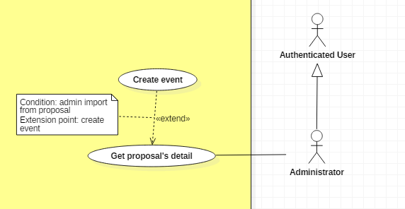

|  |  |  |  |
| --- | --- | --- | --- |
| **USE CASE – UC _Admin_10** | | | |
| **Usecase No.** | Admin_10 | **Usecase Version** | 1.0 |
| **Usecase Name** | Get proposal’s detail | | |
| **Author** | KhanhNB | | |
| **Date** | 25/09/2018 | **Priority** | Normal |
| **Actor:**   * Administrator   **Summary:**   * This use case allows admin to create an event from a proposal   **Goal:**   * The proposal data is loaded to the interface   **Triggers:**   * Admin selects “Create event from this proposal” while viewing a proposal   **Preconditions:**   * User must login into system with role Administrator.   **Post Conditions:**   * **Success**: The proposal data is loaded to the interface * **Fail**: Show error message.   **Main Success Scenario:**   |  |  |  | | --- | --- | --- | | **Step** | **Actor Action** | **System Response** | | 1 | Admin go to “Proposal detail” page | “Proposal detail” view is shown with following labels and fields:   * Title of the event * Description of the event * Location of the event * Content of the event | | 2 | Admin select “Create event from this proposal” | System redirect the admin to “Create new event” view with the following fields with proposal’s data:   * Title of the event * Description of the event * Location of the event * Content of the event |   **Alternative Scenario:**  N/A  **Exceptions:** N/A  **Relationships:** N/A  **Business** **Rules**:N/A | | | |

#### 2.3.5. < Buyer/Seller > Overview Usecase

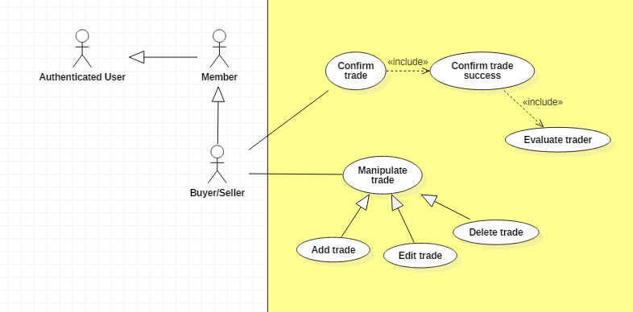

##### 2.3.5.1. < Buyer/Seller > Add trade Usecase

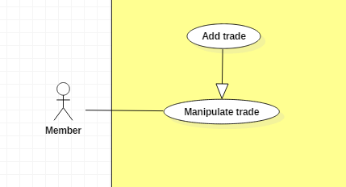

|  |  |  |  |
| --- | --- | --- | --- |
| **USE CASE – UC _BuyerSeller_01** | | | |
| **Usecase No.** | BuyerSeller_01 | **Usecase Version** | 1.0 |
| **Usecase Name** | Add trade | | |
| **Author** | SangLNN | | |
| **Date** | 25/09/2018 | **Priority** | Normal |
| **Actor:**   * Buyer/Seller   **Summary:**   * This use case allows buyer/seller to create a new trade post for trade.   **Goal:**   * A new trade post information is added to the database system.   **Triggers:**   * User sends post new trade command with post information to the system.   **Preconditions:**   * User must login into system with role Buyer/Seller.   **Post Conditions:**   * **Success**: New trade post is added to the database system. * **Fail**: Show error message.   **Main Success Scenario:**   |  |  |  | | --- | --- | --- | | **Step** | **Actor Action** | **System Response** | | 1 | User click “Post new trade” button on trade market page. | Create post new trade view is shown with following labels and fields:   * Type of Trade: radio button , required, 2 options: “I want to sell” and “I want to buy”. * Title: text input, required, length 7 – 250. * Photos: file input, required, number of file 1 – 5, maximum size per file is 2.5mb. * Condition : radio button , required, 2 options: “New” and “Used”. * Price: text, required, length 1 – 7. * Quantity: number, required, positive integer and below than 1000. * Brand: text input, required, length 3 – 50. * Model: text input, required, length 3 – 50. * Description : text input, required, length 20 – 5000.   Create trade post owner’s information view is shown with following labels and fields:   * Full name: text input, required, length 3 – 50. * Email: text input, readonly. * Phone Number: text input, required, length 7 – 12. * Address: text input, readonly. * Auto get your location: Button   [Alternative Scenario 1]   * Change your location: Button   [Alternative Scenario 2]  And “Post your trade” submit form button. | | 2 | User fills out the form. |  | | 3 | User sends post new trade command by click “Post your trade” button. | Validate data.  [Exception 1]  [Exception 2]  Add new trade post in the database.  Update trader information (optional).  System shows message trade post has been created successfully and waiting to administrators approve. |   **Alternative Scenario:**  **Alternative Scenario 1: Auto get your location Scenario.**   |  |  |  | | --- | --- | --- | | **Step** | **Actor Action** | **System Response** | | 1 | User click “Auto get your location” button to send get your location command. | [Exception 3]  System auto gets your location and generates to text address then autoforms to address field. |   **Alternative Scenario 2: Change your location Scenario.**   |  |  |  | | --- | --- | --- | | **Step** | **Actor Action** | **System Response** | | 1 | User click “Change your location” button. | System create and show modal with following labels and fields:   * Province/City: select option, required. * District: select option, required. * Ward: select option, required. * Street name: text input, required, length 3 - 50. * Apartment number: text input, required, length 3 – 50. * Your full address: text input, readonly.   And “submit” modal button. | | 2 | User fills out the form. |  | | 3 | User click “submit” button. | System close modal and get text data from “Your full address” field and fill to “Address” field on trade post owner’s information form. |   **Exceptions:**   |  |  |  | | --- | --- | --- | | **No** | **Cause** | **System Response** | | 1 | User sends post new trade command by click “Post your trade” without filling out full form. | System shows error message to ask member enters missing required fields. | | 2 | User upload file too large. | System shows error message to ask member upload correct required file size. | | 3 | User do not allows location permission. | System shows error message to ask member provide required permission. |   **Relationships:** N/A  **Business** **Rules**:   * In case of success scenarios, a trade post would be added to the system but still waiting for administrators to approve. * System auto fills out trade post owner’s information from profile database. * Member can get their location by using auto get location service or manual input. * Phone number and price must be string of numbers. * Post trade id is automatic initialized by the system. * Member need provide a location permission to use auto get your location. * File upload must be file type of images: *.jpeg, *.jpg, *.png, *.gif. | | | |

##### 2.3.5.2. < Buyer/Seller > Edit trade Usecase

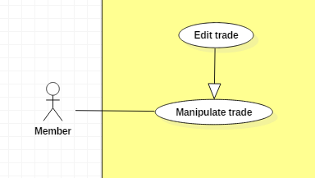

|  |  |  |  |
| --- | --- | --- | --- |
| **USE CASE – UC _BuyerSeller_02** | | | |
| **Usecase No.** | BuyerSeller_02 | **Usecase Version** | 1.0 |
| **Usecase Name** | Edit trade | | |
| **Author** | SangLNN | | |
| **Date** | 26/09/2018 | **Priority** | Normal |
| **Actor:**   * Buyer/Seller   **Summary:**   * This use case allows buyer/seller to edit their trade post information.   **Goal:**   * A new trade post information is updated to the database system.   **Triggers:**   * User sends edit trade post command with updated post information to the system.   **Preconditions:**   * User must login into system with role Member. * Trade post is on pending or trade posting empty trading activity.   **Post Conditions:**   * **Success**: A new post trade information is updated to the database system. * **Fail**: Show error message.   **Main Success Scenario:**   |  |  |  | | --- | --- | --- | | **Step** | **Actor Action** | **System Response** | | 1 | User click on “Edit post” button from any trade post. | Create edit trade post view is show with following labels and fields:   * Type of Trade: radio button , required, 2 option: “I want to sell” and “I want to buy”. * Title: text input, required, length 7 – 250. * Photos: file input, required, number of file 1 – 5, maximum size per file is 2.5mb. * Condition : radio button , required, 2 option: “New” and “Used”. * Price: text, required, length 1 – 7. * Quantity: number, required, positive integer and below than 1000. * Brand: text input, required, length 3 – 50. * Model: text input, required, length 3 – 50. * Description : text input, required, length 20 – 5000.   Create trader information view is show with following labels and fields:   * Full name: text input, required, length 3 – 50. * Email: text input, readonly. * Phone Number: text input, required, length 7 – 12. * Address: text input, readonly. * Auto get your location: Button   [Alternative Scenario 1]   * Change your location: Button   [Alternative Scenario 2]  And “Save your change” submit form button. | | 2 | User fills out the form. |  | | 3 | User sends edit trade post command by click “Save your change” button. | Validate data.  [Exception 1]  [Exception 2]  New trade post information is updated in the database.  System shows message trade post has been updated successfully and waiting to administrators approve. |   **Alternative Scenario:** **N/A**  **Alternative Scenario:**  **Alternative Scenario 1: Auto get your location Scenario.**   |  |  |  | | --- | --- | --- | | **Step** | **Actor Action** | **System Response** | | 1 | User click “Auto get your location” button to send get your location command. | [Exception 3]  System auto get your location and generated to text address then autoform to address field. |   **Alternative Scenario 2: Change your location Scenario.**   |  |  |  | | --- | --- | --- | | **Step** | **Actor Action** | **System Response** | | 1 | User click “Change your location” button. | System create and show modal with following labels and fields:   * Province/City: select option, required. * District: select option, required. * Ward: select option, required. * Street name: text input, required, length 3 - 50. * Apartment number: text input, required, length 3 – 50. * Your full address: text input, readonly.   And “submit” modal button. | | 2 | User fills out the form. |  | | 3 | User click “submit” button. | System close modal and get text data from “Your full address” field and fill to “Address” field on trader information form. |   **Exceptions:**   |  |  |  | | --- | --- | --- | | **No** | **Cause** | **System Response** | | 1 | User sends post new trade command by click “Save your change” without fills out full form. | System shows error message to ask member enters missing required fields. | | 2 | User upload file too large. | System shows error message to ask member upload correct required file size. | | 3 | User do not allows location permission. | System shows error message to ask member provide required permission. |   **Relationships:** N/A  **Business** **Rules**:   * “Edit trade post” button is only show on trade post is on pending or trade posting empty trading activity. * In case of success scenarios, a trade post information would be updated to the system but still waiting administrators approve. * Member can get their location by using auto get location service or manual input. * Phone number and price must be string of numbers. * Member need provide a location permission to use auto get your location. * File upload must be file type of images: *.jpeg, *.jpg, *.png, *.gif. | | | |

##### 2.3.5.3. < Buyer/Seller > Delete trade Usecase

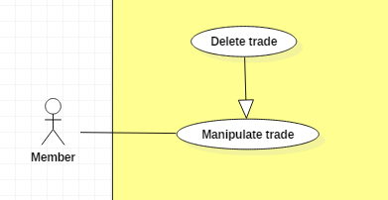

|  |  |  |  |
| --- | --- | --- | --- |
| **USE CASE – UC _BuyerSeller_03** | | | |
| **Usecase No.** | BuyerSeller_03 | **Usecase Version** | 1.0 |
| **Usecase Name** | Delete a trade post | | |
| **Author** | SangLNN | | |
| **Date** | 26/09/2018 | **Priority** | Normal |
| **Actor:**   * Buyer/Seller   **Summary:**   * This use case allows member to delete a pending trade post or a trade post have no request order.   **Goal:**   * The trade post has selected is deleted from the database system.   **Triggers:**   * User sends delete trade post command with trade post id to the system.   **Preconditions:**   * User must login into system with role Member. * Trade post is on pending or trade posting empty trading activity.   **Post Conditions:**   * **Success**: The trade post has selected is deleted from the database system. * **Fail**: Show error message.   **Main Success Scenario:**   |  |  |  | | --- | --- | --- | | **Step** | **Actor Action** | **System Response** | | 1 | User click on “Delete post” button. | System show a confirm modal with message “Are you sure to delete this post?” and two option Y/N. | | 2 | User confirm delete by click “Yes” to send delete command.  User cancel delete by click “No”. | The trade post has selected is deleted from database.  System close modal and show message trade post has been deleted successfully.  System close modal and nothing has changed. |   **Alternative Scenario:** N/A  **Exceptions:** N/A  **Relationships:** N/A  **Business** **Rules**:   * “Edit trade post” button is only show on trade post is on pending or trade posting empty trading activity. * In case of success scenarios, a trade would deleted from database system. | | | |

##### 2.3.5.4. < Buyer/Seller > Confirm trade Usecase

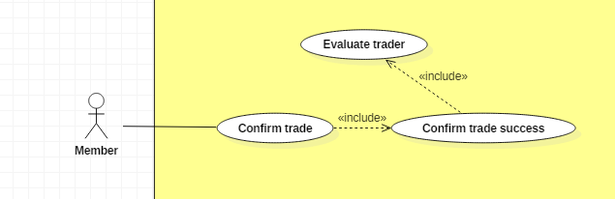

|  |  |  |  |
| --- | --- | --- | --- |
| **USE CASE – UC _BuyerSeller_04** | | | |
| **Usecase No.** | BuyerSeller_04 | **Usecase Version** | 1.0 |
| **Usecase Name** | Confirm trade | | |
| **Author** | SangLNN | | |
| **Date** | 26/09/2018 | **Priority** | Normal |
| **Actor:**   * Buyer/Seller.   **Summary:**   * This use case allows buyer/seller to confirm a order request.   **Goal:**   * After member order a trade the request send to buyer/seller. Buyer/seller can view list of order request and choose any order to accept the order request.   **Triggers:**   * Buyer/seller sends accept request command with order id to the system.   **Preconditions:**   * User must login into system with role buyer/seller. * User have at least one request order.   **Post Conditions:**   * **Success**: System show message accepted and sends notify to who ordered. * **Fail**: Show error message.   **Main Success Scenario:**   |  |  |  | | --- | --- | --- | | **Step** | **Actor Action** | **System Response** | | 1 | User click “Accept” button on request order list to send accept request command.  [Alternative 1] | System notify to who ordered the request has been accepted and set order state to accepted. The trade post owner information will send to trader. |   **Alternative Scenario:**  **Alternative Scenario 1: Decline request order.**   |  |  |  | | --- | --- | --- | | **Step** | **Actor Action** | **System Response** | | 1 | If buyer/seller decline request by click “decline” button. | System create and show modal with following labels and fields:   * Reason: text input, length 10 - 250.   And “submit” modal button. | | 2 | User fills out the form. |  | | 3 | User click “submit” button. | System close modal and set order state to rejected then notify to trader the reason. |   **Exceptions: N/A**  **Relationships:** N/A  **Business** **Rules**: N/A | | | |

##### 2.3.5.5. < Buyer/Seller > Confirm trade success Usecase



|  |  |  |  |
| --- | --- | --- | --- |
| **USE CASE – UC _BuyerSeller_05** | | | |
| **Usecase No.** | BuyerSeller_05 | **Usecase Version** | 1.0 |
| **Usecase Name** | Confirm trade success | | |
| **Author** | SangLNN | | |
| **Date** | 26/09/2018 | **Priority** | Normal |
| **Actor:**   * Buyer/Seller.   **Summary:**   * This use case allows buyer/seller to confirm a trade has been traded successfully.   **Goal:**   * After trade, buyer/seller need to confirm trade successfully.   **Triggers:**   * Buyer/seller sends confirm trade success command with order id to the system.   **Preconditions:**   * User must login into system with role buyer/seller. * User have at least one request order accepted.   **Post Conditions:**   * **Success**: System show message traded successfully and give evaluate form to who ordered. * **Fail**: Show error message.   **Main Success Scenario:**   |  |  |  | | --- | --- | --- | | **Step** | **Actor Action** | **System Response** | | 1 | User click “Confirm trade success” button on payment list..  [Alternative Scenario 1] | System shows a confirm dialog with message “Are you sure to confirm trade success?” and two option Y/N. | | 2 | User confirm by click “Yes” to send confirm trade success command.  [Alternative Scenario 2] | System close dialog and set order state to succeed then notify to trader traded successfully. |   **Alternative Scenario:**  Alternative Scenario 1: Reject a transaction   |  |  |  | | --- | --- | --- | | **Step** | **Actor Action** | **System Response** | | 1 | If buyer/seller click “Cancel” button on payment list. | System create and show modal with following labels and fields:   * Reason: text input, length 10 - 250.   And “submit” modal button. | | 2 | User fills out the form. |  | | 3 | User click “submit” button to send cancel payment command. | System close dialog and set order state to cancelled then notify to trader order has been cancelled with reason. |   Alternative Scenario 2: Confirm by click “no”   |  |  |  | | --- | --- | --- | | **Step** | **Actor Action** | **System Response** | | 1 | User confirm by click “No” | System close dialog and nothing has changed. |   **Exceptions: N/A**  **Relationships:** N/A  **Business** **Rules**: N/A | | | |

#### 2.3.6. < Handler > Overview Usecase

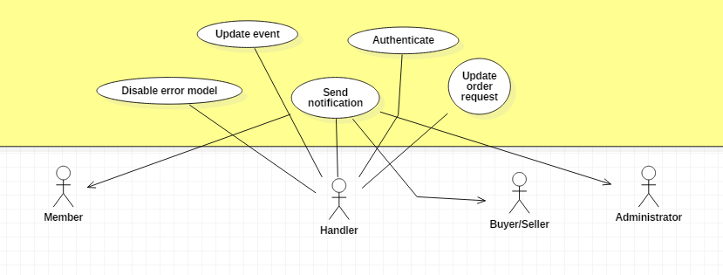

##### 2.3.6.1. < Handler > Send notification Usecase

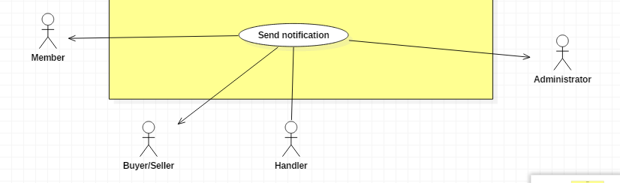

|  |  |  |  |
| --- | --- | --- | --- |
| **USE CASE – UC _Handler_01** | | | |
| **Usecase No.** | Handler_01 | **Usecase Version** | 1.0 |
| **Usecase Name** | Send notification | | |
| **Author** | TungHNM | | |
| **Date** | 20/11/2018 | **Priority** | Normal |
| **Actor:**   * Handler.   **Summary:**   * Handler will notify notifications to users through Firebase Cloud Messaging service.   **Goal:**   * Make it more convenient for user to have information.   **Triggers:**   * To profile’s owner: Administrator update user’s profile with reason * To administrator: Error 404 loading model’s images * To article’s author: Administrator approves user’s article * To event’s attendees: Event is cancelled (notification to event’s attendee) * To trader: approve/decline/cancel/rating/confirm success order * To trade post owner: Administrator approve/decline trade post request   **Preconditions:** N/A  **Post Conditions:**   * **Success**: Notification is sent to user. * **Fail**: Log error to console.   **Main Success Scenario:**   |  |  |  | | --- | --- | --- | | **Step** | **Actor Action** | **System Response** | | 1 | Handler sends send notification command | System sends notification to user |   **Alternative Scenario:** N/A  **Exceptions:** N/A  **Relationships:** N/A  **Business** **Rules**:   * In case of success scenario, system will create new notification in database with status “not seen” and push notification to user’s devices which include web browser and mobile through Firebase Cloud Messaging service | | | |

##### 2.3.6.2. < Handler > Disable error model Usecase

|  |  |  |  |
| --- | --- | --- | --- |
| **USE CASE – UC _Handler_02** | | | |
| **Usecase No.** | Handler_02 | **Usecase Version** | 1.0 |
| **Usecase Name** | Disable error model | | |
| **Author** | TungHNM | | |
| **Date** | 25/10/2018 | **Priority** | Normal |
| **Actor:**   * Handler.   **Summary:**   * Handler will notify notifications to administrator when any model loads with error 404 image.   **Goal:**   * Change status of error loading images model to “Unavailable” so as to avoid displaying error model to user’s view and send notification to administrator to update   **Triggers:**   * Member view model’s detail, model’s images are loading with error 404 url.   **Preconditions:** N/A  **Post Conditions:**   * **Success**: Notification is sent to administrator and the error model’s status is auto changed to “Unavailable”. * **Fail**: Log error to console.   **Main Success Scenario:**   |  |  |  | | --- | --- | --- | | **Step** | **Actor Action** | **System Response** | | 1 | Handler sends error model command | System auto changes the model’s status to “Unavailable” and redirects user back to search model page |   **Alternative Scenario:** N/A  **Exceptions:** N/A  **Relationships:** N/A  **Business** **Rules**:   * Model is called error model when the number of 404 error loading images is greater than 30% of the total model’s images * System will disable error model to avoid displaying on user’s view | | | |

##### 2.3.6.3. < Handler > Authenticate Usecase

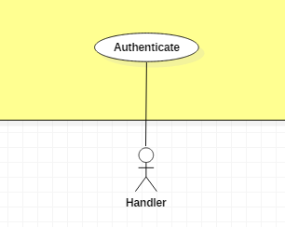

|  |  |  |  |
| --- | --- | --- | --- |
| **USE CASE – UC _Handler_03** | | | |
| **Usecase No.** | Handler_03 | **Usecase Version** | 1.0 |
| **Usecase Name** | Authenticate | | |
| **Author** | TungHNM | | |
| **Date** | 30/09/2018 | **Priority** | Normal |
| **Actor:**   * Handler.   **Summary:**   * Authentication and authorization   **Goal:**   * Authentication and authorization   **Triggers:**   * User logins to system.   **Preconditions:** N/A  **Post Conditions:**   * **Success**: System redirects user to the appropriate view depends on user’s role * **Fail**: Log error to console.   **Main Success Scenario:**   |  |  |  | | --- | --- | --- | | **Step** | **Actor Action** | **System Response** | | 1 | Handler sends authentication and authorization command | System redirects user to appropriate view depends on user’s role |   **Alternative Scenario:** N/A  **Exceptions:** N/A  **Relationships:** N/A  **Business** **Rules**:   * If Admin, redirects to Web Admin * If Member, redirects to Search Model Page * If Buyer/Seller, redirects to My Trade Page | | | |

##### 2.3.6.4. < Handler > Update event Usecase

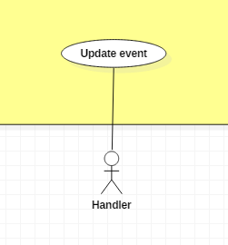

|  |  |  |  |
| --- | --- | --- | --- |
| **USE CASE – UC _Handler_04** | | | |
| **Usecase No.** | Handler_04 | **Usecase Version** | 1.0 |
| **Usecase Name** | Update event | | |
| **Author** | TungHNM | | |
| **Date** | 30/09/2018 | **Priority** | Normal |
| **Actor:**   * Handler.   **Summary:**   * Events will be cancel if there is not enough registered attendee after end-registration date   **Goal:**   * Auto disable events which don’t have enough attendee, make it more convenient for administrator to manage events.   **Triggers:**   * Schedule executes update event process   **Preconditions:** N/A  **Post Conditions:**   * **Success**: Notification is sent to event’s attendees if it is cancelled, event’s status is changed to “Inactive” * **Fail**: Log error to console.   **Main Success Scenario:**   |  |  |  | | --- | --- | --- | | **Step** | **Actor Action** | **System Response** | | 1 | Handler sends update event command | System auto changes the event’s status which don’t have enough attendee after registration date to “Inactive” and send notification to that event’s attendees |   **Alternative Scenario:** N/A  **Exceptions:** N/A  **Relationships:** N/A  **Business** **Rules**: N/A | | | |

##### 2.3.6.5. < Handler > Update order request Usecase

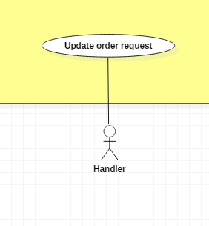

|  |  |  |  |
| --- | --- | --- | --- |
| **USE CASE – UC _Handler_05** | | | |
| **Usecase No.** | Handler_05 | **Usecase Version** | 1.0 |
| **Usecase Name** | Update order request | | |
| **Author** | TungHNM | | |
| **Date** | 30/09/2018 | **Priority** | Normal |
| **Actor:**   * Handler.   **Summary:**   * All order requests which don’t have any responses in 2 days will be rejected   **Goal:**   * Auto reject all order request which don’t have any response in 2 days.   **Triggers:**   * Schedule executes update order request process   **Preconditions:** N/A  **Post Conditions:**   * **Success**: Notification is sent to user whose order request is auto rejected by system. * **Fail**: Log error to console.   **Main Success Scenario:**   |  |  |  | | --- | --- | --- | | **Step** | **Actor Action** | **System Response** | | 1 | Handler sends update order request command | System auto changes the order request status which don’t have any response after 2 days to rejected and sends notification to user. |   **Alternative Scenario:** N/A  **Exceptions:** N/A  **Relationships:** N/A  **Business** **Rules**: N/A | | | |

## 3. Software System Attribute

### 3.1. Usability

* UI website is fit for each browser in each device

o Font style: Helvetica, Arial, Helvetica Neue, Roboto, Arial, Droid Sans, sans-serif

o Font size: 12px - 26px

o Color: green, black, red, white, blue, Light Slate Grey, Fuego, Honeysuckle…

o Background: Whitesmoke, white

* UI mobile is scalable with each monitor of smart phone:
  + Font size: 13-30pt
  + Color: darkblue, black, …
  + Background: white, black...

### 3.2. Reliability

* System crawls information from official international gunpla’s websites, so data will be high accuracy.

### 3.2. Availability

* System replies in maximum 2 seconds

### 3.3. Security

* Each role of user has a specific permission to interact with the system
* System always checks for authorization and authentication before doing anything.
* Input data is validated before saving to database

### 3.4. Maintainability

* The system is divided into separated layers with interface and modules for easy maintaining

### 3.5. Portability

* Web application can run on Chrome version 42 or later, or on firefox 56 or later.

### 3.6. Performance

* Website can locate the user’s location in 2 seconds max
* System sends email to the user in 10 seconds max
* User can view information with pagination which are saved at client-side

## 4. Conceptual Diagram

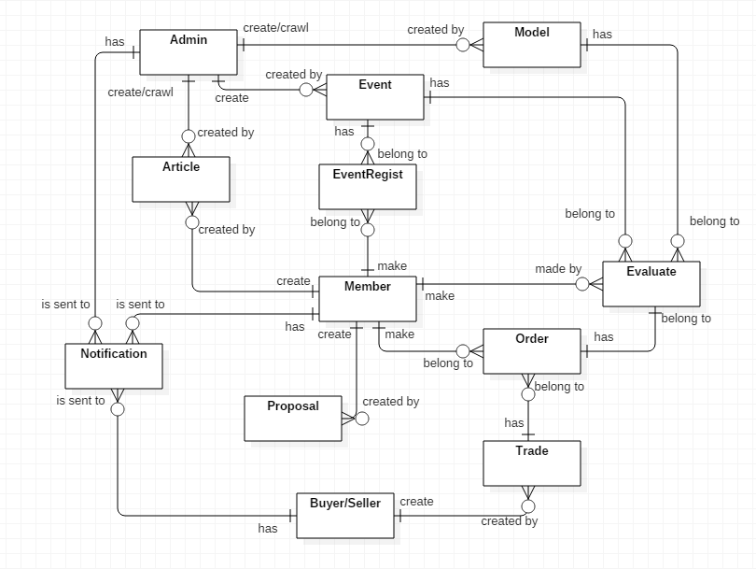

**Data Dictionary**

|  |  |
| --- | --- |
| **Entity Data Dictionary:** describe all contents of all entities | |
| **Entity Name** | **Description** |
| Article | Contain information articles, sharing experience, guide which are create by administrator or members |
| Event | Contain event’s information, created by administrator |
| Model | Contain model’s information, crawled or created by administrator |
| Proposal | Contain proposal’s information that is created by member |
| EventRegist | Contain event registrations, created by member |
| Trade | Contain exchange’s information, created by Buyer/Seller |
| Order | Contain order’s information, created by member and belongs to a trade |
| Evaluate | Contain rating and feedback/review comment about models, events and exchange, made by member |
| Notification | Is sent to administrator when models have error 404 loading images  Is sent to member when administrator update member’s profile  Is sent to users when their order request is accepted/declined/cancel/confirm exchange success or rating from trade post owner  Is sent to buyer/seller when their exchange post is approved/decline by administrator  Is sent to article’s author when their article is approved/disapproved by administrator  Is sent to event’s attendees when the event is cancelled because of not enough attendee to start |
| User (Administrator, Member, Buyer/Seller) | Abstract entities that describe a role in the system |

# D. Report No. 4 Software Design Description

## 1. Design Overview

This document describes the technical and user interface design of **GWA System**. It includes the architectural design, the detailed design of common functions and business functions and the design of database model.

The architectural design describes the overall architecture of the system and the architecture of each main component and subsystem.

The detailed design describes static and dynamic structure for each components and functions. It includes class diagram, class explanations and sequence diagrams, activity diagrams.

The database design describes the relationship between entities and detail of each entity.

Document overview:

* Section 1: gives an overview design of the sytem
* Section 2: gives an overall description of the system architecture design.
* Section 3: gives component diagrams that describe the connection and integration of the system.
* Section 4: gives the detail design description which includes class diagram, class explanation, and sequence diagram to details the application functions.
* Section 5: describe screens design.
* Section 6: describe a fully attributed ERD.
* Section 7: describe algorithms**.**

## 2. System Architectural Design

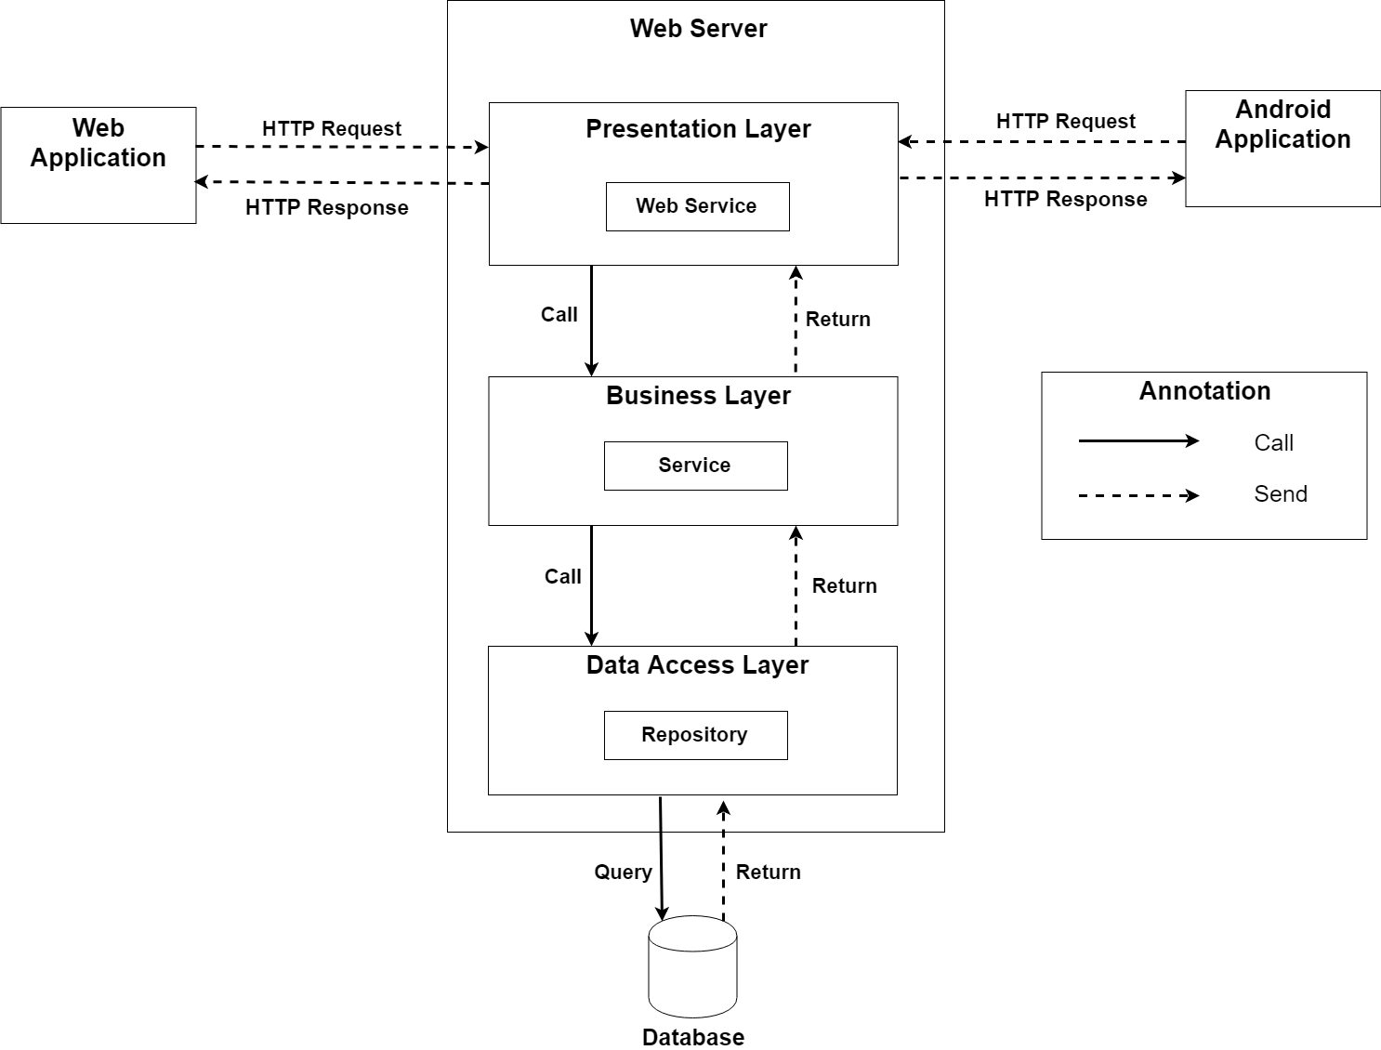

### 2.1. Web application architecture description

In Web Application, the system is developed under 3-layers architecture style, with Spring Boot technology. We choose this architecture for Web application because of the following advantages:

* We can separate our business code into logical layers, each layer performing a specific role within the application. Presentation layer is responsible for handling all user interface and browser communication logic, whereas business layer is responsible for executing business logics and data access layer is responsible for executing anythings that relate to database.
* The presentation layer provides Rest API for web and mobile app to communicate by **json** data through network environment, so we can use the business code in web service without repeating the code.
* It is easy to maintain, to apply object oriented concept and to update data provider queries.

This project follows 3-layers architecture with the following components:

* **WebController:** is the part of presentation layer that acts like event handler to handle user interaction on web application. It receives request from user by request mapping and select the appropriate view to return to user.
* **RestController:** is the part of presentation layer that provides api for client to communicate and reads data from response, call the business layer to execute business logic, then return **json** data to client. Web and Mobile app will render that **json** data to UI.
* **Service:** is the part of business layer that is responsible for executing complex business logics. This component will get user’s data from controller, call repository and perform business operations.
* **Model:** is the part of data access layer that contains the mapping of actual tables in database to classes.
* **Repository:** is the part of data access layer that uses models to execute CRUD database operations. This component only execute operations that are related to and is meant for directly accessing the database.

## 3. Component Diagram

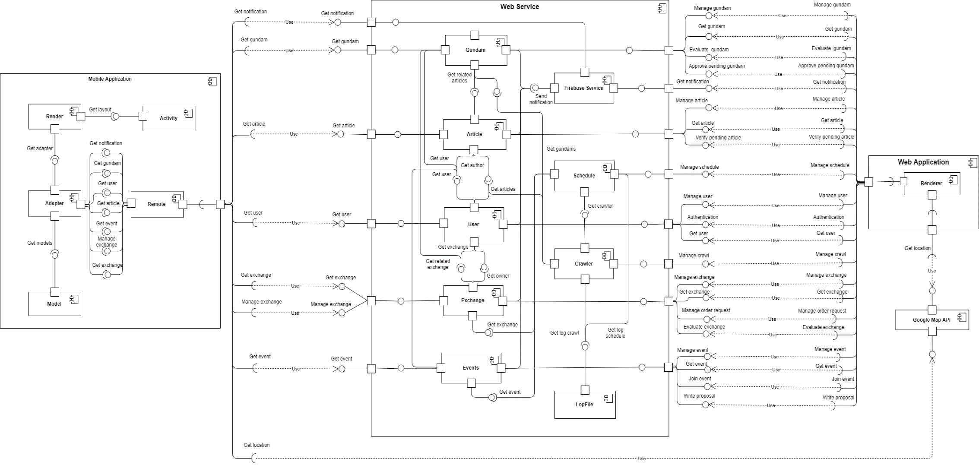

|  |  |
| --- | --- |
| Component Dictionary: Describes components | |
| Web Service | Subsystem that contains business components and provides API for client to interact with the system |
| Web Application | Subsystem that contains client view in web application |
| Mobile Application | Subsystem to handle client activities in mobile application |
| Gundams Component | Component about manipulating gundams |
| Notification Component | Component about manipulating notification |
| Articles Component | Component about manipulating articles |
| Schedule Component | Component about manipulating schedule |
| Users Component | Component about manipulating users |
| Crawler Component | Component about manipulating crawling |
| Exchange Component | Component about manipulating exchange |
| Events Component | Component about manipulating events |
| LogFile Component | Component about reading from and writing to file log |
| Renderer Component | Component to render client web view with json data response from web service |
| Google Map API Component | Component about google map api which response location |
| Remote Component | Component that handles web service request and response |
| Model Component | Component that contains data access objects |
| Adapter Component | Component that contains view custom adapter |
| Activity Component | Component that contains activities in mobile application |
| Render Component | Component to render data from adapter to activity’s layout view |

## 4. Detailed Description

### 4.1. Class Diagram

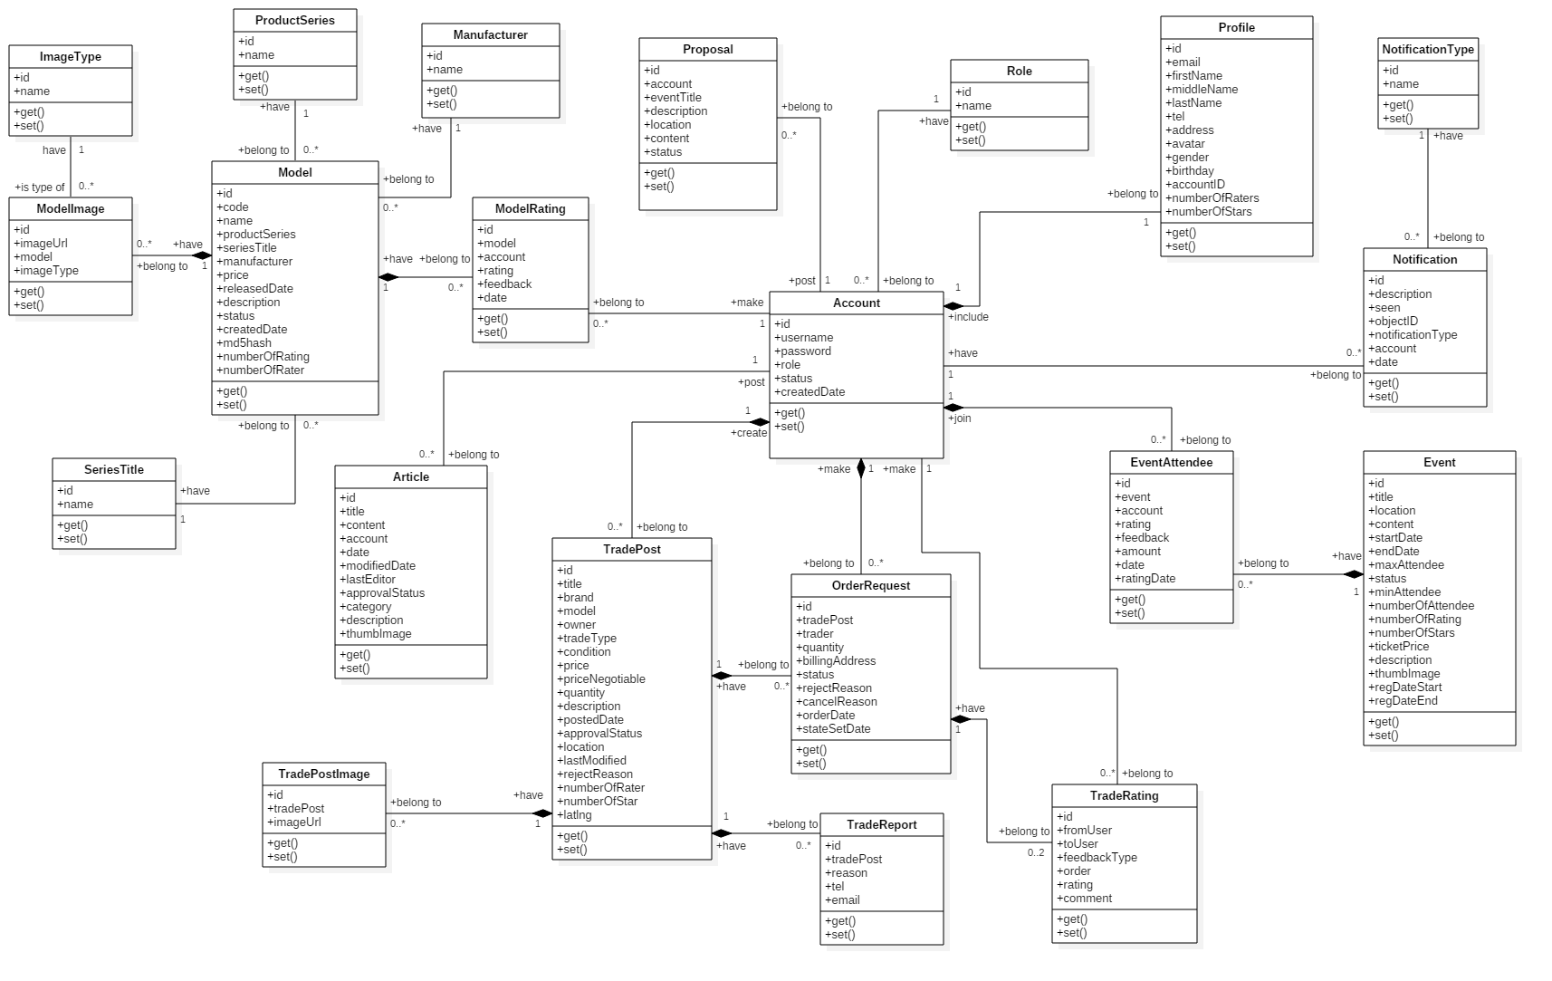

|  |  |  |
| --- | --- | --- |
| **Class Name** | **Mapping column with Conceptual diagram** | **Description** |
| Model | Model | Contain model’s information |
| ModelImage | N/A | Not exist in conceptual diagram. It’s used to contain models’s images |
| ImageType | N/A | Not exist in conceptual diagram. It’s used to contain types of images |
| ProductSeries | N/A | Not exist in conceptual diagram. It’s used to contain product series information |
| SeriesTitle | N/A | Not exist in conceptual diagram. It’s used to contain series title information |
| Manufacturer | N/A | Not exist in conceptual diagram. It’s used to contain manufacturers information |
| ModelRating | Evaluate | Contain model review rating information |
| Article | Article | Contain article information |
| Proposal | Proposal | Contain member’s proposal information |
| Account | User | Contain user’s information for authentication and authorization |
| Profile | N/A | Not exist in conceptual diagram. It’s used to contain user’s profile information |
| Role | N/A | Not exist in conceptual diagram. It’s used to contain user’s role information |
| TradePost | Trade | Contain buyer/seller’s trade post information |
| TradePostImage | N/A | Not exist in conceptual diagram. It’s used to contain trade post’s images |
| OrderRequest | Order | Contain information of user’s order request to trade |
| TradeRating | Evaluate | Contain trade rating information |
| TradeReport | N/A | Not exist in conceptual diagram. It’s used to contain user’s report on trade post |
| Event | Event | Contain event information |
| EventAttendee | EventRegist | Contain user’s registration on events |
| Notification | Notification | Contain notification information |
| NotificationType | N/A | Not exist in conceptual diagram. It’s used to contain notification type information |

### 4.2. Class Diagram Explanation

#### 4.2.1. Model

**Attribute**

|  |  |  |  |
| --- | --- | --- | --- |
| **Attribute** | **Type** | **Visibility** | **Description** |
| id | int | Private | Unique identifier of model |
| name | String | Private | Model name |
| productSeries | ProductSeries | Private | Model’s product series |
| seriesTitle | SeriesTitle | Private | Model’s series title |
| manufacturer | Manufacturer | Private | Model’s manufacturer |
| price | float | Private | Model’s price |
| realeasedDate | String | Private | Model’s released date |
| description | String | Private | Model’s description |
| status | String | Private | Model’s status |
| createdDate | String | Private | Model’s created date |
| md5hash | String | Private | Model’s md5 hash value |
| numberOfRating | int | Private | Model’s number of star ratings |
| numberOfrater | int | Private | Model’s number of raters |

**Method**

|  |  |  |  |
| --- | --- | --- | --- |
| **Method** | **Return Type** | **Visibility** | **Description** |
| getter | Attribute type | Public | Get attribute value |
| setter | Void | Public | Set value of attribute |

#### 4.2.2. SeriesTitle

**Attribute**

|  |  |  |  |
| --- | --- | --- | --- |
| **Attribute** | **Type** | **Visibility** | **Description** |
| id | int | Private | Unique identifier of series title |
| name | String | Private | Series title’s name |

**Method**

|  |  |  |  |
| --- | --- | --- | --- |
| **Method** | **Return Type** | **Visibility** | **Description** |
| getter | Attribute type | Public | Get attribute value |
| setter | Void | Public | Set value of attribute |

#### 4.2.3. ProductSeries

**Attribute**

|  |  |  |  |
| --- | --- | --- | --- |
| **Attribute** | **Type** | **Visibility** | **Description** |
| id | int | Private | Unique identifier of product series |
| name | String | Private | Product series’s name |

**Method**

|  |  |  |  |
| --- | --- | --- | --- |
| **Method** | **Return Type** | **Visibility** | **Description** |
| getter | Attribute type | Public | Get attribute value |
| setter | Void | Public | Set value of attribute |

#### 4.2.4. Manufacturer

**Attribute**

|  |  |  |  |
| --- | --- | --- | --- |
| **Attribute** | **Type** | **Visibility** | **Description** |
| id | int | Private | Unique identifier of manufacturer |
| name | String | Private | Manufacturer’s name |

**Method**

|  |  |  |  |
| --- | --- | --- | --- |
| **Method** | **Return Type** | **Visibility** | **Description** |
| getter | Attribute type | Public | Get attribute value |
| setter | Void | Public | Set value of attribute |

#### 4.2.5. ModelImage

**Attribute**

|  |  |  |  |
| --- | --- | --- | --- |
| **Attribute** | **Type** | **Visibility** | **Description** |
| id | int | Private | Unique identifier of model image |
| imageUrl | String | Private | Image’s url |
| model | Model | Private | The model which image belongs to |
| imageType | ImageType | Private | Image’s type |

**Method**

|  |  |  |  |
| --- | --- | --- | --- |
| **Method** | **Return Type** | **Visibility** | **Description** |
| getter | Attribute type | Public | Get attribute value |
| setter | Void | Public | Set value of attribute |

#### 4.2.6. ImageType

**Attribute**

|  |  |  |  |
| --- | --- | --- | --- |
| **Attribute** | **Type** | **Visibility** | **Description** |
| id | int | Private | Unique identifier of image type |
| name | String | Private | Image type’s name |

**Method**

|  |  |  |  |
| --- | --- | --- | --- |
| **Method** | **Return Type** | **Visibility** | **Description** |
| getter | Attribute type | Public | Get attribute value |
| setter | Void | Public | Set value of attribute |

#### 4.2.7. ModelRating

**Attribute**

|  |  |  |  |
| --- | --- | --- | --- |
| **Attribute** | **Type** | **Visibility** | **Description** |
| id | int | Private | Unique identifier of image type |
| model | Model | Private | Model which is evaluated |
| account | Account | Private | User who does evaluation |
| rating | int | Private | Number of stars rating |
| date | String | Private | Rating date |

**Method**

|  |  |  |  |
| --- | --- | --- | --- |
| **Method** | **Return Type** | **Visibility** | **Description** |
| getter | Attribute type | Public | Get attribute value |
| setter | Void | Public | Set value of attribute |

#### 4.2.8. Article

**Attribute**

|  |  |  |  |
| --- | --- | --- | --- |
| **Attribute** | **Type** | **Visibility** | **Description** |
| id | int | Private | Unique identifier of article |
| title | String | Private | Article title |
| content | String | Private | Article content detail information |
| account | Account | Private | User who posts article |
| date | String | Private | Article posted date |
| modifiedDate | String | Private | Article last modified date |
| lastEditor | String | Private | Username of the last editor |
| approvalStatus | String | Private | Article’s approval status |
| category | String | Private | Article’s category |
| description | String | Private | Article’s description |
| thumbImage | String | Priate | Article’s thumb image url |

**Method**

|  |  |  |  |
| --- | --- | --- | --- |
| **Method** | **Return Type** | **Visibility** | **Description** |
| getter | Attribute type | Public | Get attribute value |
| setter | Void | Public | Set value of attribute |

#### 4.2.9. Proposal

**Attribute**

|  |  |  |  |
| --- | --- | --- | --- |
| **Attribute** | **Type** | **Visibility** | **Description** |
| id | int | Private | Unique identifier of proposal |
| account | Account | Private | User who posts proposal |
| eventTitle | String | Private | Proposal event title |
| description | String | Private | Proposal description |
| location | String | Private | Proposal event location |
| content | String | Private | Proposal content |
| status | String | Private | Proposal status |

**Method**

|  |  |  |  |
| --- | --- | --- | --- |
| **Method** | **Return Type** | **Visibility** | **Description** |
| getter | Attribute type | Public | Get attribute value |
| setter | Void | Public | Set value of attribute |

#### 4.2.10. Account

**Attribute**

|  |  |  |  |
| --- | --- | --- | --- |
| **Attribute** | **Type** | **Visibility** | **Description** |
| id | int | Private | Unique identifier of account |
| username | String | Private | Account username |
| password | String | Private | Account password |
| role | Role | Private | Account role |
| status | String | Private | Account status |
| createdDate | String | Private | Account created date |

**Method**

|  |  |  |  |
| --- | --- | --- | --- |
| **Method** | **Return Type** | **Visibility** | **Description** |
| getter | Attribute type | Public | Get attribute value |
| setter | Void | Public | Set value of attribute |

#### 4.2.11. Role

**Attribute**

|  |  |  |  |
| --- | --- | --- | --- |
| **Attribute** | **Type** | **Visibility** | **Description** |
| id | int | Private | Unique identifier of role |
| name | String | Private | Role name |

**Method**

|  |  |  |  |
| --- | --- | --- | --- |
| **Method** | **Return Type** | **Visibility** | **Description** |
| getter | Attribute type | Public | Get attribute value |
| setter | Void | Public | Set value of attribute |

#### 4.2.12. Profile

**Attribute**

|  |  |  |  |
| --- | --- | --- | --- |
| **Attribute** | **Type** | **Visibility** | **Description** |
| id | int | Private | Unique identifier of user profile |
| email | String | Private | User’s email |
| firstName | String | Private | User’s first name |
| middleName | String | Private | User’s middle name |
| lastName | String | Private | User’s last name |
| tel | String | Private | User’s mobile number |
| address | String | Private | User’s address |
| avatar | String | Private | User’s avatar as image |
| gender | String | Private | User’s gender |
| birthday | String | Private | User’s birthday |
| account | Account | Private | Profile owner |
| numberOfRaters | int | Private | User’s number of raters |
| numberOfStars | int | Private | User’s number of star rating |

**Method**

|  |  |  |  |
| --- | --- | --- | --- |
| **Method** | **Return Type** | **Visibility** | **Description** |
| getter | Attribute type | Public | Get attribute value |
| setter | Void | Public | Set value of attribute |

#### 4.2.13. Event

**Attribute**

|  |  |  |  |
| --- | --- | --- | --- |
| **Attribute** | **Type** | **Visibility** | **Description** |
| id | int | Private | Unique identifier of event |
| title | String | Private | Event title |
| location | String | Private | Event location occur |
| content | String | Private | Event content |
| startDate | String | Private | Event start date |
| endDate | String | Private | Event end date |
| maxAttendee | int | Private | Event’s maximum attendee |
| status | String | Private | Event status |
| minAttendee | int | Private | Event’s minimum attendee |
| numberOfAttendee | int | Private | Event’s current number of attendee, this attribute is for improving performance |
| numberOfRating | int | Private | Number of users who evaluate the events, this attribute is for improving performance in calculating event rating |
| numberOfStars | int | Private | Number of star rating, this attribute is for improving performance in calculating event rating |
| ticketPrice | float | Private | Price of event’s ticket |
| description | String | Private | Event description |
| thumbImage | String | Private | Event’s thumb image url |
| regDateStart | String | Private | Event’s start registration date |
| regDateEnd | String | Private | Event’s end registration date |

**Method**

|  |  |  |  |
| --- | --- | --- | --- |
| **Method** | **Return Type** | **Visibility** | **Description** |
| getter | Attribute type | Public | Get attribute value |
| setter | Void | Public | Set value of attribute |

#### 4.2.14. EventAttendee

**Attribute**

|  |  |  |  |
| --- | --- | --- | --- |
| **Attribute** | **Type** | **Visibility** | **Description** |
| id | int | Private | Unique identifier of eventattendee |
| event | Event | Private | Object event |
| account | Account | Private | Object account which represents the event attendee |
| rating | int | Private | User’s rating on events |
| feedback | String | Private | User’s feedback on events |
| amount | int | Private | Number of tickets which a user regist for |
| date | String | Private | Event registration date |
| ratingDate | String | Private | User’s rating date |

**Method**

|  |  |  |  |
| --- | --- | --- | --- |
| **Method** | **Return Type** | **Visibility** | **Description** |
| getter | Attribute type | Public | Get attribute value |
| setter | Void | Public | Set value of attribute |

#### 4.2.15. Notification

**Attribute**

|  |  |  |  |
| --- | --- | --- | --- |
| **Attribute** | **Type** | **Visibility** | **Description** |
| id | int | Private | Unique identifier of notification |
| description | String | Private | Notification description |
| seen | int | Private | Notification seen status |
| object | object | Private | Notification object message |
| notificationType | NoticationType | Private | Notification type object |
| account | Account | Private | User whom notification is sent to |
| date | String | Private | Created date |

**Method**

|  |  |  |  |
| --- | --- | --- | --- |
| **Method** | **Return Type** | **Visibility** | **Description** |
| getter | Attribute type | Public | Get attribute value |
| setter | Void | Public | Set value of attribute |

#### 4.2.16. NotificationType

**Attribute**

|  |  |  |  |
| --- | --- | --- | --- |
| **Attribute** | **Type** | **Visibility** | **Description** |
| id | int | Private | Unique identifier of notificationtype |
| name | String | Private | NotificationType name |

**Method**

|  |  |  |  |
| --- | --- | --- | --- |
| **Method** | **Return Type** | **Visibility** | **Description** |
| getter | Attribute type | Public | Get attribute value |
| setter | Void | Public | Set value of attribute |

**4.2.17. TradePost**

**Attribute**

|  |  |  |  |
| --- | --- | --- | --- |
| **Attribute** | **Type** | **Visibility** | **Description** |
| id | int | Private | Unique identifier of trade post |
| title | String | Private | Trade post title |
| brand | String | Private | Product’s brand |
| model | String | Private | Product name |
| owner | Account | Private | Trade post owner |
| tradeType | int | Private | Trade type |
| condition | int | Private | Trade condition |
| price | double | Private | Products’s price |
| priceNegotiable | int | Private | Price may be negotiable when exchange |
| quantity | int | Private | Product quantity |
| description | String | Private | Trade post description |
| postedDate | String | Private | Trade posted date |
| approvalStatus | int | Private | Trade’s approval status |
| location | String | Private | Location for exchange |
| lastModified | String | Private | Trade post’s last modified |
| rejectReason | String | Private | Reject reason from administrator |
| numberOfRater | int | Private | Number of users who evaluate this trade |
| numberOfStars | int | Private | Number of stars rating |
| latlng | String | Private | Trade post’s location latitude and longitude |

**Method**

|  |  |  |  |
| --- | --- | --- | --- |
| **Method** | **Return Type** | **Visibility** | **Description** |
| getter | Attribute type | Public | Get attribute value |
| setter | Void | Public | Set value of attribute |

#### 4.2.18. OrderRequest

**Attribute**

|  |  |  |  |
| --- | --- | --- | --- |
| **Attribute** | **Type** | **Visibility** | **Description** |
| id | int | Private | Unique identifier of order request |
| tradePost | TradePost | Private | Trade post that user request to order |
| trader | Account | Private | Member who sends order request to buyer/seller for exchange |
| quantity | int | Private | Number of order products |
| billingAddress | String | Private | Negotiable exchange location |
| status | String | Private | Order request status |
| rejectReason | String | Private | Reason that buyer/seller reject the exchange after accepted order request |
| cancelReason | String | Private | Reason that buyer/seller cancel order request |
| orderDate | String | Private | Order request date |
| stateSetDate | String | Private | The datetime which the order request is reject or canceled |

**Method**

|  |  |  |  |
| --- | --- | --- | --- |
| **Method** | **Return Type** | **Visibility** | **Description** |
| getter | Attribute type | Public | Get attribute value |
| setter | Void | Public | Set value of attribute |

#### 4.2.19. TradePostImage

**Attribute**

|  |  |  |  |
| --- | --- | --- | --- |
| **Attribute** | **Type** | **Visibility** | **Description** |
| id | int | Private | Unique identifier of trade post image |
| tradePost | TradePost | Private | The trade post which image belongs to |
| imageUrl | String | Private | Image url |

**Method**

|  |  |  |  |
| --- | --- | --- | --- |
| **Method** | **Return Type** | **Visibility** | **Description** |
| getter | Attribute type | Public | Get attribute value |
| setter | Void | Public | Set value of attribute |

#### 4.2.20. TradeReport

**Attribute**

|  |  |  |  |
| --- | --- | --- | --- |
| **Attribute** | **Type** | **Visibility** | **Description** |
| id | int | Private | Unique identifier of trade report |
| tradePost | TradePost | Private | The trade post which trade report belongs to |
| reason | String | Private | Reason of report |
| tel | String | Private | Reporter’s mobile phone |
| email | String | Private | Reporter’s email |

**Method**

|  |  |  |  |
| --- | --- | --- | --- |
| **Method** | **Return Type** | **Visibility** | **Description** |
| getter | Attribute type | Public | Get attribute value |
| setter | Void | Public | Set value of attribute |

#### 4.2.21. TradeRating

**Attribute**

|  |  |  |  |
| --- | --- | --- | --- |
| **Attribute** | **Type** | **Visibility** | **Description** |
| id | int | Private | Unique identifier of trade rating |
| fromUser | Account | Private | User who does the evaluation |
| toUser | Account | Private | User who receives the rating |
| feedbackType | String | Private | Represents for type of rating, a member evaluate the exchange for trade post owner or trade post owner evaluates the traders |
| order | OrderRequest | Private | OrderRequest that is evaluated |
| rating | int | Private | Number of stars rating |
| comment | String | Private | Feedback about exchange |

**Method**

|  |  |  |  |
| --- | --- | --- | --- |
| **Method** | **Return Type** | **Visibility** | **Description** |
| getter | Attribute type | Public | Get attribute value |
| setter | Void | Public | Set value of attribute |

### 4.3. Interaction Diagram

#### 4.3.1. Sequence Diagram

##### 4.3.1.1. Create model

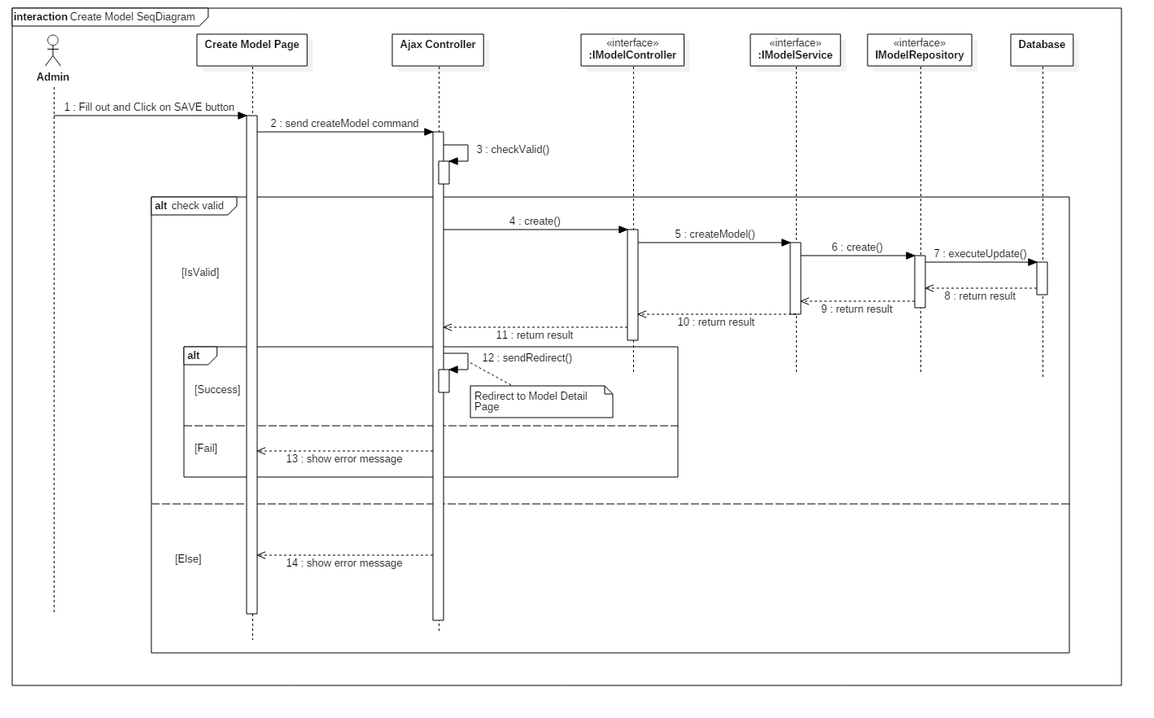

##### 4.3.1.2. Edit model

##### 4.3.1.3. Search Trade Post

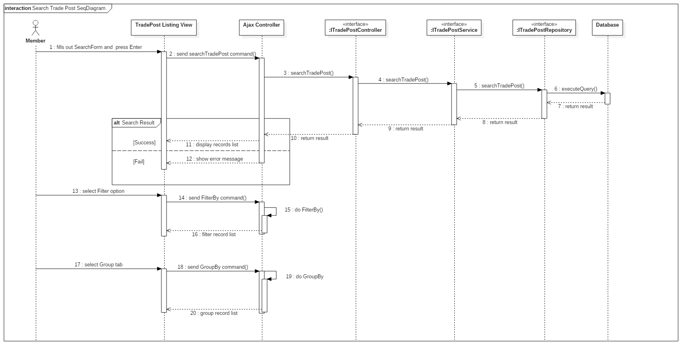

##### 4.3.1.4. Post new trade

##### 4.3.1.5. Edit trade post

##### 4.3.1.6. Request order to a trade post

##### 4.3.1.7. Approve order request

##### 4.3.1.8. Confirm trade success

##### 4.3.1.9. Create new article

##### 4.3.1.10. Edit article

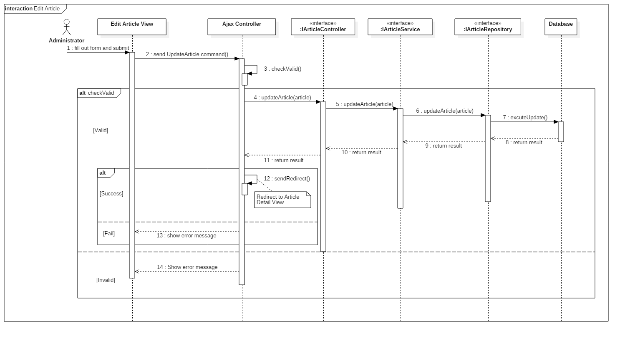

##### 4.3.1.11. Create event

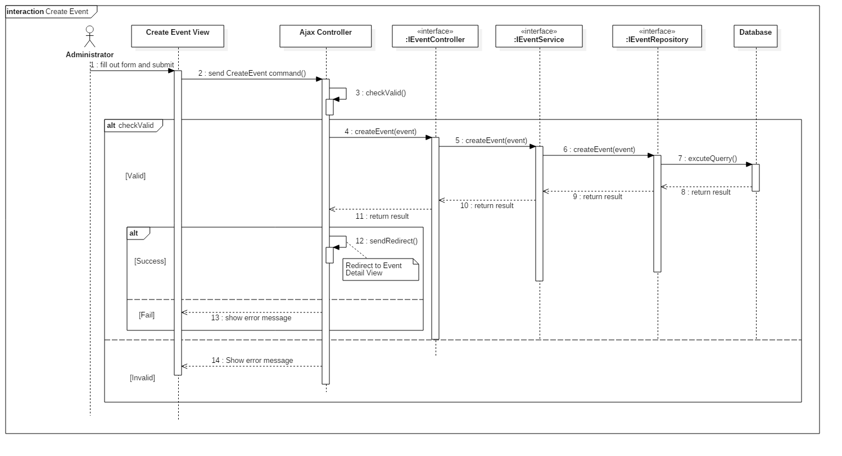

##### 4.3.1.12. Edit event

##### 4.3.1.13. Register event

#### 4.3.2. Activity Diagram

##### 4.3.2.1. Search Gundam

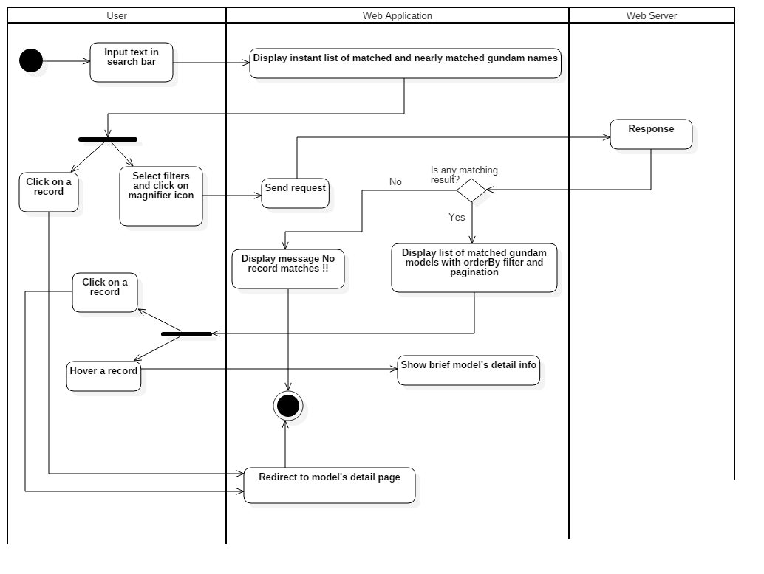

##### 4.3.2.2. Evaluate Gundam

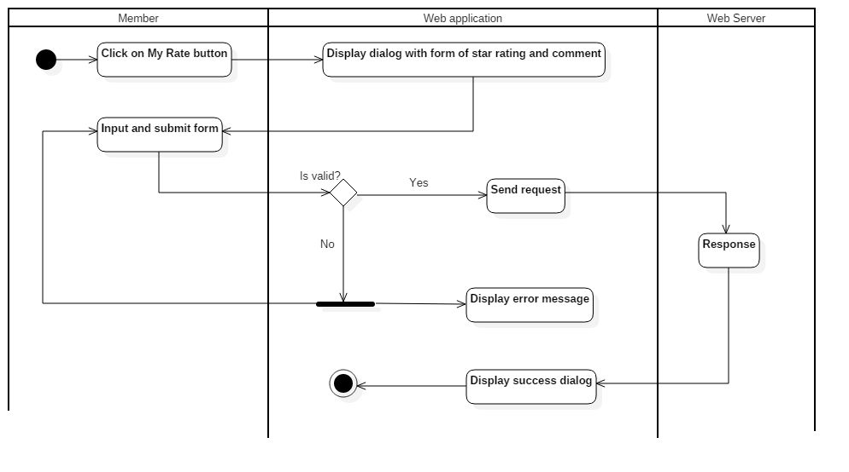

##### 4.3.2.3. Update profile

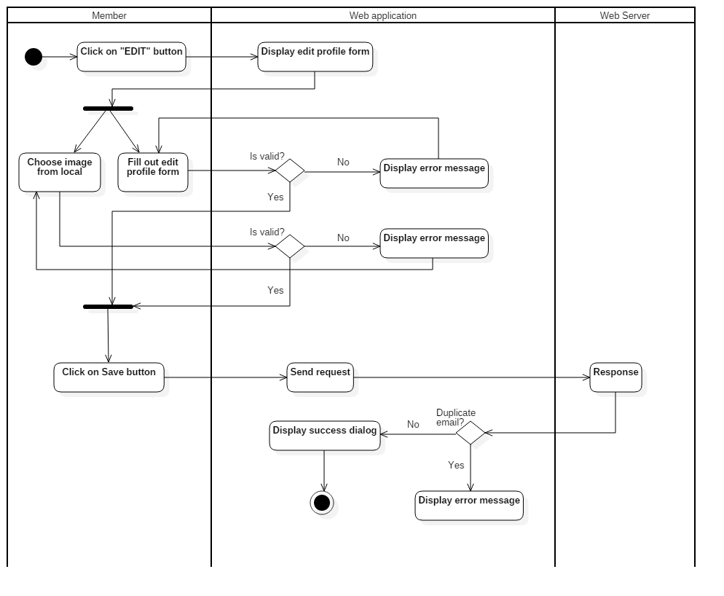

##### 4.3.2.4. Manage order

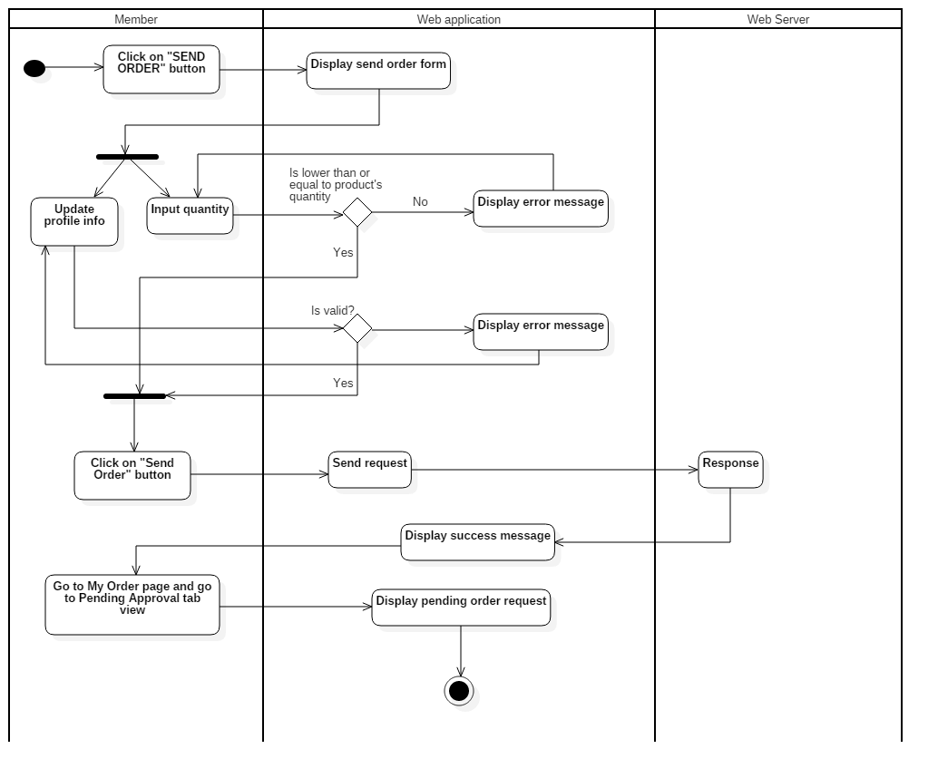

## 5. Interface

### 5.1. Member

#### 5.1.1. Web application

##### 5.1.1.1. Display search model view

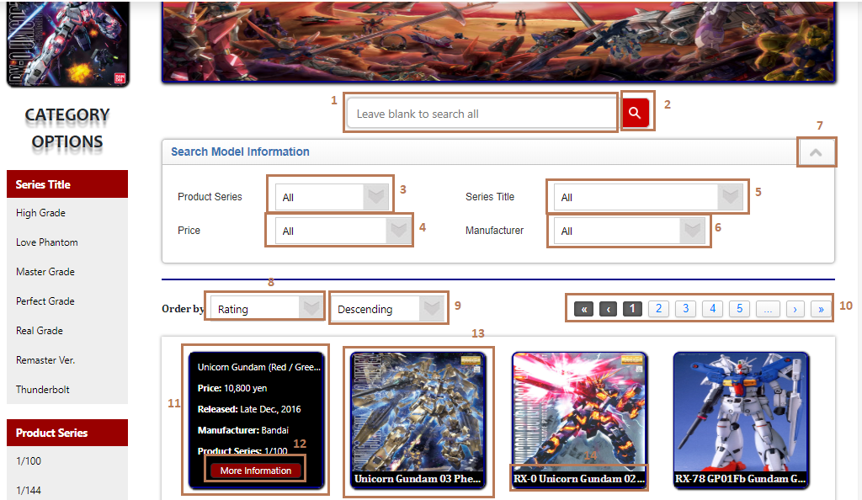

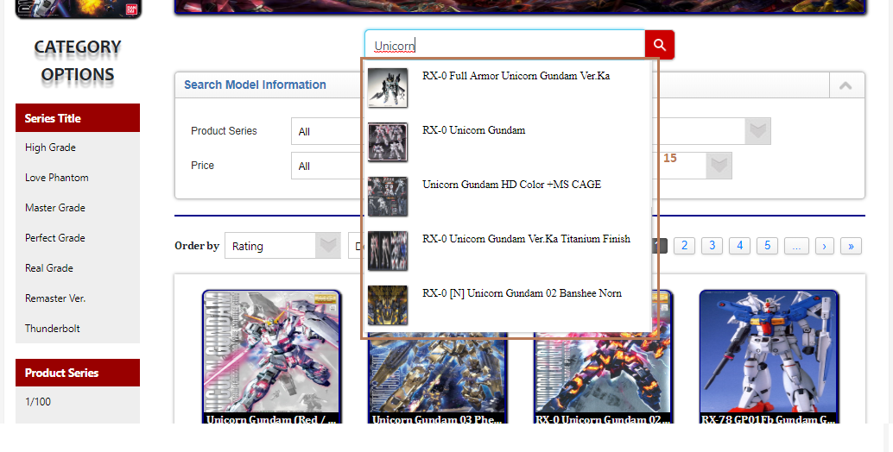

**Fields**

|  |  |  |  |  |  |  |  |
| --- | --- | --- | --- | --- | --- | --- | --- |
| **No** | **Field Name** | **Description** | **Read only** | **Mandatory** | **Control Type** | **Data Type** | **Length** |
| 1 | Search input text | Input search keyword, search by model name | No | No | Text input | String | N/A |
| 3 | Product Series | Choose product series filter | No | No | Dropdown list | String | N/A |
| 4 | Price | Choose price filter | No | No | Dropdown list | String | N/A |
| 5 | Series Title | Choose series title filter | No | No | Dropdown list | Float | N/A |
| 6 | Manufacturer | Choose manufacturer filter | No | No | Dropdown list | String | N/A |
| 8 | Order By options | Choose order by options | No | No | Dropdown list | String | N/A |
| 9 | Ascending or Descending options | This dropdown list follows with order by dropdown list | No | No | Dropdwon list | String | N/A |
| 11 | Model detail info | Display model detail info when hover on a record | Yes | Yes | N/A | String | N/A |
| 13 | Search record | Search record | Yes | Yes | N/A | N/A | N/A |
| 14 | Model name | Display model’s name | Yes | Yes | N/A | String | N/A |
| 15 | As-you-type list | This list appears when user types any text in search input bar | Yes | No | N/A | N/A | N/A |

**Buttons/Hyperlinks**

|  |  |  |  |  |
| --- | --- | --- | --- | --- |
| **No** | **Function** | **Description** | **Validation** | **Outcome** |
| 2 | Search | Send search command to server with value in search input text | N/A | List records match with the input keyword |
| 7 | Open/close search information form | Open or close the search filters form | N/A | The search filters form will be pulled up/pushed down when click |
| 10 | Pagination | For paging with first, next, page numbers, next and last | N/A | The list records is updated match with page numbers |
| 12 | Redirect to the selected model’s detail page | Redirect to the selected model’s detail page | N/A | The selected model’s detail page is shown |

##### 5.1.1.2. Display model detail

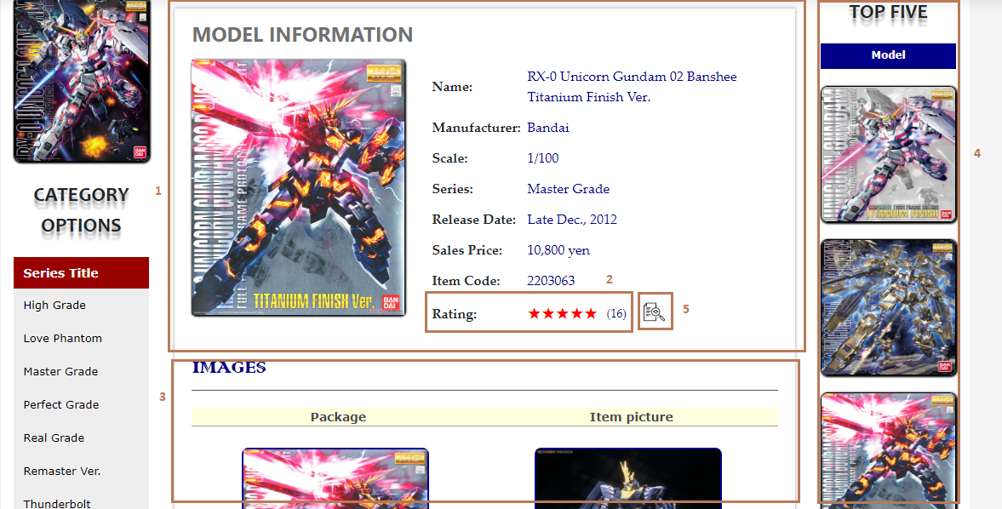

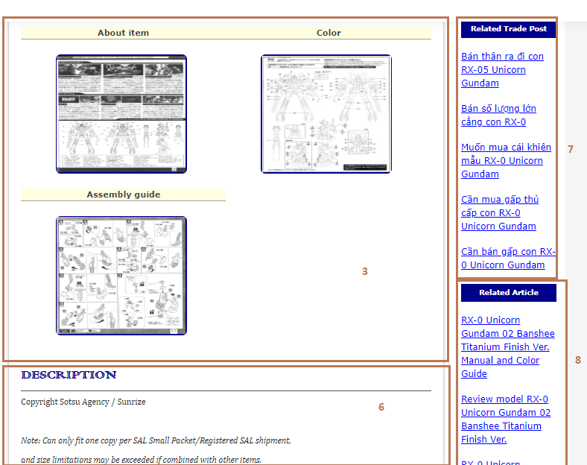

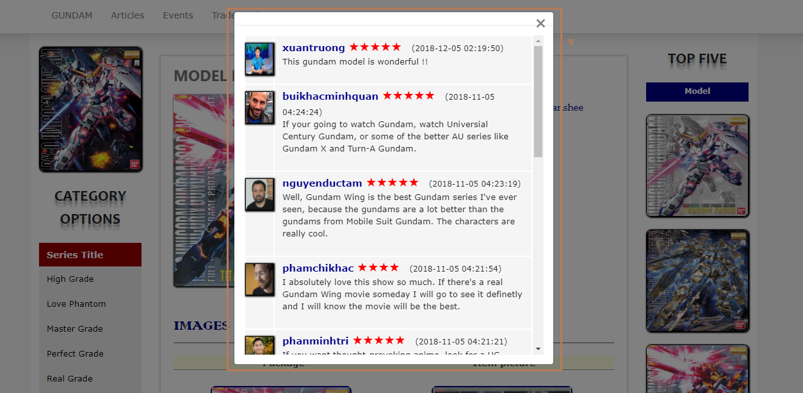

**Fields**

|  |  |  |  |  |  |  |  |
| --- | --- | --- | --- | --- | --- | --- | --- |
| **No** | **Field Name** | **Description** | **Read only** | **Mandatory** | **Control Type** | **Data Type** | **Length** |
| 1 | Model information | Model detail info | Yes | Yes | N/A | String | N/A |
| 2 | Model rating | Average rating of model | Yes | Yes | N/A | N/A | N/A |
| 3 | Model images | Model images | Yes | Yes | N/A | Img | N/A |
| 4 | TOP FIVE | Top 5 rating models | Yes | Yes | N/A | N/A | N/A |
| 6 | Model description | Model’s description | Yes | Yes | N/A | String | N/A |
| 7 | Related trade post | Related exchange | Yes | Yes | N/A | N/A | N/A |
| 8 | Related article | Related article | Yes | Yes | N/A | N/A | N/A |
| 9 | Review evaluation | User’s review evaluation | Yes | Yes | N/A | N/A | N/A |

**Buttons/Hyperlinks**

|  |  |  |  |  |
| --- | --- | --- | --- | --- |
| **No** | **Function** | **Description** | **Validation** | **Outcome** |
| 5 | Display review evaluation dialog | Display other user’s review evaluation on current model | N/A | A dialog with user’s review evaluation |

##### 5.1.1.3. Display TradePost Listing view

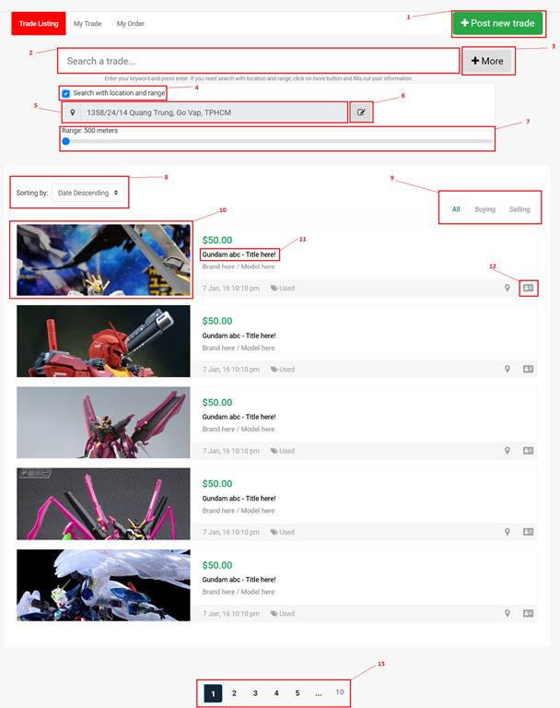

**Fields**

|  |  |  |  |  |  |  |  |
| --- | --- | --- | --- | --- | --- | --- | --- |
| **No** | **Field Name** | **Description** | **Read only** | **Mandatory** | **Control Type** | **Data Type** | **Length** |
| 2 | Search tradepost | Enter your keyword to search your tradepost. | No | Yes | Textbox | String | N/A |
| 4 | Search with location and range | Enable/Disable search with location and range | No | No | Checkbox | Boolean | N/A |
| 5 | Location | Display your location here | Yes | Yes | Textbox | String | N/A |
| 7 | Range | Slide to choose your range you want to search | No | Yes | Range input | Integer | N/A |
| 8 | Sorting | Select your sorting type. | No | Yes | Drop list | Integer | N/A |

**Buttons/Hyperlinks**

|  |  |  |  |  |
| --- | --- | --- | --- | --- |
| **No** | **Function** | **Description** | **Validation** | **Outcome** |
| 1 | Post New Trade | Go to Post New Trade page and display post new trade form. | N/A | Go to post new trade Page |
| 3 | More search | Show/Hide more search panel. | N/A | Show/Hide search form |
| 6 | Edit Location | Show Location editor modal. | N/A | Show edit modal |
| 9 | Change tab | Change tab view group by all/selling/buying. | N/A | Change tab |
| 10,11 | View TradePost details | Go to TradePost details view page to display all information about tradepost. | N/A | Go to post details Page |
| 12 | View owner profile | Go to tradepost owner profile. | N/A | Go to profile Page |
| 13 | Paging | Separate content to page list. | N/A | Change page content |

##### 5.1.1.4. Display TradePost details view

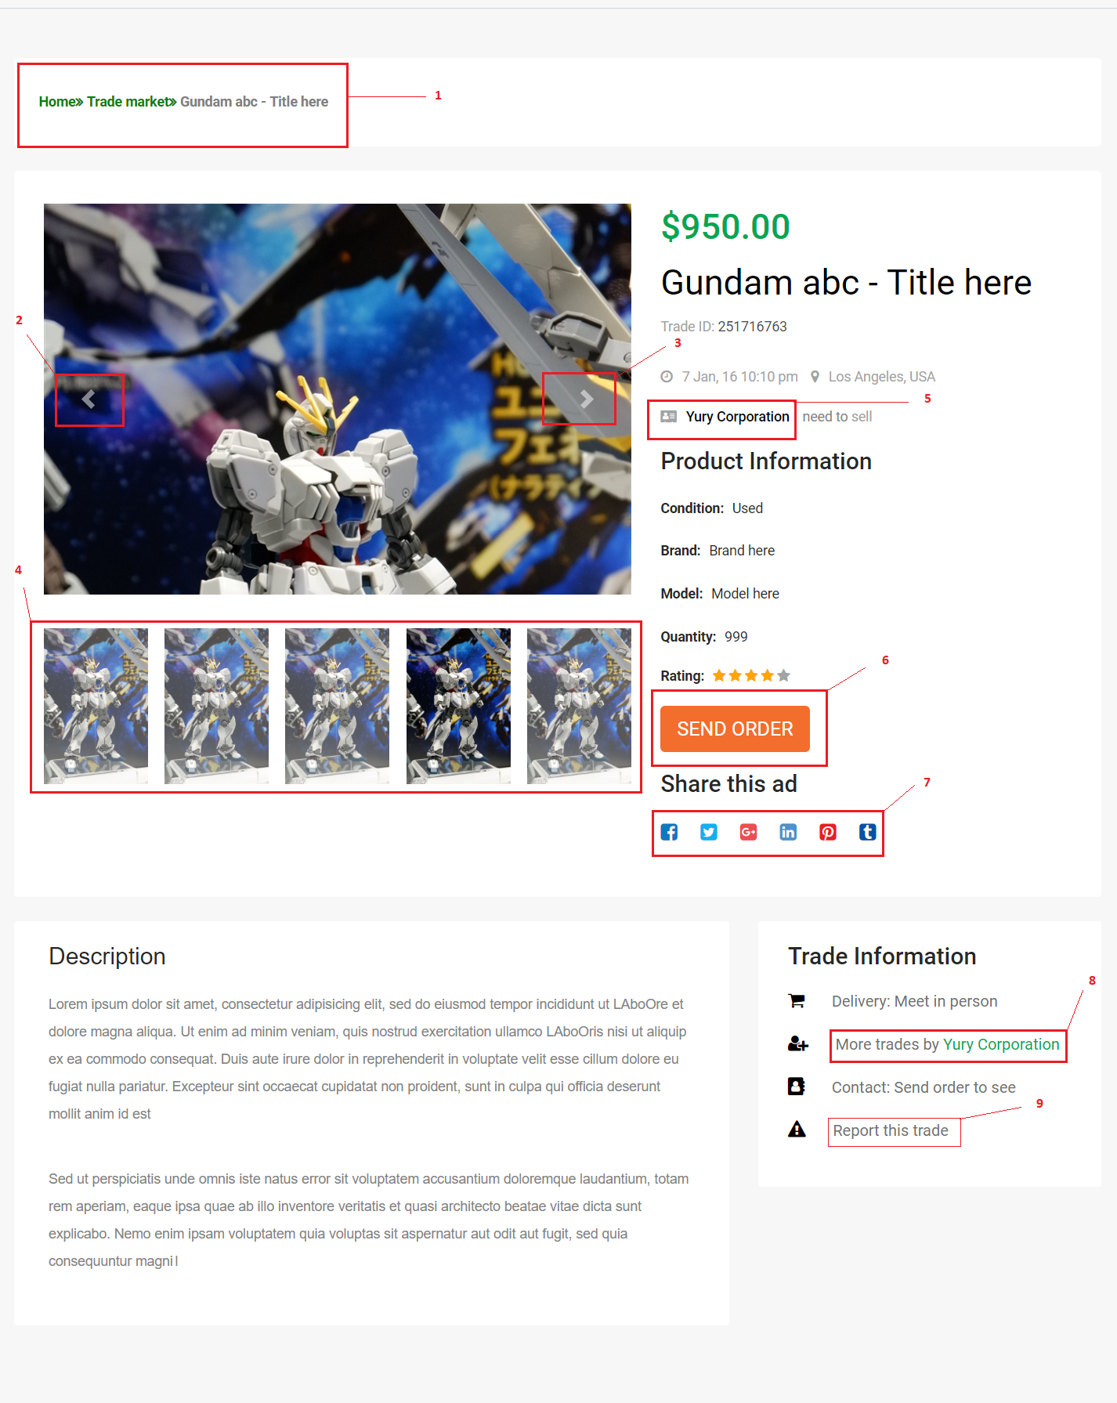

**Fields:** N/A

**Buttons/Hyperlinks**

|  |  |  |  |  |
| --- | --- | --- | --- | --- |
| **No** | **Function** | **Description** | **Validation** | **Outcome** |
| 1 | Page Address | Show address link to explore post. | N/A | Go to Page |
| 2 | Previous Image | Previous control for product Image slideshow. | N/A | Click for previous Image. |
| 3 | Next Image | Next control for product Image slideshow. | N/A | Click for next Image. |
| 4 | Slideshow indicator | List images in slideshow. Click to view this image. | N/A | Change Image. |
| 5 | Owner link | Click to go to owner profile page. | N/A | Go to profile Page |
| 6 | Send order button | Click to show send order modal. | N/A | Show  send order modal |
| 7 | Share this trade button list | Click on any social button to share this trade. | N/A | Share link to social page. |
| 8 | More trade post from owner | Click to show modal with trade post list from this trade post owner. | N/A | Show more post modal |
| 9 | Report button | Click to show report form. | N/A | Show report modal. |

##### 5.1.1.5. Display MyOrder view

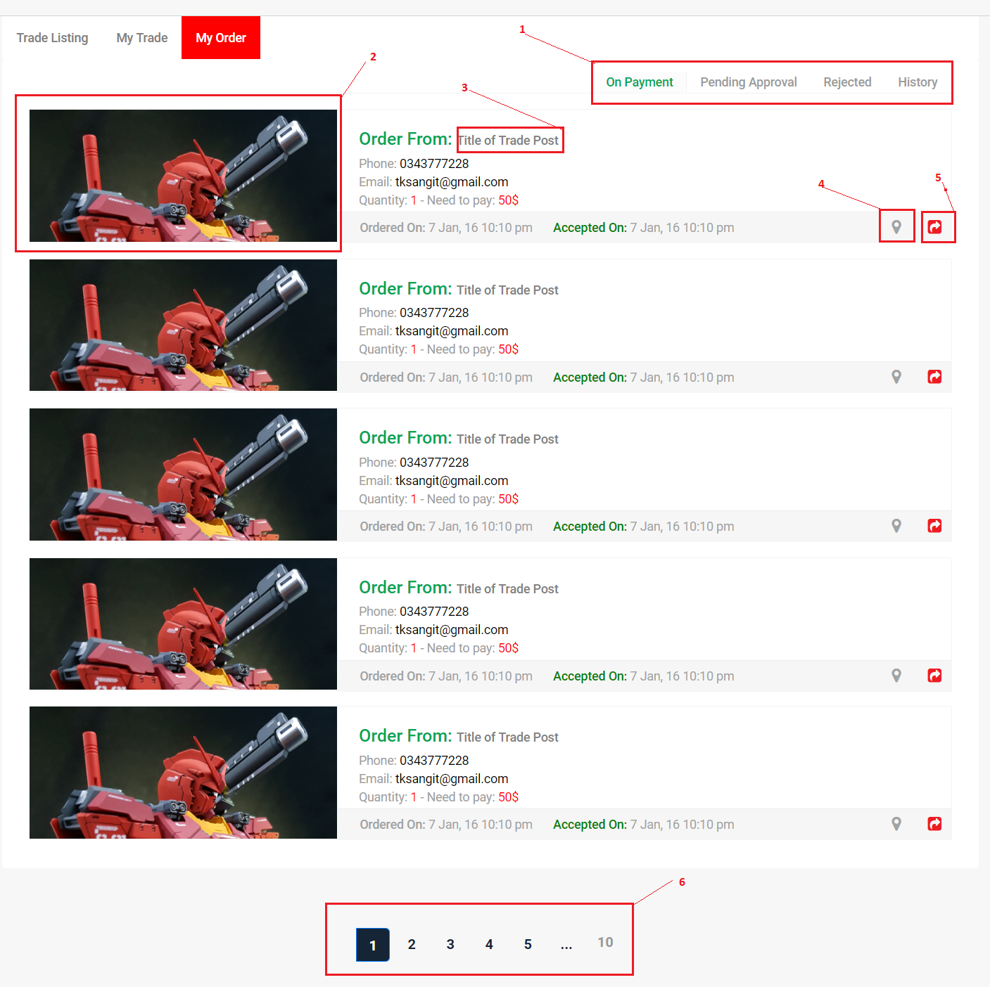

**Fields:** N/A

**Buttons/Hyperlinks:**

|  |  |  |  |  |
| --- | --- | --- | --- | --- |
| No | Function | Description | Validation | Outcome |
| 1 | Change tab | Click to change tab. | N/A | Change tab group |
| 2,3 | View Post details | Click to go to trade post details page. | N/A | Go to details page. |
| 4 | Get direction | Click to get direction to trade post owner. | N/A | Show direction modal. |
| 5 | Cancel order | Click to cancel order. | N/A | Show cancel order modal. |
| 6 | Paging | Separate content to page list. | N/A | Change page content. |

##### 5.1.1.6. Display article listing view

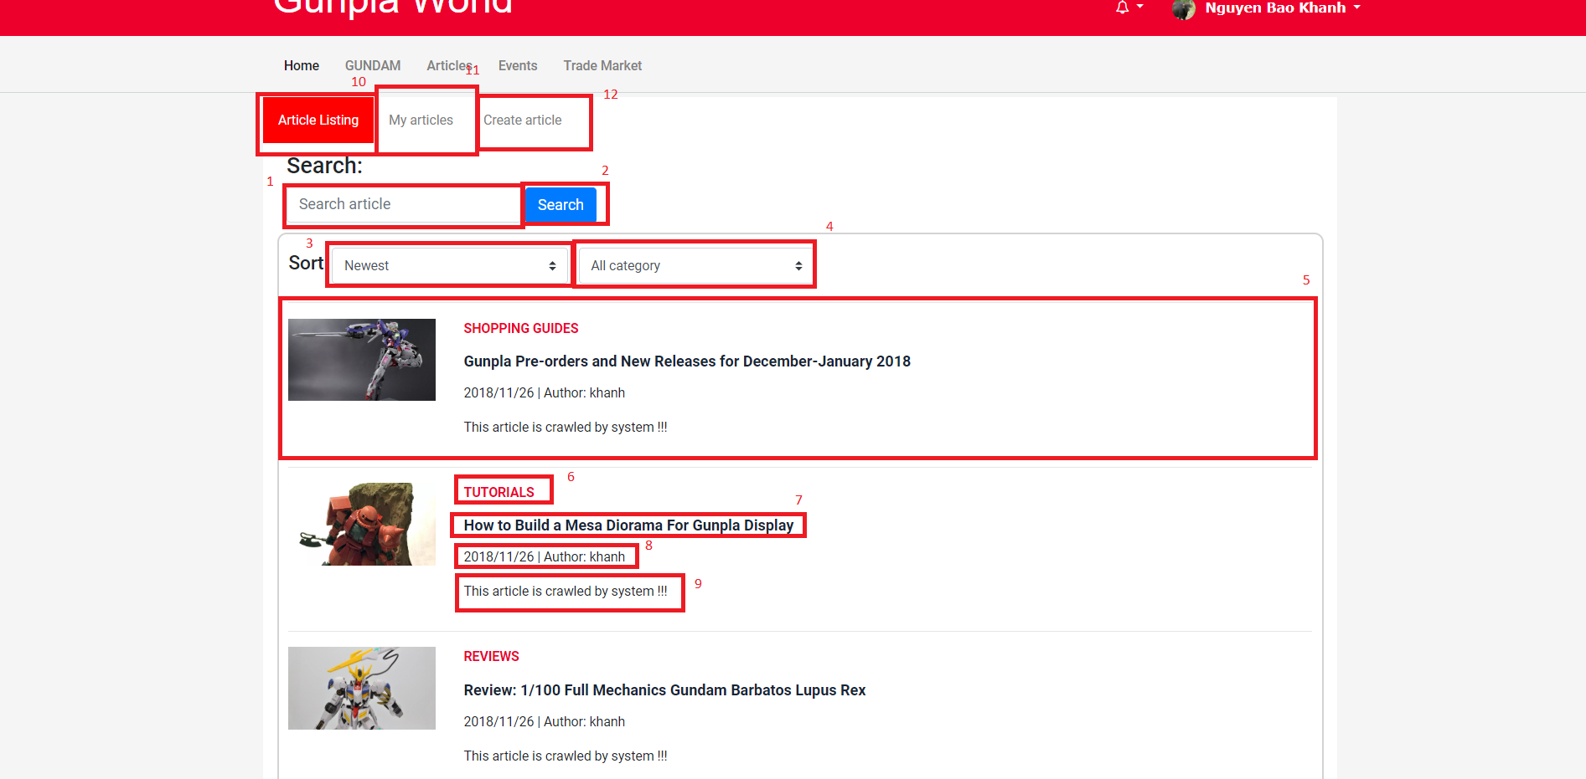

**Fields**

|  |  |  |  |  |  |  |  |
| --- | --- | --- | --- | --- | --- | --- | --- |
| **No** | **Field Name** | **Description** | **Read only** | **Mandatory** | **Control Type** | **Data Type** | **Length** |
| 1 | Search input text | Input search keyword, search by article title | No | Yes | Text input | String | N/A |
| 5 | Search record | Result record from searching | No | Yes | N/A | N/A | N/A |
| 3 | Sort by date | Sort by newest first or oldest first | No | Yes | Dropdown list | String | N/A |
| 4 | Category type | Select article’s category | Yes | Yes | Dropdown list | String | N/A |
| 6 | Article category | The category that this article belongs to | Yes | Yes | N/A | String | N/A |
| 8 | Article post date and author | Date when article was posted and the user who posted it | Yes | Yes | N/A | String | N/A |
| 9 | Article description | Short description of the article | Yes | Yes | N/A | String | N/A |

**Buttons/Hyperlinks**

|  |  |  |  |  |
| --- | --- | --- | --- | --- |
| **No** | **Function** | **Description** | **Validation** | **Outcome** |
| 2 | Search | Send search command to server with value in search input text | N/A | List records match with the input keyword |
| 7 | Article’s title | Title of the article | N/A | Redirects to the article’s detail view |
| 10 | Article listing | Tab for searching articles | N/A | Redirect to article listing tab |
| 11 | My article | Tab for showing article posted by the logged in user | N/A | Redirect to my article tab |
| 12 | Create article | Link to the create article page | N/A | Redirects to the create article view |

##### 5.1.1.7. Article detail view

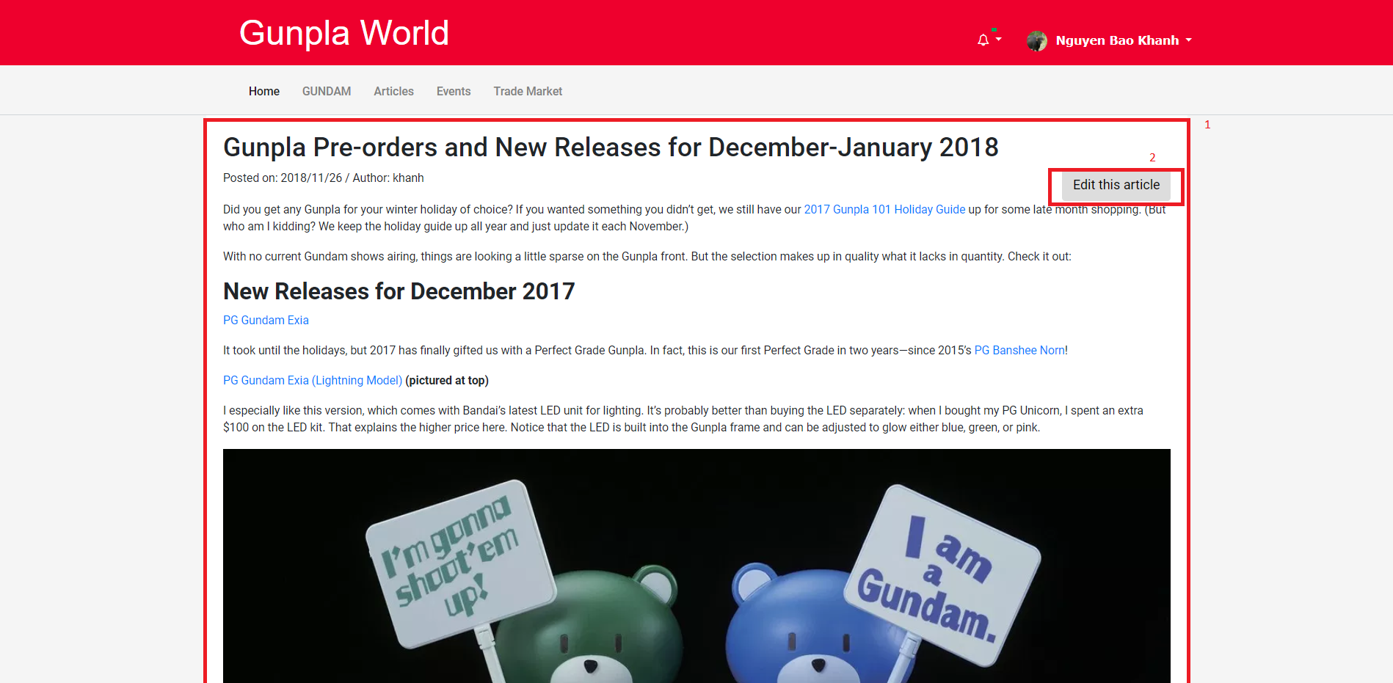

**Fields**

|  |  |  |  |  |  |  |  |
| --- | --- | --- | --- | --- | --- | --- | --- |
| **No** | **Field Name** | **Description** | **Read only** | **Mandatory** | **Control Type** | **Data Type** | **Length** |
| 1 | Article’s information | All the information of an article | Yes | Yes | N/A | N/A | N/A |

**Buttons/Hyperlinks**

|  |  |  |  |  |
| --- | --- | --- | --- | --- |
| **No** | **Function** | **Description** | **Validation** | **Outcome** |
| 2 | Edit this article | Let the user edit the article, only visible if the logged user is the author of this article | Yes | Redirects the user to the edit article view |

##### 5.1.1.8. Edit Article view

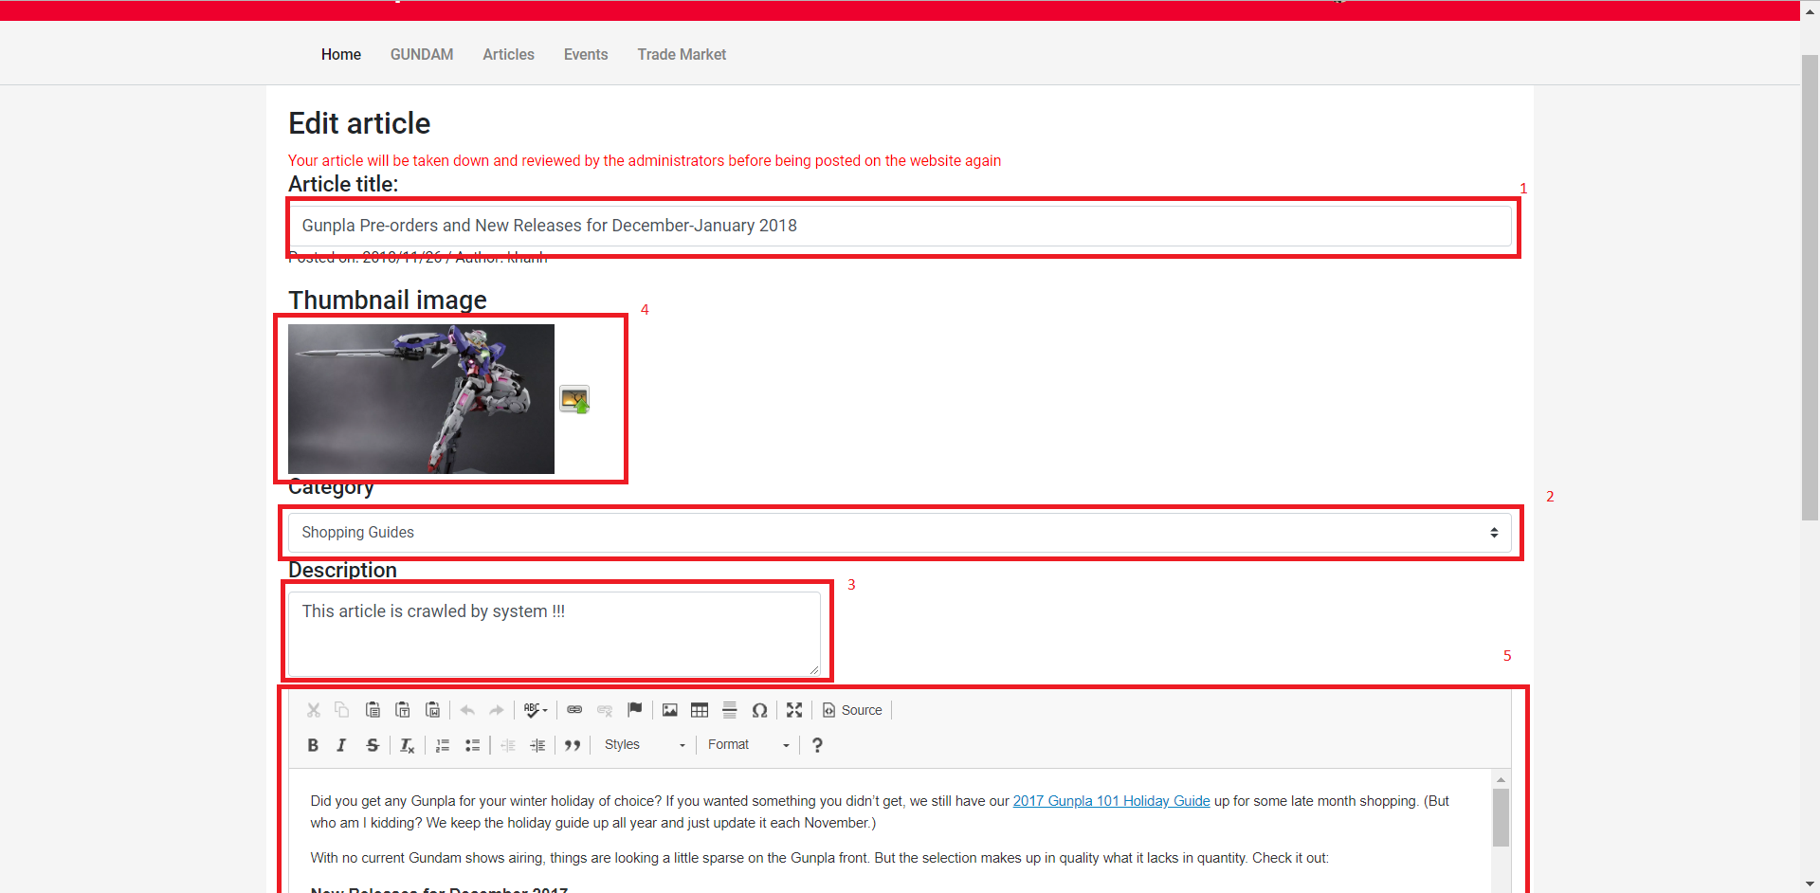

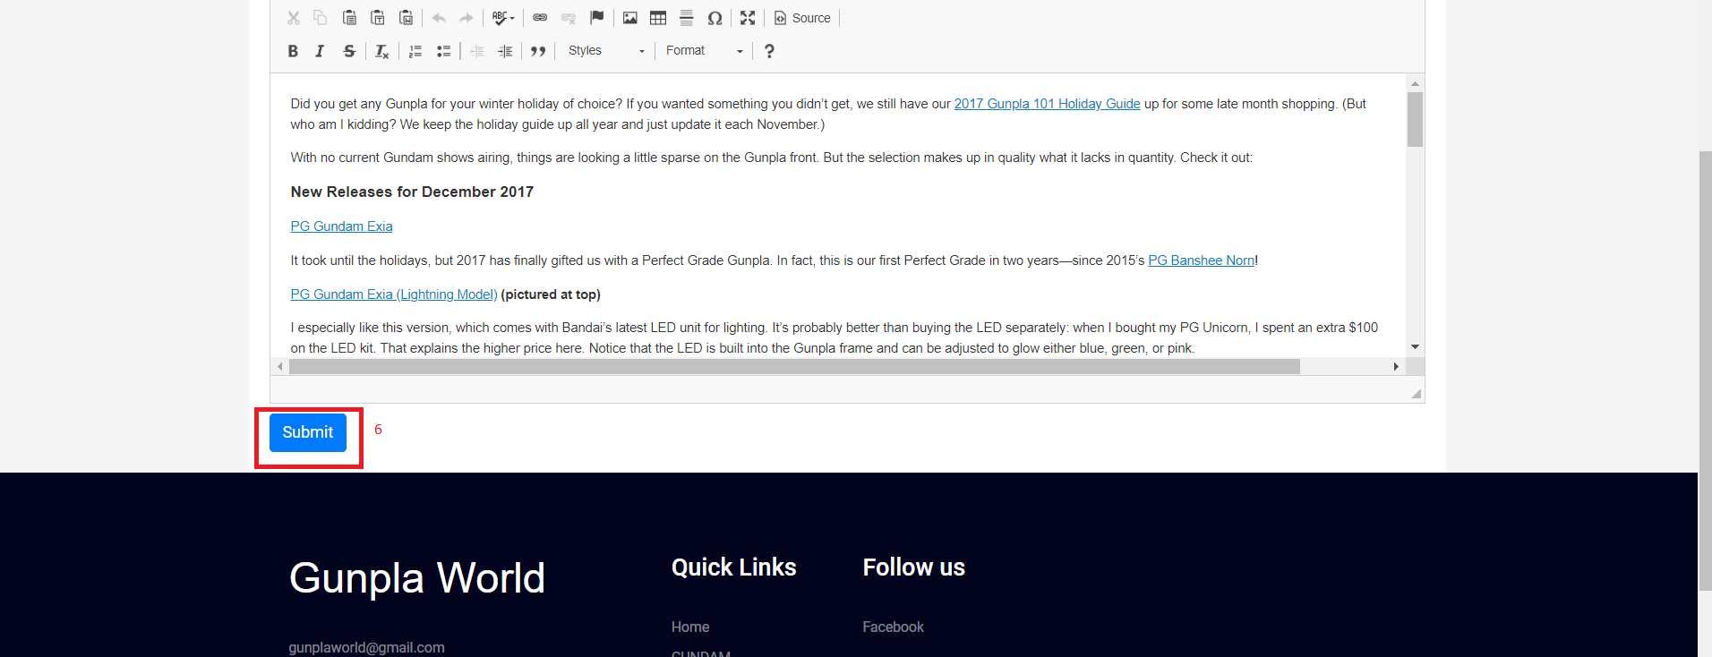**Fields**

|  |  |  |  |  |  |  |  |
| --- | --- | --- | --- | --- | --- | --- | --- |
| **No** | **Field Name** | **Description** | **Read only** | **Mandatory** | **Control Type** | **Data Type** | **Length** |
| 1 | Article’s title | The title of the article | No | Yes | Input field | String | <=250 |
| 2 | Article’s category | The category of the article | No | Yes | Drop-down list | String | N/A |
| 3 | Article’s description | Short description of the article | No | Yes | Textarea | String | <=250 |
| 4 | Article’s thumbnail | Thumbnail of the article | No | Yes | Image | String | N/A |
| 5 | Article’s content | The content of the article | No | Yes | Textarea | String | N/A |

**Buttons/Hyperlinks**

|  |  |  |  |  |
| --- | --- | --- | --- | --- |
| **No** | **Function** | **Description** | **Validation** | **Outcome** |
| 6 | Submit article | Let the user submit the article | Yes | Validate all fields and submit article. |

##### 5.1.1.9. Create Article view

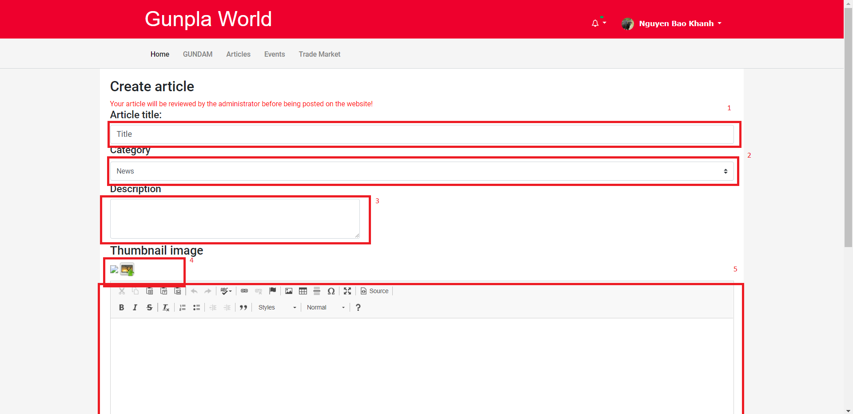



**Fields**

|  |  |  |  |  |  |  |  |
| --- | --- | --- | --- | --- | --- | --- | --- |
| **No** | **Field Name** | **Description** | **Read only** | **Mandatory** | **Control Type** | **Data Type** | **Length** |
| 1 | Article’s title | The title of the article | No | Yes | Input field | String | <=250 |
| 2 | Article’s category | The category of the article | No | Yes | Drop-down list | String | N/A |
| 3 | Article’s description | Short description of the article | No | Yes | Textarea | String | <=250 |
| 4 | Article’s thumbnail | Thumbnail of the article | No | Yes | Image | String | N/A |
| 5 | Article’s content | The content of the article | No | Yes | Textarea | String | N/A |

**Buttons/Hyperlinks**

|  |  |  |  |  |
| --- | --- | --- | --- | --- |
| **No** | **Function** | **Description** | **Validation** | **Outcome** |
| 6 | Submit article | Let the user submit the article | Yes | Validate all fields and submit article. |

##### 5.1.1.10. Event list view

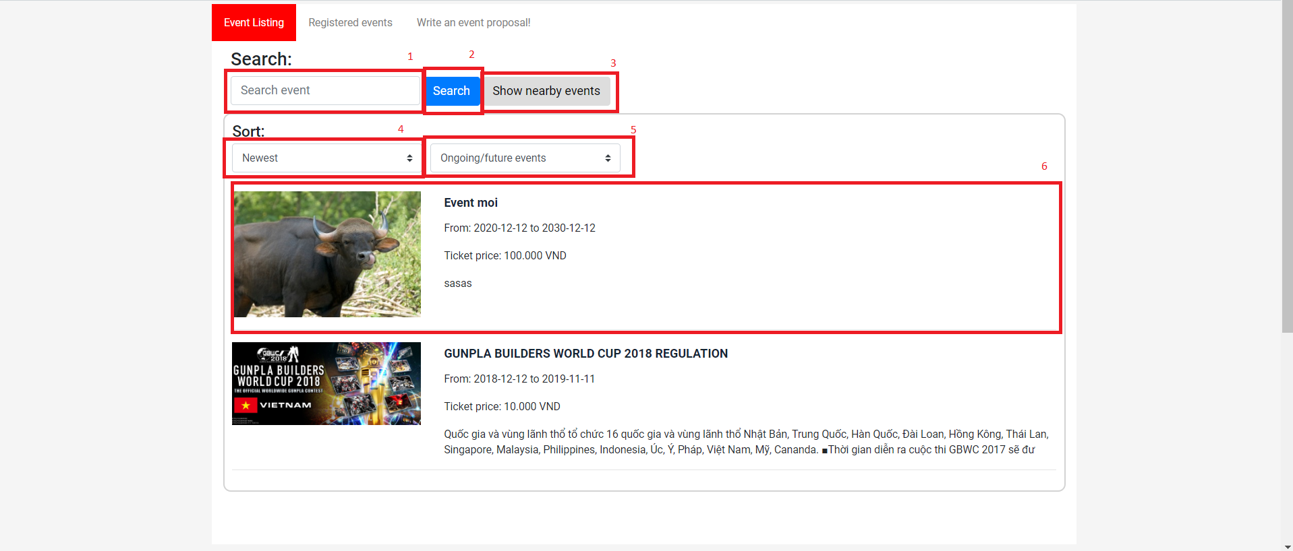

**Fields**

|  |  |  |  |  |  |  |  |
| --- | --- | --- | --- | --- | --- | --- | --- |
| **No** | **Field Name** | **Description** | **Read only** | **Mandatory** | **Control Type** | **Data Type** | **Length** |
| 1 | Search input text | Input search keyword, search by article title | No | No | N/A | String | N/A |
| 4 | Sort by date | Sort by date newest or oldest first | No | Yes | Drop-down list | String | N/A |
| 5 | Status of event | Filter status of the event, active or finished events | No | Yes | Drop-down list | String | N/A |
| 6 | Search result | Event records from searching | Yes | No | N/A | String | N/A |

**Buttons/Hyperlinks**

|  |  |  |  |  |
| --- | --- | --- | --- | --- |
| **No** | **Function** | **Description** | **Validation** | **Outcome** |
| 2 | Search | Search event by title | N/A | List records match with the input keyword |
| 3 | Show nearby events | Search events within 10km of the user | N/A | List records match with location within 10km of the user |
| 5 | Event’s date | The date the event was posted on | N/A | Redirects the user to the event’s detail view |
| 6 | Event’s content | A short part of the event’s content | N/A | Redirects the user to the event’s detail view |

##### 5.1.1.11. Event detail view

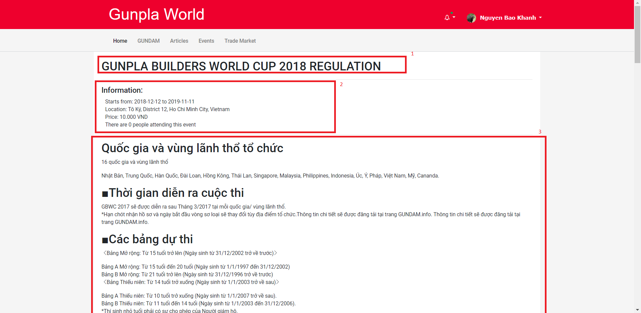

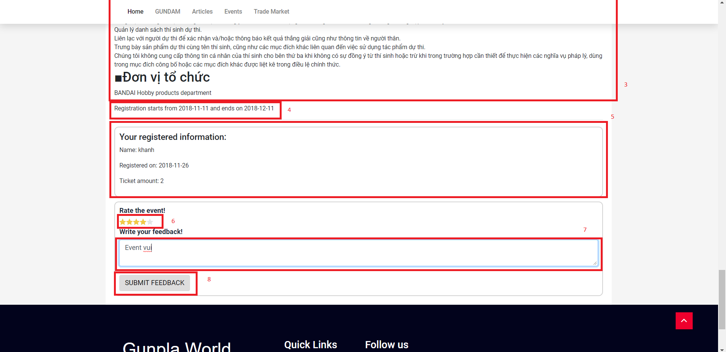

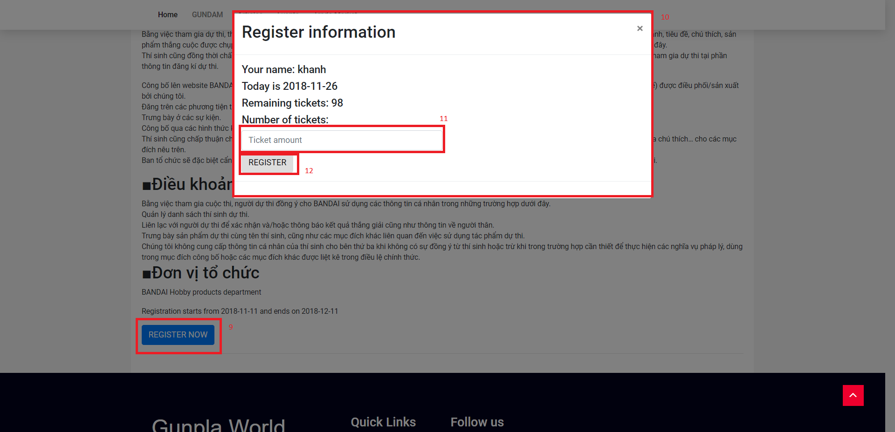**Fields**

|  |  |  |  |  |  |  |  |
| --- | --- | --- | --- | --- | --- | --- | --- |
| **No** | **Field Name** | **Description** | **Read only** | **Mandatory** | **Control Type** | **Data Type** | **Length** |
| 1 | Event’s title | The event’s title | Yes | Yes | N/A | String | N/A |
| 2 | Event’s information | Information of the event | Yes | Yes | N/A | String | N/A |
| 3 | Event’s content | The content of the event | Yes | Yes | N/A | String | N/A |
| 4 | Registration dates | The time when user can register to this event | Yes | Yes | N/A | String | N/A |
| 5 | Registered information | The registered information (visible only after user registered) | Yes | No | N/A | String | N/A |
| 6 | Star ratings | Star ratings for the user to rate the event from 1-5 | No | No | Star ratings | int | N/A |
| 7 | Feedback text | Feedback for the event | No | No | Textarea | String | <=250 |
| 10 | Register Information | The register information | No | Yes | N/A | N/A | N/A |
| 11 | Ticket amount | The number of tickets the user want to buy | No | Yes | Input field | String | N/A |

**Buttons/Hyperlinks**

|  |  |  |  |  |
| --- | --- | --- | --- | --- |
| **No** | **Function** | **Description** | **Validation** | **Outcome** |
| 8 | Submit feedback | Button that submit feedback of the user | N/A | Submit the ratings and the feedback text |
| 9 | Show register information modal | Register button (visible only if the user hasn’t registered and the day is within register dates) | Yes | Make the Register Information modal visible |
| 12 | Submit register information | Submit register information | Yes | Validate data and submit the information |

##### 5.1.1.12. Create proposal view

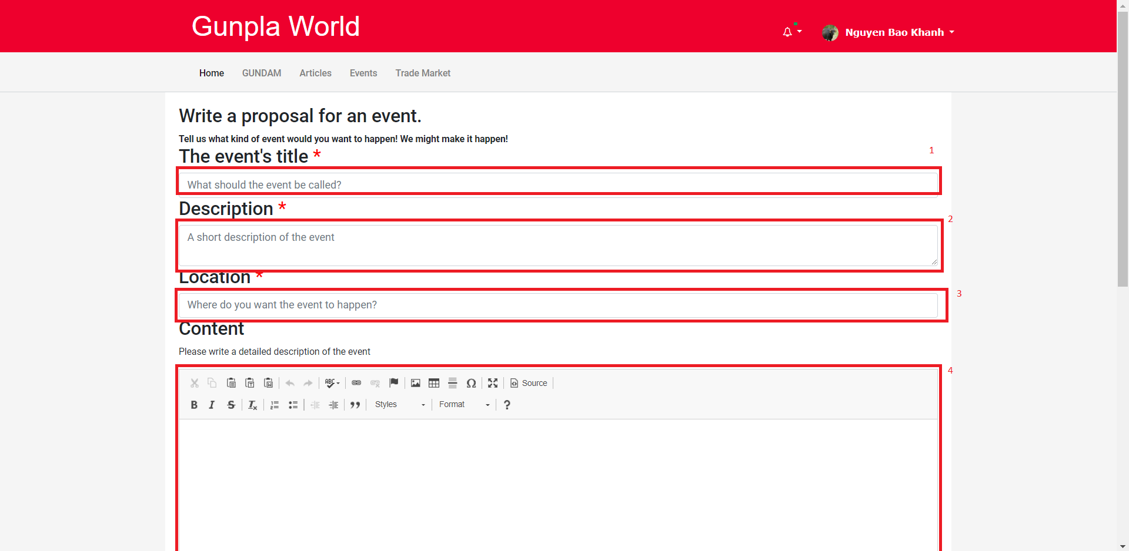

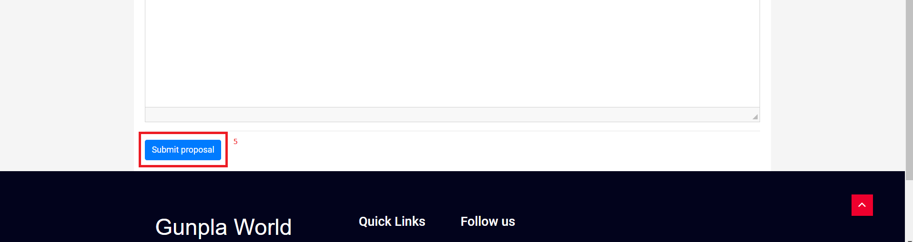

**Fields**

|  |  |  |  |  |  |  |  |
| --- | --- | --- | --- | --- | --- | --- | --- |
| **No** | **Field Name** | **Description** | **Read only** | **Mandatory** | **Control Type** | **Data Type** | **Length** |
| 1 | Event title | The title of the proposed event | No | Yes | Input field | String | <=250 |
| 2 | Event description | Description of the proposed event | No | Yes | Input field | String | <=250 |
| 3 | Location | Proposed location | No | Yes | Input field | String | <=250 |
| 4 | Event content | Content of the proposed event | No | Yes | Textarea | String | N/A |

**Buttons/Hyperlinks**

|  |  |  |  |  |
| --- | --- | --- | --- | --- |
| **No** | **Function** | **Description** | **Validation** | **Outcome** |
| 5 | Submit proposal | Submit proposal button | N/A | Submit the proposal to the server |

#### 5.1.2. Mobile application

##### 5.1.2.1. Get model information

##### 5.1.2.2. Get user information

##### 5.1.2.3. Get user’s exchange evaluation

##### 5.1.2.4. Get notification

### 5.2. Buyer/Seller

#### 5.2.1. Web application

##### 5.2.1.1. Display Post New TradePost view

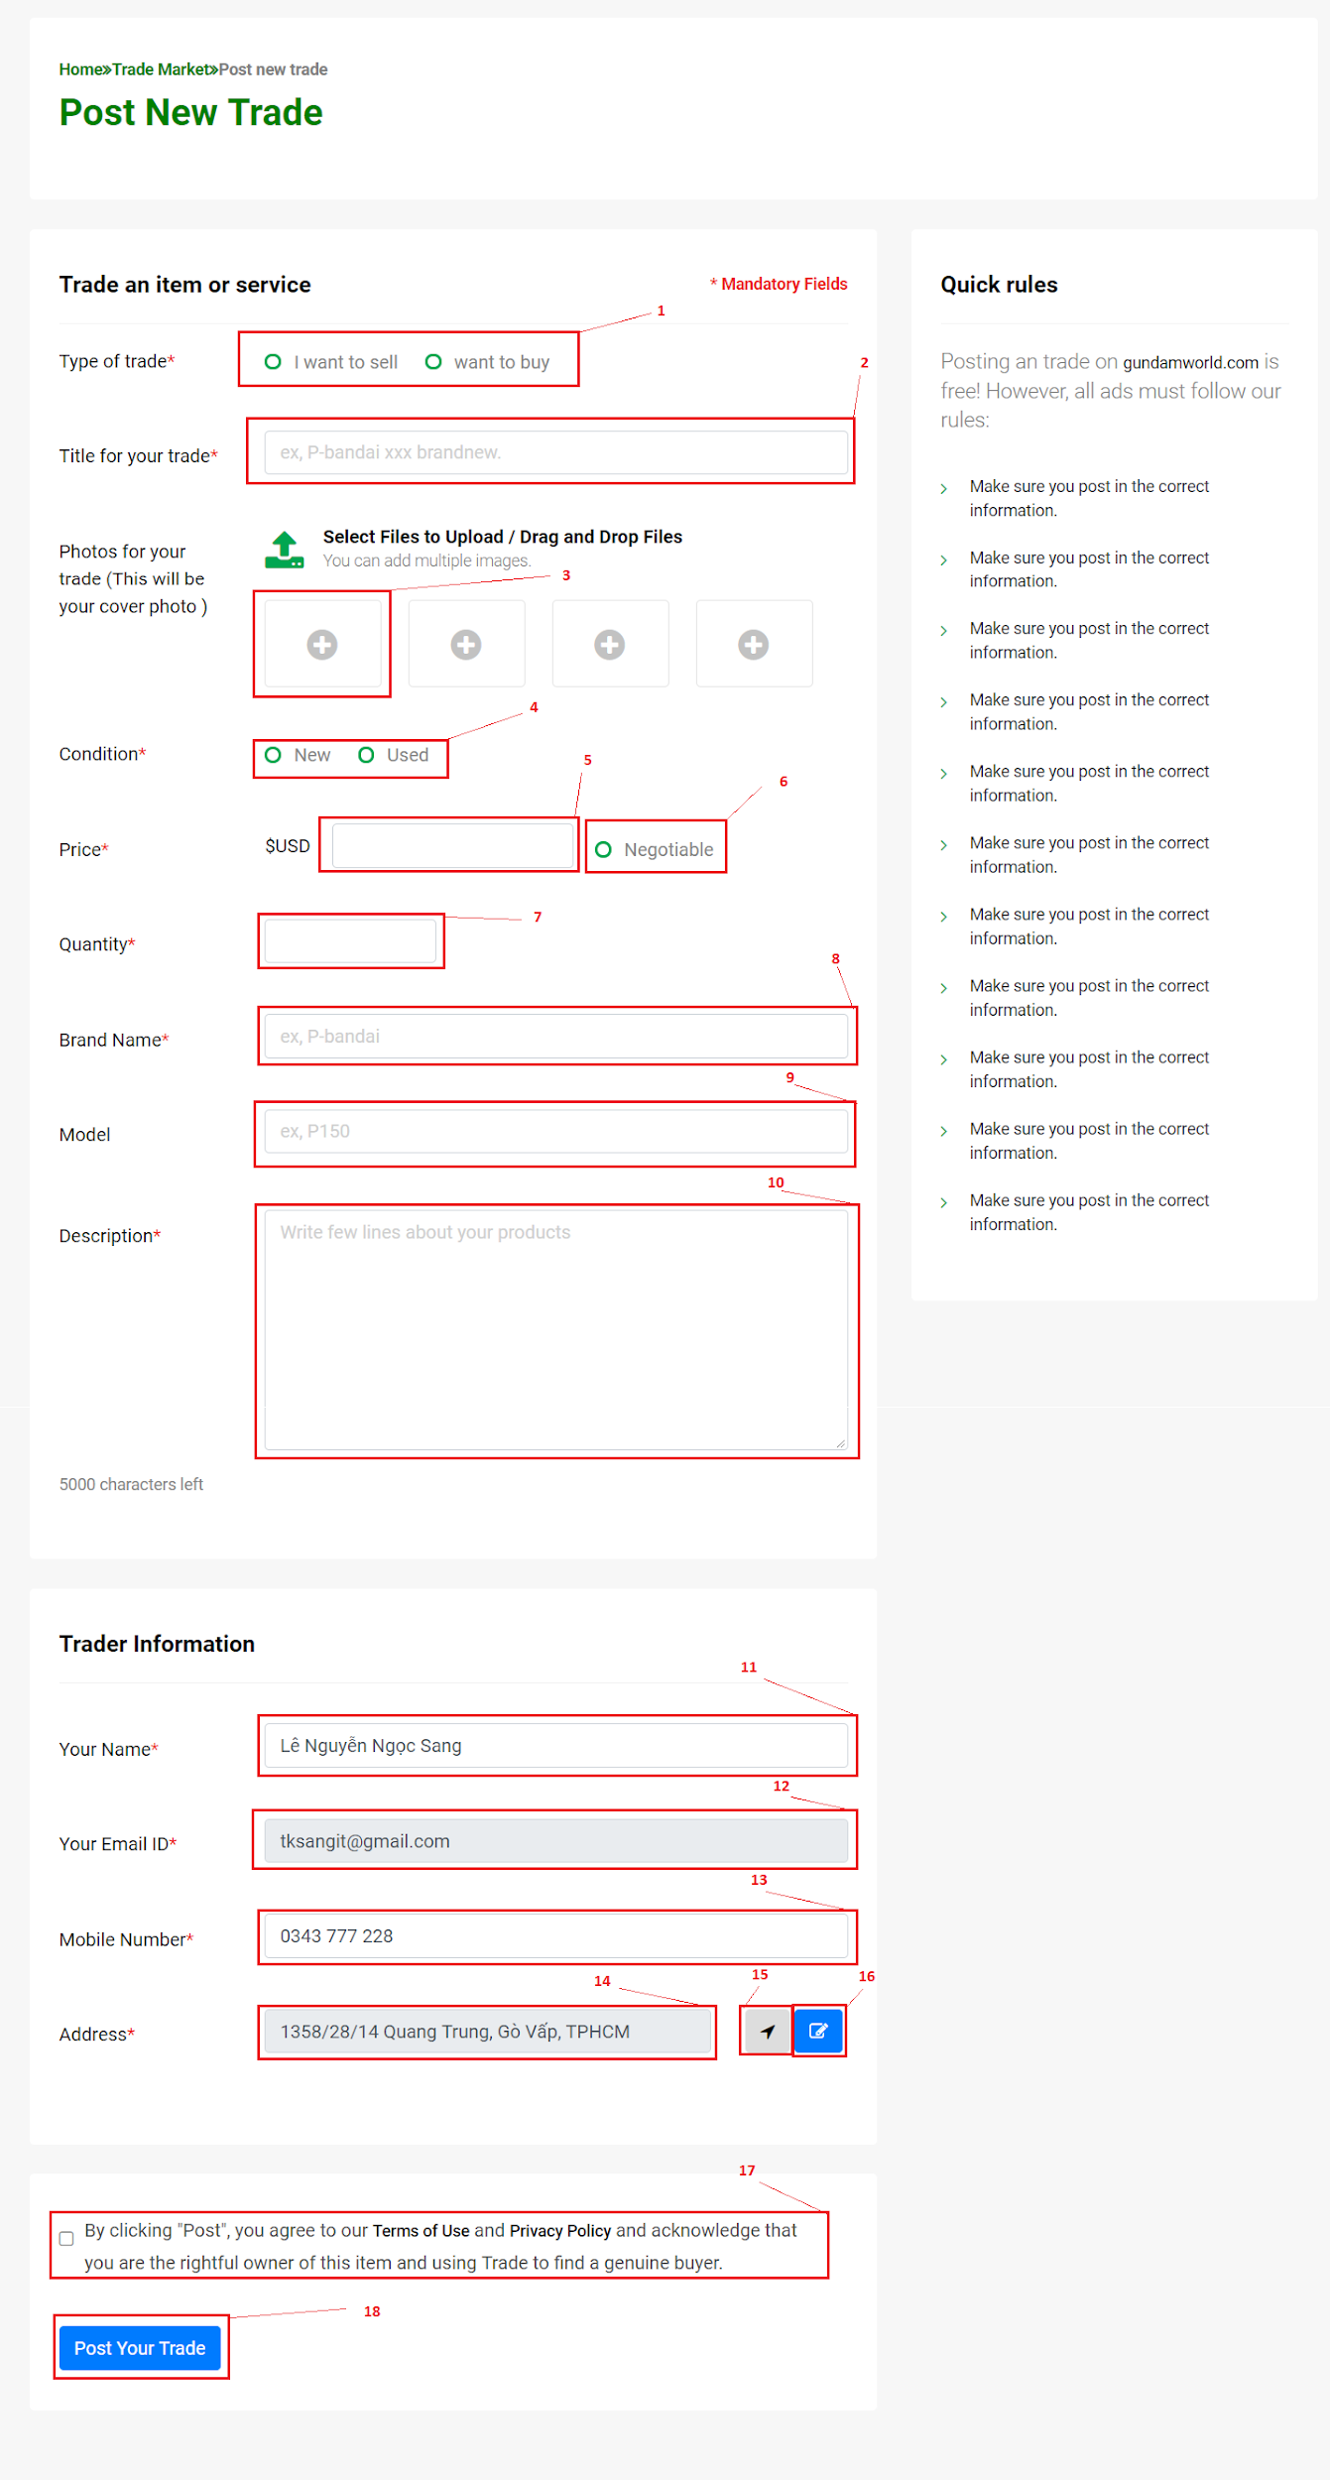

**Fields**

|  |  |  |  |  |  |  |  |
| --- | --- | --- | --- | --- | --- | --- | --- |
| **No** | **Field Name** | **Description** | **Read only** | **Mandatory** | **Control Type** | **Data Type** | **Length** |
| 1 | Type of trade | Select your type of trade: sell or buy | No | Yes | Radio button group | Integer | N/A |
| 2 | Title of your trade | Type your title here. | No | Yes | Textbox | String | N/A |
| 3 | Upload Image | Click to choose your image. | No | Yes | File | Image file type: png ,jpeg, jpg, gif | N/A |
| 4 | Condition | Choose your product condition: Used or New | No | Yes | Radio button group | Integer | N/A |
| 5 | Price | Type your price here | No | Yes | Textbox | String | N/A |
| 6 | Price Negotiable | Set your price can negotiable: Yes or No | No | No | Radio button | Boolean | N/A |
| 7 | Quantity | Type your quantity here | No | Yes | Textbox | Integer | N/A |
| 8 | Brand name | Type your product brand here | No | No | Textbox | String | N/A |
| 9 | Model | Type your product model here | No | No | Textbox | String | N/A |
| 10 | Description | Type your product description here | No | Yes | Textbox | String | N/A |
| 11 | Your name | Input your name here | No | Yes | Textbox | String | N/A |
| 12 | Your Email | Your email will show here | Yes | Yes | Textbox | String | N/A |
| 13 | Mobile Number | Input your mobile number here | No | Yes | Textbox | String | N/A |
| 14 | Address | Your location will show here | Yes | No | Textbox | String | N/A |
| 17 | Agree term | You need agree button to post your trade | No | Yes | Radio button | Boolean | N/A |

**Buttons/Hyperlinks**

|  |  |  |  |  |
| --- | --- | --- | --- | --- |
| **No** | **Function** | **Description** | **Validation** | **Outcome** |
| 15 | Auto get your location | Click to auto get your location and fills result to address field. | N/A | Call auto get location function |
| 16 | Edit your location | Click to show modal to select correct your location | N/A | Show  edit location modal |
| 18 | Post your trade | Click to submit your trade post | N/A | Submit form. |

##### 5.2.1.2. Display My trade view

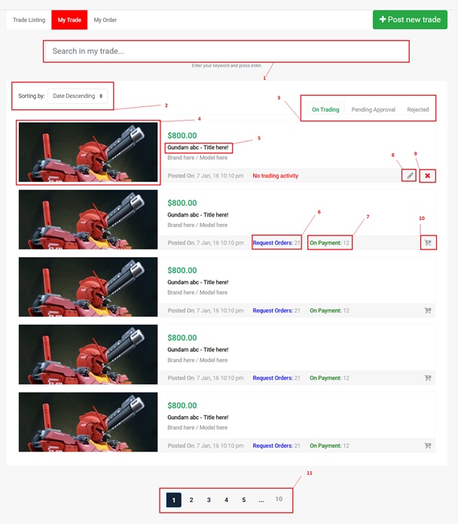

**Fields**

|  |  |  |  |  |  |  |  |
| --- | --- | --- | --- | --- | --- | --- | --- |
| **No** | **Field Name** | **Description** | **Read only** | **Mandatory** | **Control Type** | **Data Type** | **Length** |
| 1 | Search in my trade | Enter your keyword to search your tradepost. | No | Yes | Textbox | String | N/A |
| 2 | Sorting | Select your sorting type. | No | Yes | Drop list | Integer | N/A |

**Buttons/Hyperlinks**

|  |  |  |  |  |
| --- | --- | --- | --- | --- |
| **No** | **Function** | **Description** | **Validation** | **Outcome** |
| 3 | Change tab | Change tab view group by On trading/Pending Approval/Rejected | N/A | Change page content |
| 4,5 | View TradePost details | Go to TradePost details view page to display all information about tradepost. | N/A | Go to post details Page |
| 6 | View all Request Order | View all request order for the trade post. | N/A | Show  all request modal |
| 7 | View all On Payment | View all on payment for the trade post. | N/A | Show  on payment modal |
| 8 | Edit this trade | Edit information of this trade. | N/A | Show  edit modal |
| 9 | Delete this trade | Delete the trade | N/A | Show delete modal |
| 10 | Update Quantity | Update trade quantity | N/A | Show update quantity modal |
| 11 | Paging | Separate content to page list. | N/A | Change page content |

#### 5.2.2. Mobile Application

### 5.3. Guest

#### 5.3.1. Web application

##### 5.3.1.1. Register account

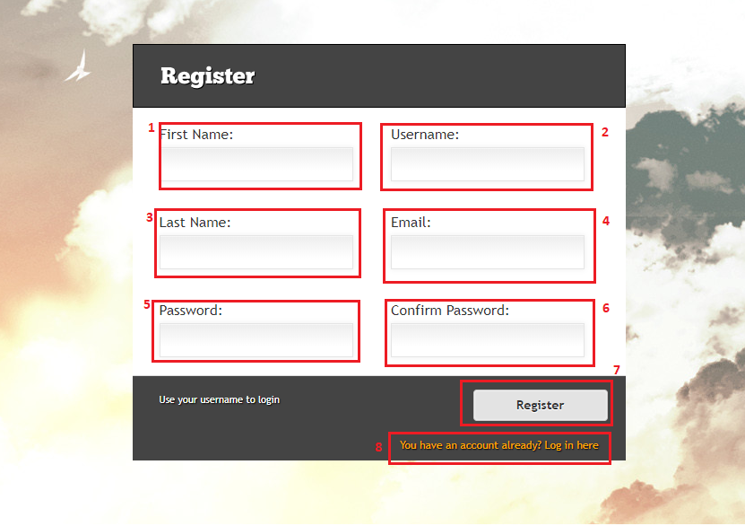

**Fields**

|  |  |  |  |  |  |  |  |
| --- | --- | --- | --- | --- | --- | --- | --- |
| **No** | **Field Name** | **Description** | **Read only** | **Mandatory** | **Control Type** | **Data Type** | **Length** |
| 1 | Firstname | User’s first name | No | Yes | Text input | String | <= 50 |
| 2 | Username | User’s username for login | No | Yes | Text input | String | <= 50 |
| 3 | Lastname | User’s lastname | No | Yes | Text input | String | <= 50 |
| 4 | Email | User’s email | No | Yes | Text input | String | <= 50 |
| 5 | Password | User’s password | No | Yes | Text input | String | <= 50 |
| 6 | ConfirmPassword | To confirm password, this field’s value must be the same as password | No | Yes | Text input | String | N/A |

**Buttons/Hyperlinks**

|  |  |  |  |  |
| --- | --- | --- | --- | --- |
| **No** | **Function** | **Description** | **Validation** | **Outcome** |
| 7 | Register | Send register command with values | Entered email must match the required format  Entered email and username must not be duplicate in database  Length of field’s value must not be out of range  Password and confirm password must match to each other  All required fields must be filled out | Login page with register success message |
| 8 | Redirect to login page | For whom already had account | N/A | Login page |

##### 5.3.1.2. Login

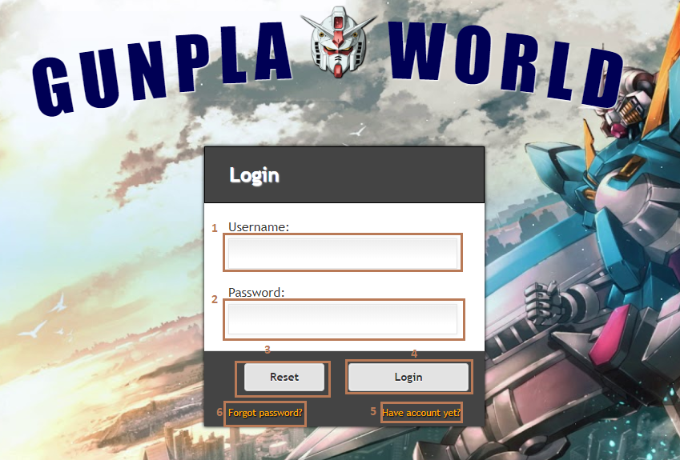

**Fields**

|  |  |  |  |  |  |  |  |
| --- | --- | --- | --- | --- | --- | --- | --- |
| **No** | **Field Name** | **Description** | **Read only** | **Mandatory** | **Control Type** | **Data Type** | **Length** |
| 1 | Username | User’s username | No | Yes | Text input | String | N/A |
| 2 | Password | User’s password | No | Yes | Text input | String | N/A |

**Buttons/Hyperlinks**

|  |  |  |  |  |
| --- | --- | --- | --- | --- |
| **No** | **Function** | **Description** | **Validation** | **Outcome** |
| 3 | Reset | Reset all fields | N/A | All fields are clear |
| 4 | Login | Send login command to the system with username and password | Check exist in database | Success: show homepage  Fail: show error message |
| 5 | Redirect to Register page | For whom doesn’t have an account | N/A | Register page is shown |
| 6 | Redirect to get forgot password page | For who forgot password | N/A | Get forgot password is shown |

#### 5.3.2. Mobile application

##### 5.3.2.1. Login

##### 5.3.2.2. Register account

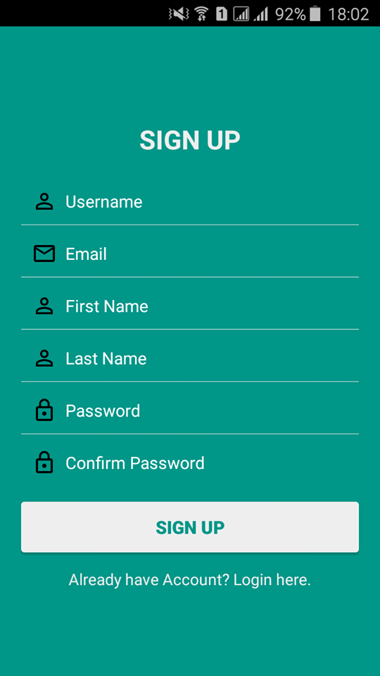

### 5.4. Authenticated User

#### 5.4.1. Get profile

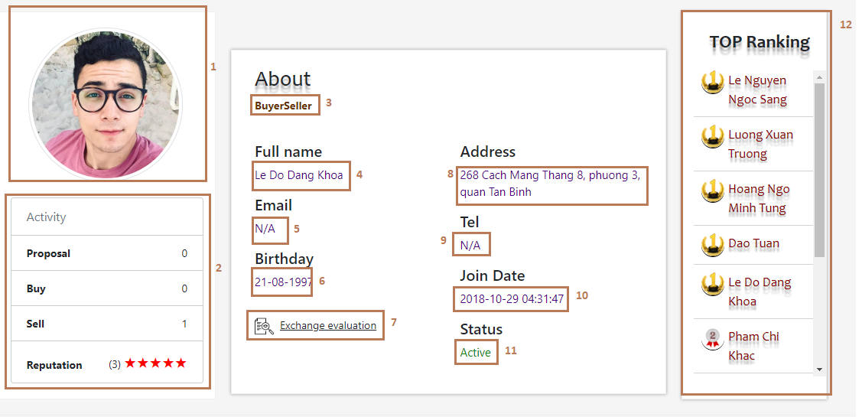

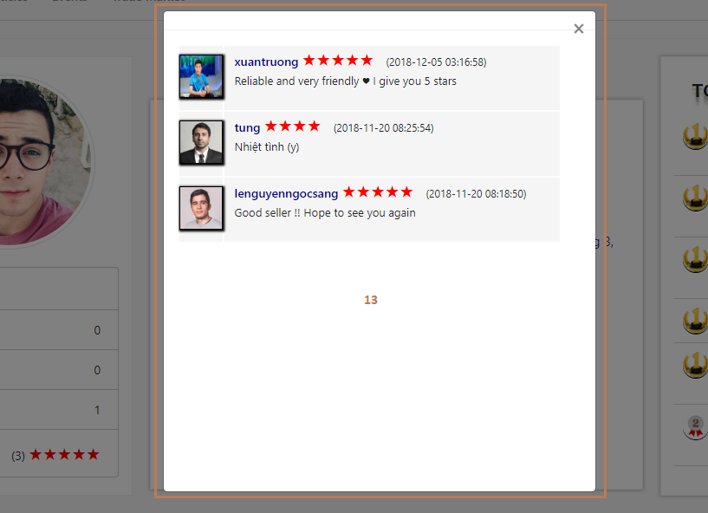

**Fields**

|  |  |  |  |  |  |  |  |
| --- | --- | --- | --- | --- | --- | --- | --- |
| **No** | **Field Name** | **Description** | **Read only** | **Mandatory** | **Control Type** | **Data Type** | **Length** |
| 1 | Avatar | User’s image | Yes | Yes | Img | Img | N/A |
| 2 | Statistic | User’s statistics and ratings | Yes | Yes | N/A | String | N/A |
| 3 | Role | User’s role | Yes | Yes | Label | String | N/A |
| 4 | Fullname | User’s fullname | Yes | Yes | Label | String | N/A |
| 5 | Email | User’s email | Yes | Yes | Label | String | N/A |
| 6 | Birthday | User’s birthday | Yes | No | Label | String | N/A |
| 8 | Address | User’s address | Yes | No | Label | String | N/A |
| 9 | Tel | User’s mobile number | Yes | No | Label | String | N/A |
| 10 | Join Date | User’s register datetime | Yes | Yes | Label | String | N/A |
| 11 | Status | User’s status | Yes | Yes | Label | String | N/A |
| 12 | Top ranking | Top ranking user | Yes | Yes | N/A | N/A | N/A |
| 13 | Exchange evaluation | User’s exchange evaluation | Yes | Yes | N/A | N/A | N/A |

**Buttons/Hyperlinks**

|  |  |  |  |  |
| --- | --- | --- | --- | --- |
| **No** | **Function** | **Description** | **Validation** | **Outcome** |
| 7 | View exchange evaluation | Get other user’s exchange evaluation | N/A | Exchange evaluation dialog is shown |

#### 5.4.2. Edit profile

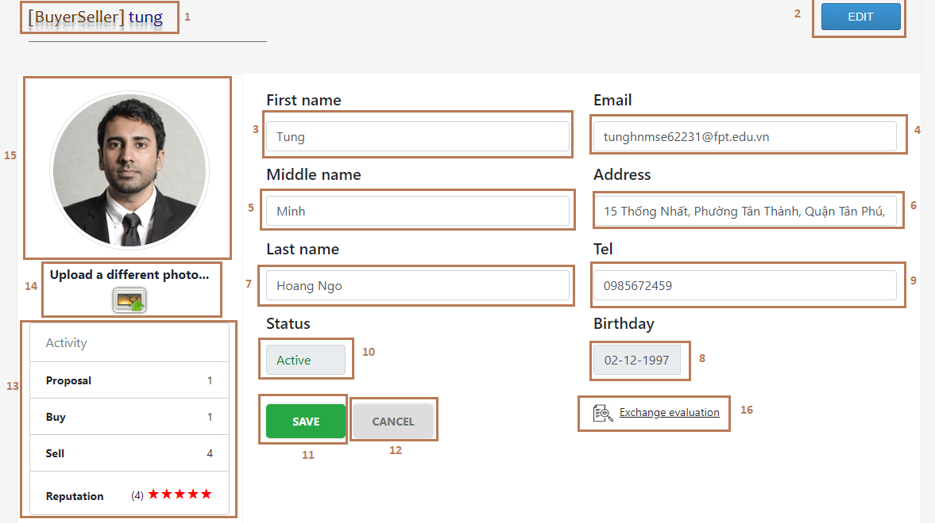

**Fields**

|  |  |  |  |  |  |  |  |
| --- | --- | --- | --- | --- | --- | --- | --- |
| **No** | **Field Name** | **Description** | **Read only** | **Mandatory** | **Control Type** | **Data Type** | **Length** |
| 1 | Username and role | User’s username for login and role | Yes | Yes | Label | String | <= 50 |
| 3 | Firstname | User’s firstname | No | Yes | Text input | String | <= 50 |
| 4 | Email | User’s email | No | Yes | Text input | String | <=50 |
| 5 | Middlename | User’s middle name | No | No | Text input | String | <=50 |
| 6 | Address | User’s address | No | No | Text input | String | <= 250 |
| 7 | Lastname | User’s lastname | No | Yes | Text input | String | <= 50 |
| 8 | Birthday | User’s birthday | No | No | DateTimePicker | String | <= 20 |
| 9 | Tel | User’s mobile number | No | No | Text input | String | 10-11 |
| 10 | Status | User’s status | Yes | Yes | Text input | String | N/A |
| 13 | Statistic | User’s statistics and ratings | Yes | Yes | N/A | String | N/A |
| 15 | Avatar | User’s image | No | Yes | Img | Img | N/A |

**Buttons/Hyperlinks**

|  |  |  |  |  |
| --- | --- | --- | --- | --- |
| **No** | **Function** | **Description** | **Validation** | **Outcome** |
| 2 | Edit | Redirect to edit page | N/A | Edit page is shown |
| 11 | Save | Send edit profile with values | Email must match the required format  All required fields must be filled out  Phone number is string of number  Email must not be duplicate in database  Length of all field’s values must be in range | Profile page is shown |
| 12 | Cancel | All fields are reset to the beginning values | N/A | All fields are reset to the beginning values |
| 14 | Choose file | Update avatar | Check valid type of file image | Success: avatar is updated with the selected image from user  Fail: show error message |
| 16 | View exchange evaluation | Display dialog with user’s exchange evaluation | N/A | Display dialog with user’s exchange evaluation |

### 5.5. Administrator

##### 5.5.1. Create model

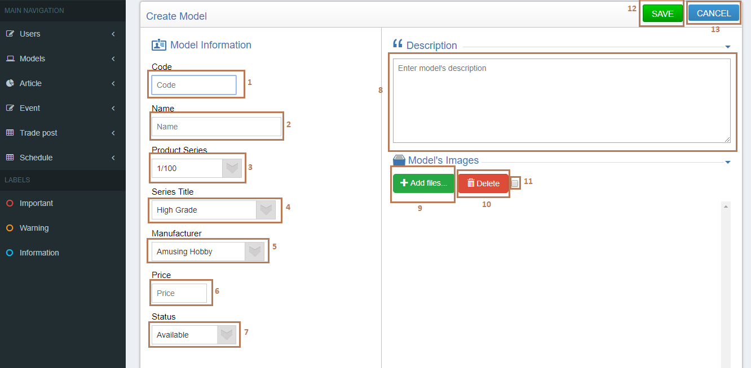

**Fields**

|  |  |  |  |  |  |  |  |
| --- | --- | --- | --- | --- | --- | --- | --- |
| **No** | **Field Name** | **Description** | **Read only** | **Mandatory** | **Control Type** | **Data Type** | **Length** |
| 1 | Code | Model’s code | No | Yes | Text input | String | <= 50 |
| 2 | Name | Model’s name | No | Yes | Text input | String | <= 50 |
| 3 | Product Series | Model’s product series | No | Yes | Dropdown list | String | N/A |
| 4 | Series Title | Model’s series title | No | Yes | Dropdown list | String | N/A |
| 5 | Manufacturer | Model’s manufacturer | No | Yes | Dropdown list | String | N/A |
| 6 | Price | Model’s price | No | No | Text input | String | <= 20 |
| 7 | Status | Model’s status | No | Yes | Dropdown list | String | N/A |
| 8 | Description | Model’s description | No | No | Text input | String | <= 350 |
| 11 | Check all | Check all images displaying on the view | No | No | Checkbox | N/A | N/A |

**Buttons/Hyperlinks**

|  |  |  |  |  |
| --- | --- | --- | --- | --- |
| **No** | **Function** | **Description** | **Validation** | **Outcome** |
| 9 | Add images | Choose model’s image | Check valid type of file image | Image name is shown next by |
| 10 | Delete images | Delete model’s image | N/A | Images are removed from view |
| 12 | Save | Send create model command | All required fields must be input  Invalid format of code  Duplicate model’s code  Length of fields’s value must be in range | Success: model information is saved to database and display model detail page  Fail: show error message |
| 13 | Cancel | Cancel creating model | N/A | Search model page is displayed |

##### 5.5.2. Edit model

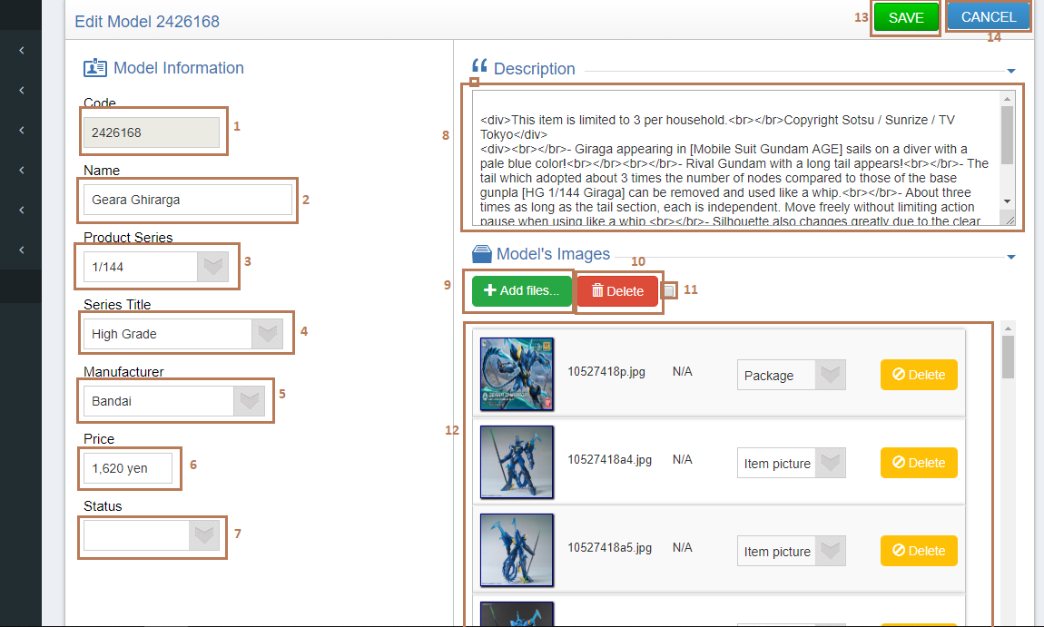

**Fields**

|  |  |  |  |  |  |  |  |
| --- | --- | --- | --- | --- | --- | --- | --- |
| **No** | **Field Name** | **Description** | **Read only** | **Mandatory** | **Control Type** | **Data Type** | **Length** |
| 1 | Code | Model’s code | No | Yes | Text input | String | <= 50 |
| 2 | Name | Model’s name | No | Yes | Text input | String | <= 50 |
| 3 | Product Series | Model’s product series | No | Yes | Dropdown list | String | N/A |
| 4 | Series Title | Model’s series title | No | Yes | Dropdown list | String | N/A |
| 5 | Manufacturer | Model’s manufacturer | No | Yes | Dropdown list | String | N/A |
| 6 | Price | Model’s price | No | No | Text input | String | <= 20 |
| 7 | Status | Model’s status | No | Yes | Dropdown list | String | N/A |
| 8 | Description | Model’s description | No | No | Text input | String | <= 350 |
| 11 | Check all | Check all images displaying on the view | No | No | Checkbox | N/A | N/A |
| 12 | Model’s images | Model’s images | No | Yes | N/A | N/A | N/A |

**Buttons/Hyperlinks**

|  |  |  |  |  |
| --- | --- | --- | --- | --- |
| **No** | **Function** | **Description** | **Validation** | **Outcome** |
| 9 | Add images | Choose model’s image | Check valid type of file image | Image name is shown next by |
| 10 | Delete images | Delete model’s image | N/A | Images are removed from view |
| 13 | Save | Send edit model command | All required fields must be input  Invalid format of code  Duplicate model’s code  Length of fields’s value must be in range | Success: model information is saved to database and display model detail page  Fail: show error message |
| 14 | Cancel | Cancel edit model | N/A | Selected model detail page is displayed |

##### 5.5.3. Delete model

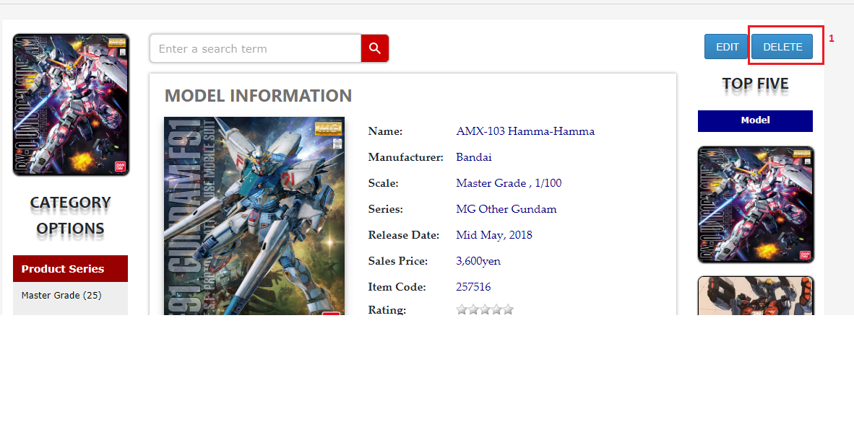

**Buttons/Hyperlinks**

|  |  |  |  |  |
| --- | --- | --- | --- | --- |
| **No** | **Function** | **Description** | **Validation** | **Outcome** |
| 1 | Delete model | Send delete model command | N/A | The selected model is delete and search model page is shown |

##### 5.5.4. Manage users

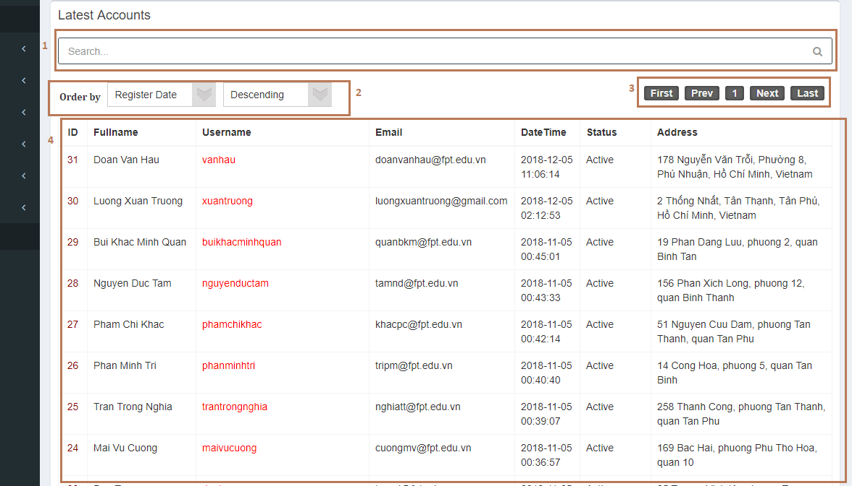

**Fields**

|  |  |  |  |  |  |  |  |
| --- | --- | --- | --- | --- | --- | --- | --- |
| **No** | **Field Name** | **Description** | **Read only** | **Mandatory** | **Control Type** | **Data Type** | **Length** |
| 1 | Search field | Search accounts | No | No | Text input | String | N/A |
| 2 | Order by filter | Order by filter | No | No | Dropdown list | String | N/A |
| 3 | Pagination | Pagination | No | No | N/A | String | N/A |
| 4 | List accounts | List accounts | No | Yes | N/A | String | N/A |

##### 5.5.5. Crawling

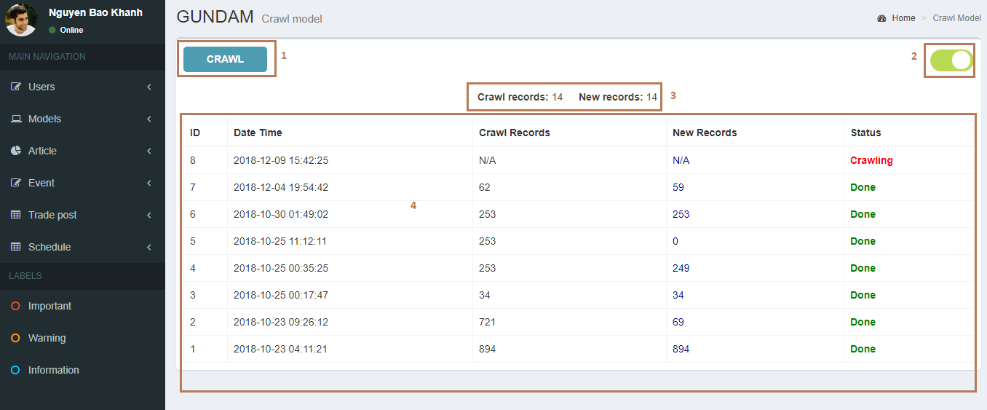

**Fields**

|  |  |  |  |  |  |  |  |
| --- | --- | --- | --- | --- | --- | --- | --- |
| **No** | **Field Name** | **Description** | **Read only** | **Mandatory** | **Control Type** | **Data Type** | **Length** |
| 3 | Count records | Counting crawl records and new records which are saved in database | Yes | No | Label | String | N/A |
| 4 | Log data | History crawling | Yes | Yes | Label | String | N/A |

**Buttons/Hyperlinks**

|  |  |  |  |  |
| --- | --- | --- | --- | --- |
| **No** | **Function** | **Description** | **Validation** | **Outcome** |
| 1 | Start crawl | Send crawl command to server | N/A | System displays message: “System is crawling successfully!” |
| 2 | Switch tracking | Switch on/off tracking crawl process | N/A | Number of crawl records and number of new records are displayed on the view |

##### 5.5.6. Manage schedule

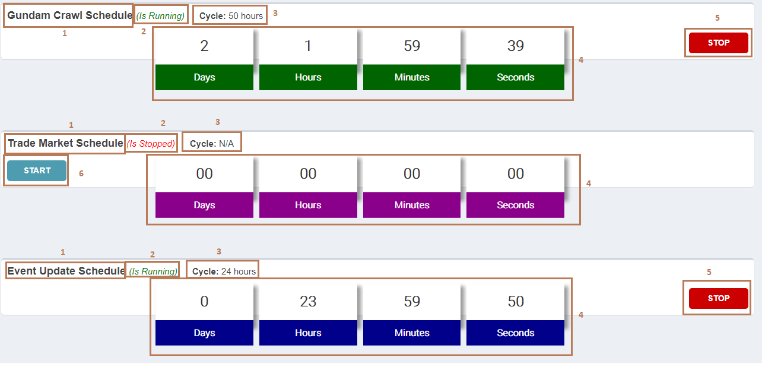

**Fields**

|  |  |  |  |  |  |  |  |
| --- | --- | --- | --- | --- | --- | --- | --- |
| **No** | **Field Name** | **Description** | **Read only** | **Mandatory** | **Control Type** | **Data Type** | **Length** |
| 1 | Schedule name | Schedule name | Yes | Yes | Label | String | N/A |
| 2 | Schedule’s status | Status of schedule | Yes | Yes | Label | String | N/A |
| 3 | Update cycle | Update cycle of schedule | Yes | Yes | Label | String | N/A |
| 4 | Countdown | Countdown time | Yes | Yes | Label | String | N/A |

**Buttons/Hyperlinks**

|  |  |  |  |  |
| --- | --- | --- | --- | --- |
| **No** | **Function** | **Description** | **Validation** | **Outcome** |
| 5 | Stop schedule | Send stop schedule command to server | N/A | System displays message: “Schedule is stopped successfully!” |
| 6 | Start schedule | Send start schedule command to server | N/A | System displays message: “Schedule starts successfully!” |

##### 5.5.7. Search article

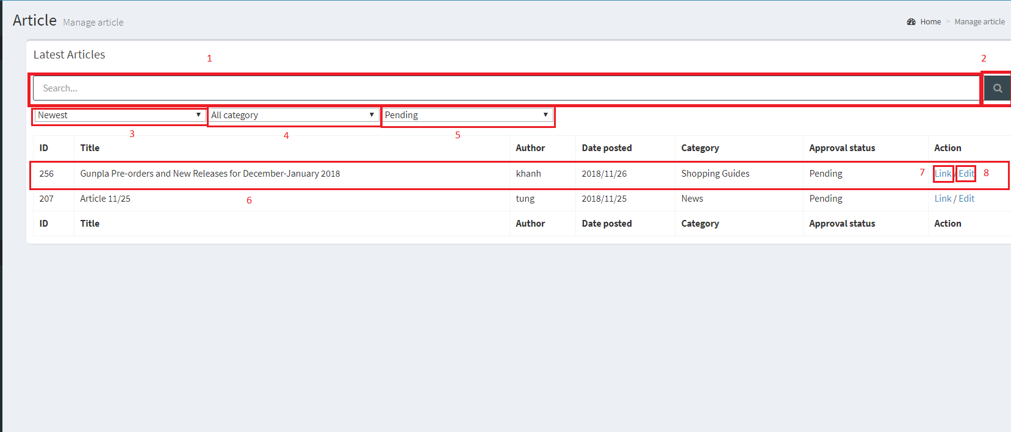

**Fields**

|  |  |  |  |  |  |  |  |
| --- | --- | --- | --- | --- | --- | --- | --- |
| **No** | **Field Name** | **Description** | **Read only** | **Mandatory** | **Control Type** | **Data Type** | **Length** |
| 1 | Search article | Search article by title | No | No | Text input | String | N/A |
| 3 | Sort by date | Sort by date newest or oldest first | No | Yes | Drop-down list | String | N/A |
| 4 | Article’s category | Category to search article | No | Yes | Dropdown list | String | N/A |
| 5 | Article’s status | Status to search article | No | Yes | Dropdown list | String | N/A |
| 6 | Search record | Result of searching | No | Yes | N/A | N/A | N/A |

**Buttons/Hyperlinks**

|  |  |  |  |  |
| --- | --- | --- | --- | --- |
| **No** | **Function** | **Description** | **Validation** | **Outcome** |
| 2 | Search | Search articles by title | No | Search articles by title and filters |
| 7 | Link to the article | Link to the article | No | Redirects to the article |
| 8 | Link to edit page | Link to edit page | No | Redirect to the edit page |

##### 5.5.8. Edit article

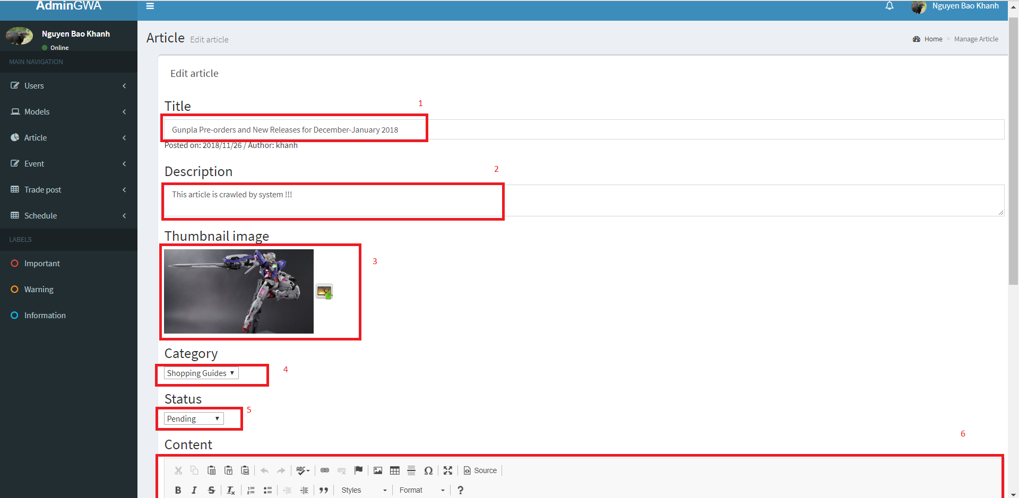

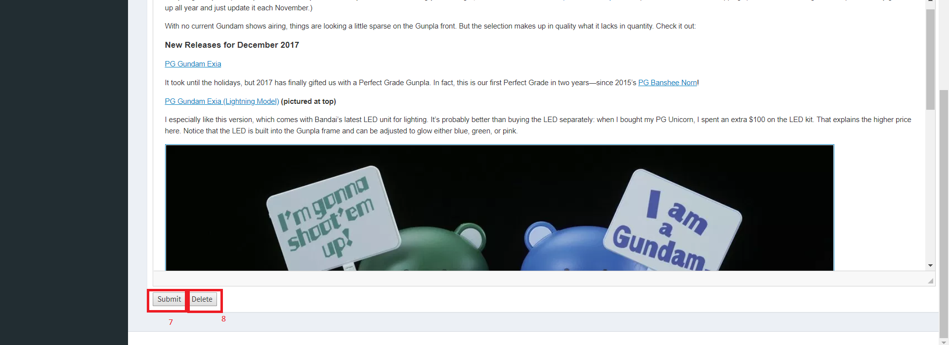

**Fields**

|  |  |  |  |  |  |  |  |
| --- | --- | --- | --- | --- | --- | --- | --- |
| **No** | **Field Name** | **Description** | **Read only** | **Mandatory** | **Control Type** | **Data Type** | **Length** |
| 1 | Article’s title | The title of the article | No | Yes | Input field | String | <=250 |
| 4 | Article’s category | The category of the article | No | Yes | Drop-down list | String | N/A |
| 2 | Article’s description | Short description of the article | No | Yes | Textarea | String | <=250 |
| 3 | Article’s thumbnail | Thumbnail of the article | No | Yes | Image | String | N/A |
| 5 | Article’s status | Status of the article | No | Yes | Drop-down list | String | N/A |
| 6 | Article’s content | The content of the article | No | Yes | Textarea | String | N/A |

**Buttons/Hyperlinks**

|  |  |  |  |  |
| --- | --- | --- | --- | --- |
| **No** | **Function** | **Description** | **Validation** | **Outcome** |
| 7 | Submit article | Let the user submit the article | Yes | Validate all fields and submit article. |
| 8 | Delete article | Let the user delete the article | Yes | Prompts user “**Are you sure you want to delete this article?”**  Deletes the article if the user select Yes, cancel if No |

##### 5.5.9. Create article

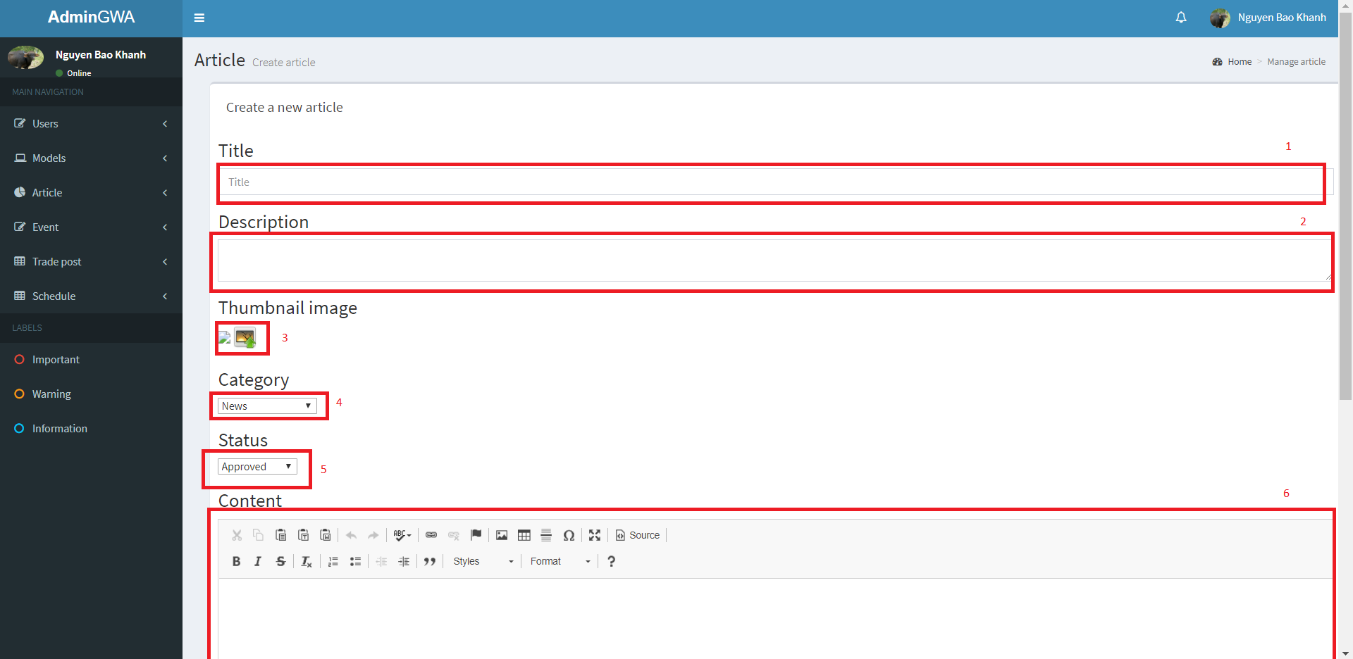

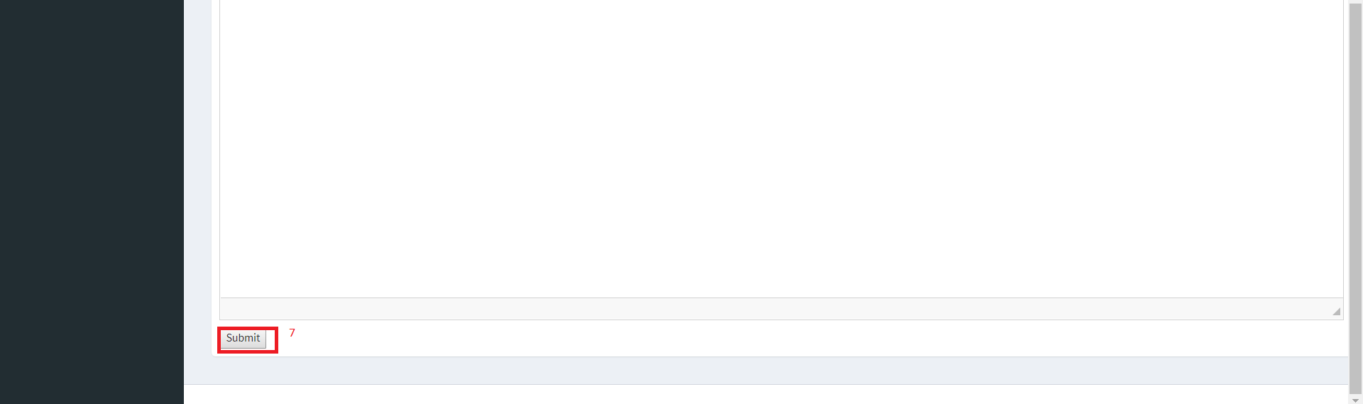

**Fields**

|  |  |  |  |  |  |  |  |
| --- | --- | --- | --- | --- | --- | --- | --- |
| **No** | **Field Name** | **Description** | **Read only** | **Mandatory** | **Control Type** | **Data Type** | **Length** |
| 1 | Article’s title | The title of the article | No | Yes | Input field | String | <=250 |
| 4 | Article’s category | The category of the article | No | Yes | Drop-down list | String | N/A |
| 2 | Article’s description | Short description of the article | No | Yes | Textarea | String | <=250 |
| 3 | Article’s thumbnail | Thumbnail of the article | No | Yes | Image | String | N/A |
| 5 | Article’s status | Status of the article | No | Yes | Drop-down list | String | N/A |
| 6 | Article’s content | The content of the article | No | Yes | Textarea | String | N/A |

**Buttons/Hyperlinks**

|  |  |  |  |  |
| --- | --- | --- | --- | --- |
| **No** | **Function** | **Description** | **Validation** | **Outcome** |
| 7 | Submit article | Let the user submit the article | Yes | Validate all fields and submit article. |

##### 5.5.10. Search event

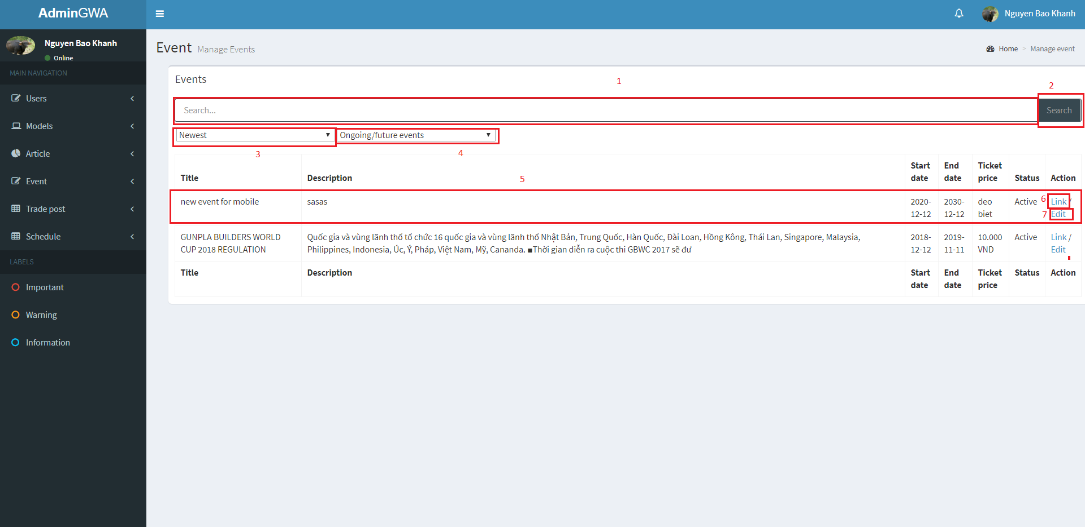

**Fields**

|  |  |  |  |  |  |  |  |
| --- | --- | --- | --- | --- | --- | --- | --- |
| **No** | **Field Name** | **Description** | **Read only** | **Mandatory** | **Control Type** | **Data Type** | **Length** |
| 1 | Search event | Search event by title | No | No | Text input | String | N/A |
| 3 | Sort by date | Sort by date newest or oldest first | No | Yes | Drop-down list | String | N/A |
| 4 | Event’s status | Status to search article | No | Yes | Dropdown list | String | N/A |
| 6 | Search record | Result of searching | No | Yes | N/A | N/A | N/A |

**Buttons/Hyperlinks**

|  |  |  |  |  |
| --- | --- | --- | --- | --- |
| **No** | **Function** | **Description** | **Validation** | **Outcome** |
| 2 | Search | Search articles by title | No | Search articles by title and filters |
| 6 | Link to the article | Link to the event | No | Redirects to the event |
| 7 | Link to edit page | Link to edit page | No | Redirect to the edit page |

##### 5.5.11. Create event

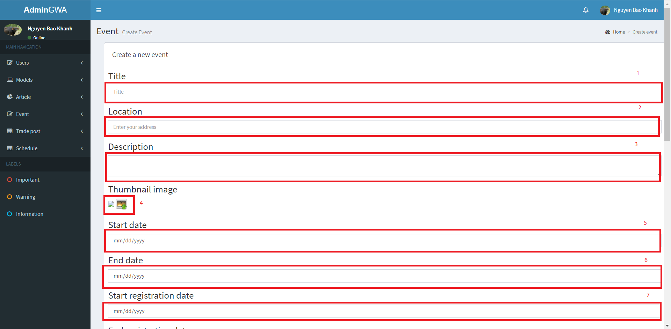

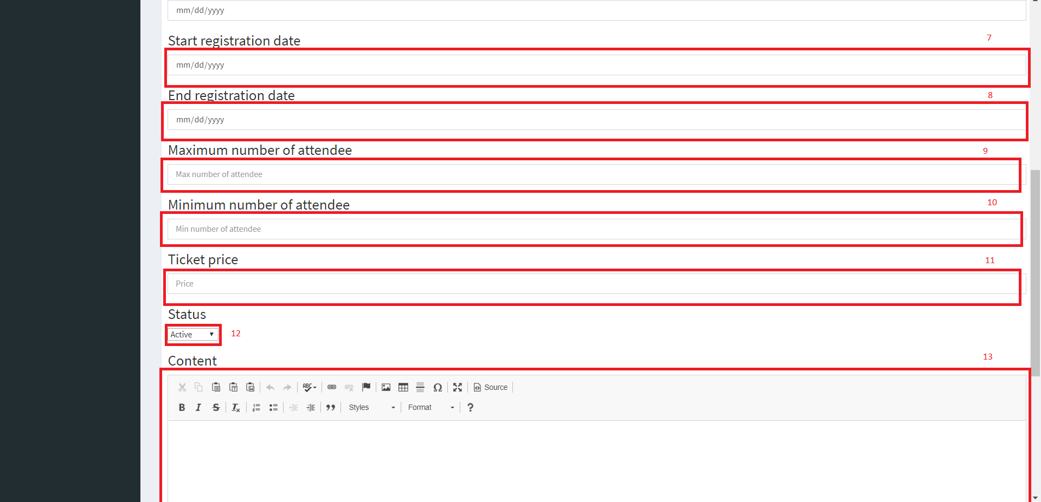

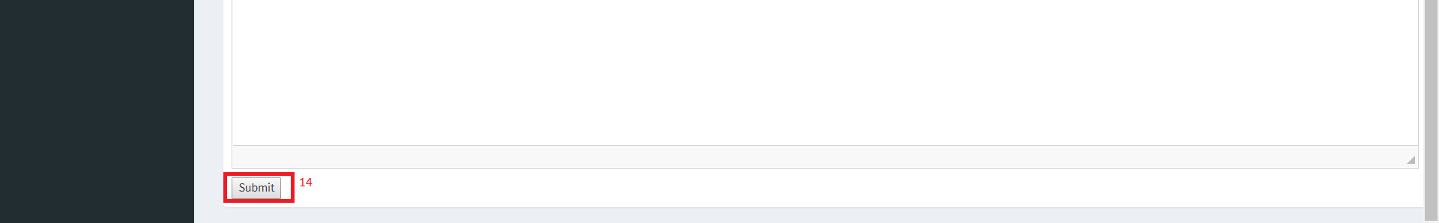

**Fields**

|  |  |  |  |  |  |  |  |
| --- | --- | --- | --- | --- | --- | --- | --- |
| **No** | **Field Name** | **Description** | **Read only** | **Mandatory** | **Control Type** | **Data Type** | **Length** |
| 1 | Event’s title | Title of the event | No | Yes | Text input | String | <= 250 |
| 2 | Event’s location | Location of the event | No | Yes | Text input | String | <=250 |
| 3 | Event’s description | Description of the event | No | Yes | Text input | String | <=250 |
| 4 | Event’s thumbnail | Thumbnail of the event | No | Yes | Image | N/A | N/A |
| 5 | Event’s start date | Event’s start date | No | Yes | Date input | String | N/A |
| 6 | Event’s end date | Event’s end date | No | Yes | Date input | String | N/A |
| 7 | Event’s start registration date | Date when users can register to the event | No | Yes | Date input | String | N/A |
| 8 | Event’s start registration date | End date of when users can register to the event | No | Yes | Date input | String | N/A |
| 9 | Max number of attendee | Maximum number of tickets available of the event | No | Yes | Text input | int | N/A |
| 10 | Min number of attendee | Minimum number of attendee required | No | Yes | Text input | int | N/A |
| 11 | Ticket price | Ticket price of the event | No | Yes | Text input | String | <=20 |
| 12 | Event status | Status of the event | No | Yes | Drop-down list | String | N/A |
| 13 | Event content | Content of the event | No | Yes | Textarea | String | N/A |

**Buttons/Hyperlinks**

|  |  |  |  |  |
| --- | --- | --- | --- | --- |
| **No** | **Function** | **Description** | **Validation** | **Outcome** |
| 14 | Submit event | Submit the event | Yes | Validate data and submit the event |

##### 5.5.12. Edit event

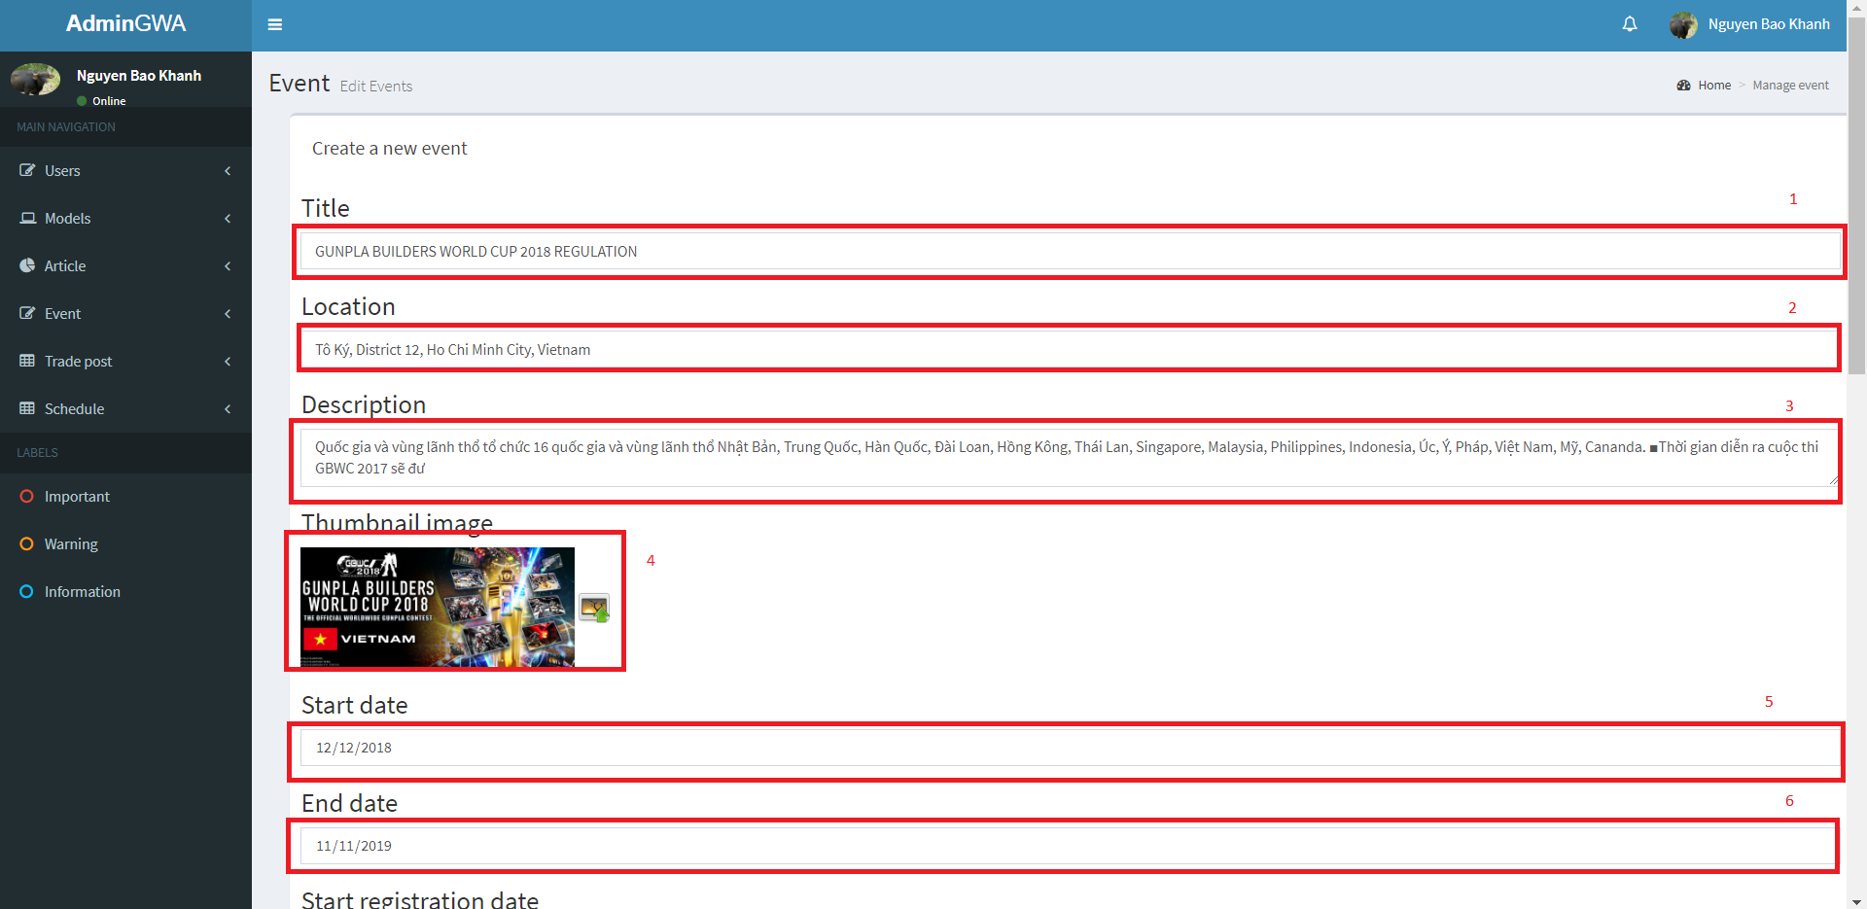





**Fields**

|  |  |  |  |  |  |  |  |
| --- | --- | --- | --- | --- | --- | --- | --- |
| **No** | **Field Name** | **Description** | **Read only** | **Mandatory** | **Control Type** | **Data Type** | **Length** |
| 1 | Event’s title | Title of the event | No | Yes | Text input | String | <= 250 |
| 2 | Event’s location | Location of the event | No | Yes | Text input | String | <=250 |
| 3 | Event’s description | Description of the event | No | Yes | Text input | String | <=250 |
| 4 | Event’s thumbnail | Thumbnail of the event | No | Yes | Image | N/A | N/A |
| 5 | Event’s start date | Event’s start date | No | Yes | Date input | String | N/A |
| 6 | Event’s end date | Event’s end date | No | Yes | Date input | String | N/A |
| 7 | Event’s start registration date | Date when users can register to the event | No | Yes | Date input | String | N/A |
| 8 | Event’s start registration date | End date of when users can register to the event | No | Yes | Date input | String | N/A |
| 9 | Max number of attendee | Maximum number of tickets available of the event | No | Yes | Text input | int | N/A |
| 10 | Min number of attendee | Minimum number of attendee required | No | Yes | Text input | int | N/A |
| 11 | Ticket price | Ticket price of the event | No | Yes | Text input | String | <=20 |
| 12 | Event status | Status of the event | No | Yes | Drop-down list | String | N/A |
| 13 | Event content | Content of the event | No | Yes | Textarea | String | N/A |

**Buttons/Hyperlinks**

|  |  |  |  |  |
| --- | --- | --- | --- | --- |
| **No** | **Function** | **Description** | **Validation** | **Outcome** |
| 14 | Submit event | Submit the event | Yes | Validate data and submit the event |

##### 5.5.13. List proposal

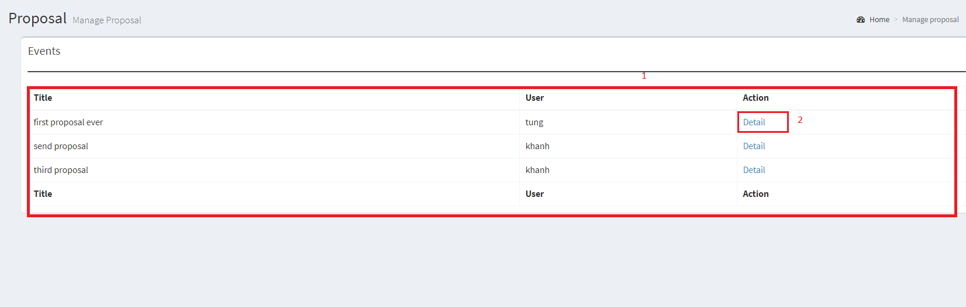

**Fields**

|  |  |  |  |  |  |  |  |
| --- | --- | --- | --- | --- | --- | --- | --- |
| **No** | **Field Name** | **Description** | **Read only** | **Mandatory** | **Control Type** | **Data Type** | **Length** |
| 1 | Proposal list | List of the proposals posted by the users | No | Yes | N/A | N/A | N/A |

**Buttons/Hyperlinks**

|  |  |  |  |  |
| --- | --- | --- | --- | --- |
| **No** | **Function** | **Description** | **Validation** | **Outcome** |
| 2 | Proposal detail link | Link to the proposal’s detail | No | Redirects to the proposal’s detail |

##### 5.5.14. Proposal detail

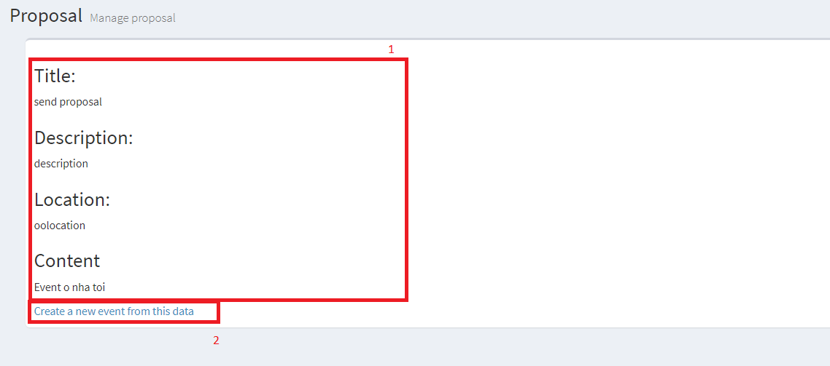

**Fields**

|  |  |  |  |  |  |  |  |
| --- | --- | --- | --- | --- | --- | --- | --- |
| **No** | **Field Name** | **Description** | **Read only** | **Mandatory** | **Control Type** | **Data Type** | **Length** |
| 1 | Proposal detail | Detail of the proposal | Yes | Yes | N/A | N/A | N/A |

**Buttons/Hyperlinks**

|  |  |  |  |  |
| --- | --- | --- | --- | --- |
| **No** | **Function** | **Description** | **Validation** | **Outcome** |
| 2 | Create event with proposal | Link to the event create view | No | Redirects to the event create view with the proposal’s data loaded |

## 6. Database Design

### 6.1. Entity Relationship Diagram (ERD)

### 6.2. Data Dictionary

|  |  |
| --- | --- |
| **Entity Data Dictionary** | |
| **Entity name** | **Description** |
| Model | Contain model information |
| SeriesTitle | Contain series title information, this is a type of model’s category |
| ProductSeries | Contain product series information, this is a type of model’s category |
| Manufacturer | Contain model’s manufacturer information |
| ModelImage | Contain model’s images |
| ImageType | Contain model’s image type |
| ModelRating | Contain model’s user review evaluation |
| Article | Contain article information which is posted by authenticated users |
| Proposal | Contain proposal information which is posted by members |
| Account | Contain account information |
| Profile | Contain user’s profile information |
| Role | Contain role information |
| Event | Contain event information, which is created by administrator |
| EventAttendee | Contain information about event’s attendee, we also use this table to contain user’s evaluation about the events |
| Notification | Contain notification information |
| NotificationType | Contain types of notification |
| TradePost | Contain trade post information, which is created by buyer/seller |
| TradeRating | Contain user’s evaluation about the exchange |
| TradePostImage | Contain trade post’s images |
| TradeReport | Contain information about user’s report on exchange |
| OrderRequest | Contain member’s order request to trade posts |

## 7. Algorithms

### 7.1. As-you-type search with instant results and pagination with sessionStorage

#### 7.1.1. Definition

"As-you-type" search is a user interface interaction method to progressively search for and filter through text. As the user types text, one or more possible matches or nearly matches for the text are found and immediately presented to the user.

"Instant results" make as-you-type search offer actual results instead of just query reformulations, provide shortcut to search results.

"Pagination with sessionStorage" is a pagination method that saves records of user's each selected page and nextby pages to sessionStorage and retrieves when user reselected.

#### 7.1.2. Define problems

User sometimes have to type the entire word or phrase to find models they were looking for and may not know the exact name of gundam models, this lead to no result matches situation. We also want to reduce HTTP requests from client to speed up the system, the fewer requests send to server, the faster client will load.

#### 7.1.3. Solution

The processing model for search gundam models follow these steps:

1. Save all gundam model names and thumb images to user's localStorage

- When user goes to search model page, system check if data is in localStorage or not

+ If data not exist in localStorage, system request to get all model names and thumb images from server and save to localStorage with current datetime.

+ If data existed in localStorage, system will check the last saved datetime compare to present, request to get data from server if larger than 2 days

2. Find gundam models which match or nearly match with user's input keyword

- When user types any character in search input, system find models which have name contains the text input

- Next step, use Levenshtein edit distance algorithm to calculate percentage string comparison between models name and text input from user

- Append all the models which have larger than or equal to 50% string comparison to result list

- Display results with thumb image and name on the view

3. If user selects one of those, redirect user to model specific detail page

4. Pagination with sessionStorage, reduce request send to server, system doesn’t have to send request to get data when user re-clicks on a page

- When user clicks on a page, check if data of that page is in sessionStorage or not

+ If existed, system get current page's data from sessionStorage and render to view

+ If not, request to server to get current page's data and render to view

- System also prepares data of two pages nextby for user

#### 7.1.4. Flow chart

### 7.2. MD5 hash function

#### 7.2.1. Definition

"MD5" is a widely used one-way cryptographic hash function, which produces a hash of 128-bit hash value. It returns a 32 character string of hexadecimal digits 0-9 & a-f and returns null if the input is null.

#### 7.2.2. Define problems

When execute crawling data from sites, crawl records must be maching with data in database. Matching by traditional way waste time and memory when need to compare with multi attributes of a model.

#### 7.2.3. Solution

- When crawling a model, combine following attributes of a gundam model to a string:

+ name

+ product series

+ series title

+ manufacturer

- Use MessageDigest to find MD5 hash value of string

- Compare to all other model's MD5 hash value

### 7.3. Schedule Tracking

#### 7.3.1. Definition

"Schedule Tracking" is the process which allows administrator to track the system schedules with countdown time, status and also history execute updates.

#### 7.3.2. Define problems

Our system needs to have some schedules to make it more convenient for administrator and also users to interact with system such as schedule about crawling data, schedule about auto disable all events which don’t have enough minimum attendee after end registration date,.. Administrator also needs to track the schedule for information

#### 7.3.3. Solution

- Use Thread to implement Schedule

- When administrator starts a schedule, system starts Thread with input update cycle (hour), datetime when execute update, status…

- When administrator stops a schedule, system interrupts the selected Schedule thread and reset all fields (cycle, status,..)

- When administrator goes to Manage Schedule view:

+ System get status, update cycle, log data from all Schedules

+ System calculate countdown time of each schedule with the following formula (if the schedule is running):

**Countdown time = last execute update time + cycle – current time**

With “last execute update time” is datetime when the schedule executed update process, “cycle” is the interval input from administrator and “current time” is now.

+ Next step, system responses all above data to admin web app

+ System calculate counting down time and render to view with javascript at client-side

### 7.4. Search nearby location with Haversine formula

#### 7.4.1. Definition

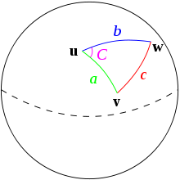 The haversine formula determines the great-circle distance between two points on a sphere given their longitudes and latitudes. Important in navigation, it is a special case of a more general formula in spherical trigonometry, the law of haversines, that relates the sides and angles of spherical triangles.

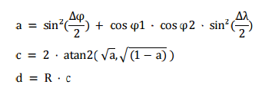

#### 7.4.2. Define problems

When user want to find an exchange around them with specific range, system will help them find with location and range by using haversin formula.

#### 7.4.3. Solution

- When search an exchange user can setting up their location by auto or manual select address.

-

- System will geocoder this address from user and all address from all exchange to latlng position.

- System will calculate distance from user position and exchange position using haversin formula and compare with range inputted. If distance is lower than range inputted, system will selected this exchange to search result list.

# E. System Implementation & Test

## 1. Introduction

### 1.1. Overview

This section provides in detail all necessary information about implementation information of **GWA** which includes physical database design, system state machine diagram and testing procedures which includes test plans, test cases and test result.

### 1.2. Test Approach

We use black box test approach to estimate our system quality. It’s the most appropriate testing method for the system to test all functions from a user’s point of view and help in exposing discrepancies in the specifications. Our testers don’t need to know how the software has been implemented, tests can be conducted by a body independent from the developers, allowing for an objective perspective and the avoidance of developer-bias.

## 2. Database Relationship Diagram

### 2.1. Physical Diagram

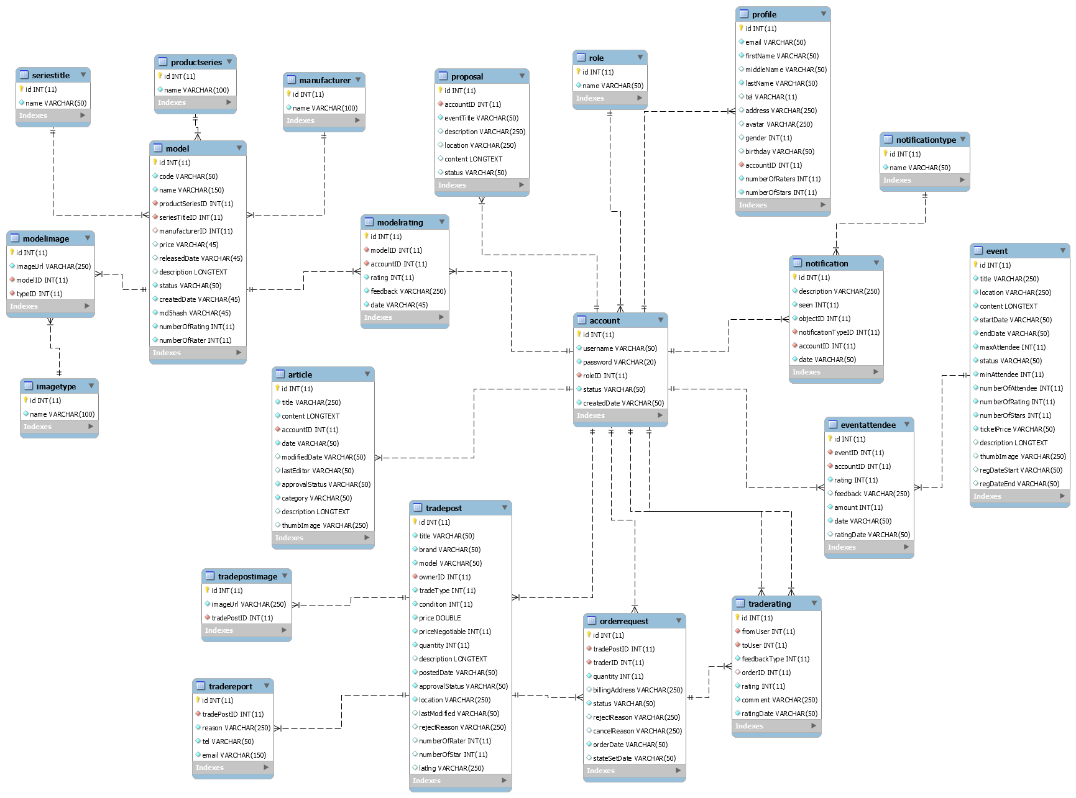

### 2.2. Data dictionary

|  |  |
| --- | --- |
| **Data dictionary: describe content of all tables** | |
| **Table name** | **Description** |
| model | Table which contains model information |
| seriestitle | Table which contains series title information, this is a type of model’s category |
| productseries | Table which contains product series information, this is a type of model’s category |
| manufacturer | Table which contains model’s manufacturer information |
| modelimage | Table which contains model’s images |
| imagetype | Table which contains model’s image type |
| article | Table which contains article information which is posted by authenticated users |
| modelrating | Table which contains user review evaluation on models |
| proposal | Table which contains proposal information which is posted by members |
| account | Table which contains account information |
| profile | Table which contains user’s profile information |
| role | Table which contains role information |
| event | Table which contains event information, which is created by administrator |
| eventattendee | Table which contains information about event’s attendee, we also use this table to contain user’s evaluation about the events |
| notification | Table which contains notification information |
| notificationtype | Table which contains types of notification |
| tradepost | Table which contains trade post information, which is created by buyer/seller |
| traderating | Table which contains user’s evaluation about the exchange |
| tradepostimage | Table which contains trade post’s images |
| tradereport | Table which contains information about user’s report on exchange |
| orderrequest | Table which contains member’s order request to trade posts |

|  |  |  |  |
| --- | --- | --- | --- |
| **Entity name** | **Attributes** | **Description** | **Null** |
| model | id {pk} | Auto increment unique identifier | No |
| code | Model code | No |
| name | Model name | No |
| productSeriesID{fk} | Model’s product series | No |
| seriesTitleID {fk} | Model’s series title | No |
| manufacturerID {fk} | Model’s manufacturer | Yes |
| price | Model’s price | Yes |
| releasedDate | Model’s released date | Yes |
| description | Model’s description | Yes |
| status | Model’s status | No |
| createdDate | Model’s created date | No |
| md5hash | Model’s md5 hash value | No |
| numberOfRating | Number of stars rating | No |
| numberOfRater | Number of users who make review evaluation | No |
| productseries | id {pk} | Auto increment unique identifier | No |
| name | Unique name of product series | No |
| seriestitle | id {pk} | Auto increment unique identifier | No |
| name | Unique name of series title | No |
| manufacturer | id {pk} | Auto increment unique identifier | No |
| name | Unique name of manufacturer | No |
| modelimage | id {pk} | Auto increment unique identifier | No |
| imageUrl | Url of images | No |
| modelID {fk} | Model which images belong to | No |
| typeID {fk} | Type of images | No |
| imagetype | id {pk} | Auto increment unique identifier | No |
| name | Unique name of image type | No |
| modelrating | id {pk} | Auto increment unique identifier | No |
| modelID {fk} | Model which is evaluated | No |
| accountID {fk} | User who makes evaluation | No |
| rating | Number of stars rating | No |
| feedback | User’s feedback | No |
| date | Rating date | No |
| account | id {pk} | Auto increment unique identifier | No |
| username | Unique username of user | No |
| password | Account password to login | No |
| roleID {fk} | Account’s role | No |
| status | Account status | No |
| createdDate | Account’s created datetime | No |
| role | id {pk} | Auto increment unique identifier | No |
| name | Unique name of role | No |
| proposal | id {pk} | Auto increment unique identifier | No |
| accountID {fk} | Proposal owner | No |
| eventTitle | Proposal event’s title | No |
| description | Proposal description | Yes |
| location | Proposal event’s location | Yes |
| content | Proposal event’s content | Yes |
| status | Proposal event status | Yes |
| article | id {pk} | Auto increment unique identifier | No |
| title | Article title | No |
| content | Article content | No |
| accountID {fk} | User who posts the articles | No |
| date | Article posted date | No |
| modifiedDate | Article modified date | Yes |
| lastEditor | Article’s last editor | Yes |
| approvalStatus | Article’s approval status | No |
| category | Article’s category | No |
| description | Artícle’s description | Yes |
| thumbImage | Article’s thumb image url | Yes |
| notification | id {pk} | Auto increment unique identifier | No |
| description | Notification description | No |
| seen | Status seen | No |
| objectID | To save id of content object | No |
| notificationTypeID {fk} | Type of notification | No |
| accountID {fk} | User whom the notification is sent to | No |
| date | Notification sent datetime | No |
| notificationtype | id {pk} | Auto increment unique identifier | No |
| name | Unique name of notification type | No |
| event | id {pk} | Auto increment unique identifier | No |
| title | Event title | No |
| location | Event location | No |
| content | Event’s content | No |
| startDate | Event start date | No |
| endDate | Event end date | No |
| maxAttendee | Event’s max attendee | No |
| status | Event’s status | No |
| minAttendee | Event’s min attendee | No |
| numberOfAttendee | Event’s number of attendee, this attribute is to improve query performance | No |
| numberOfRating | Event’s number of raters, this attribute is to improve query performance | No |
| numberOfStars | Event’s number of star ratings, this attribute is to improve query performance | No |
| ticketPrice | Event’s ticket price | No |
| description | Event’s description | Yes |
| thumbImage | Event’s thumb image url | Yes |
| regDateStart | Event’s start registration date | Yes |
| regDateEnd | Event’s end registration date | Yes |
| eventattendee | id {pk} | Auto increment unique identifier | No |
| eventID {fk} | ID of event | No |
| accountID {fk} | Event’s attendee | No |
| rating | Event’s rating which is evaluated by user | No |
| feedback | Feedback of user about event | Yes |
| amount | Number of tickets that a user register | No |
| date | Date when user registers for event | No |
| ratingDate | Date when user evaluates event | Yes |
| profile | id {pk} | Auto increment unique identifier | No |
| email | User’s email | No |
| firstName | User’s firstname | No |
| middleName | User’s middleName | Yes |
| lastName | User’s lastname | No |
| tel | User’s mobile number | Yes |
| address | User’s address | Yes |
| avatar | User’s avatar image | Yes |
| gender | User’s gender | Yes |
| birthday | User’s birthday | No |
| accountID {fk} | Profile owner | No |
| numberOfRaters | Number of users who rate this user, this attribute is to improve query performance | No |
| numberOfStars | Number of star ratings from users, this attribute is to improve query performance | No |
| tradepost | id {pk} | Auto increment unique identifier | No |
| title | Trade post title | No |
| brand | Sale product’s brand | No |
| model | Sale product name | No |
| ownerID {fk} | User who posts this trade post | No |
| tradeType | Type of trade post: buyer/seller | No |
| condition | Condition of trade post | No |
| price | Sale product’s price | No |
| priceNegotiable | Price that may be negotiable between traders | No |
| quantity | Sale product quantity | No |
| description | Trade post description | Yes |
| postedDate | Date when trade post is created | No |
| approvalStatus | Trade post approval status by administrator | No |
| location | Trade post location | No |
| lastModified | Trade post’s last modified | Yes |
| rejectReason | Trade post’s reject reason by admin | Yes |
| numberOfRater | Number of users who make rating | Yes |
| numberOfStar | Number of stars rating | Yes |
| latlng | Trade post’s location latitude and longitude | Yes |
| tradereport | id {pk} | Auto increment unique identifier | No |
| tradePostID {fk} | ID of the trade post which is reported by user | No |
| reason | Report reason | No |
| tel | Reporter’s mobile number | No |
| email | Reporter’s email | No |
| tradepostimage | id {pk} | Auto increment unique identifier | No |
| imageUrl | Url of image | No |
| tradePostID {fk} | Trade post which images belong to | No |
| traderating | id {pk} | Auto increment unique identifier | No |
| fromUser {fk} | User who evaluates | No |
| toUser {fk} | User who is evaluated | No |
| feedbackType | To check whether the evaluation is from trade owner to user or user to trade owner | No |
| orderID {fk} | Each order request have at most 2 ratings | Yes |
| rating | Number of stars rating | No |
| comment | User’s feedback about trade post | No |
| ratingDate | Rating date | No |
| orderrequest | id {pk} | Auto increment unique identifier | No |
| tradePostID {fk} | The trade post which user request order to | No |
| traderID {fk} | User who requests order to trade post | No |
| quantity | Product order quantity | No |
| billingAddress | Address that is negotiable for exchange | Yes |
| status | Order request status | No |
| rejectReason | This attribute is used when trade post owner reject traders after accepted their order request | Yes |
| cancelReason | This attribute is used when trade post owner cancel user’s order request to trade post | Yes |
| orderDate | Date of order request | No |
| stateSetDate | This attribute is used when trade post owner reject or cancel order request, if reject, this attribute will belong to reject concept. If cancel, this attribute will belong to cancel concept | Yes |

## 3. Performance Measures

* Website can locate the user’s location in 2 seconds max
* System sends email to the user in 10 seconds max
* User can view information with pagination which are saved at client-side
* Crawling can take at least 30 minutes
* Notification is sent in 1 second max

## 4. Test plan

The purpose of this section is to verify and ensure that GWA meets its requirements and design specification. The following part will describe which features to be tested and which will not.

### 4.1. Features to be tested

**Web and mobile application:**

* Search models and view detail
* Crawl models, articles
* Proposal to open event
* Register for event
* Post for trade/exchange
* Request order to a trade post

### 4.2. Features not to be tested

Functions are not listed above won’t be tested.

## 5. System Testing Test Case

### 5.1. Communication Diagram

#### 5.1.1. Manipulate crawling

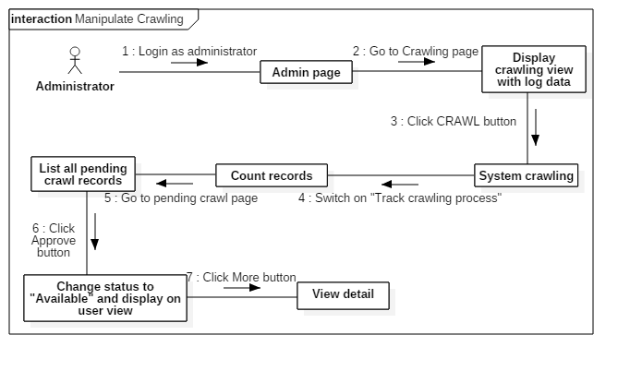

#### 5.1.2. Search for model information

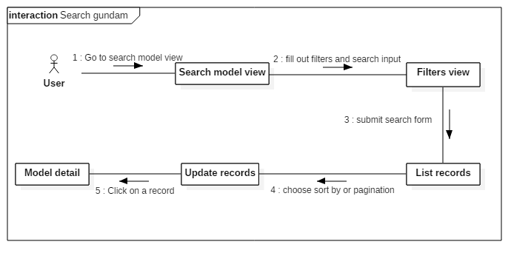

#### 5.1.3. Manipulate trade post

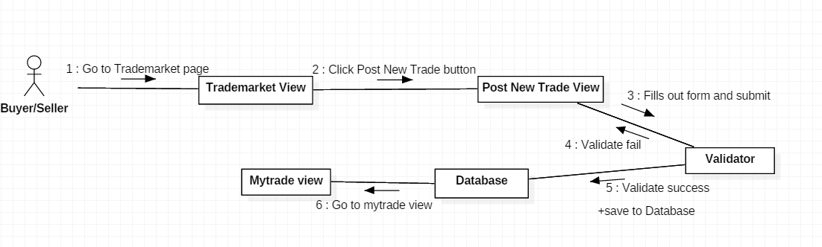

#### 5.1.4. Request order to trade post for exchange

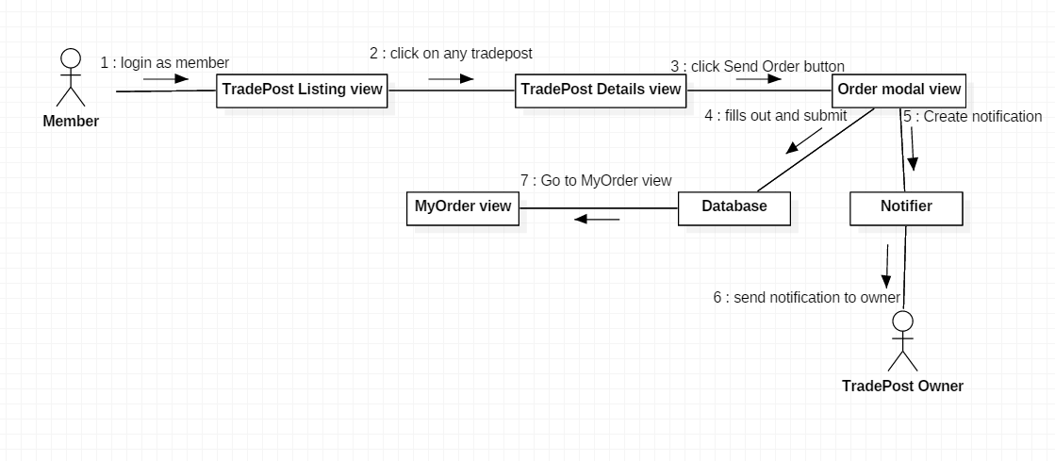

#### 5.1.5. Register for event

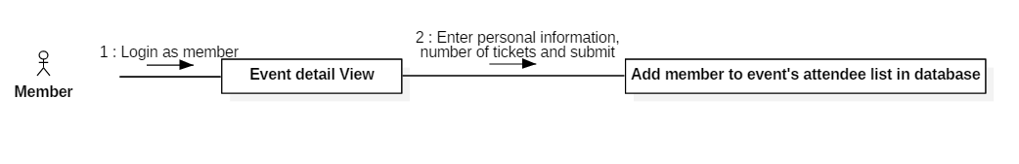

#### 5.1.6. Create articles

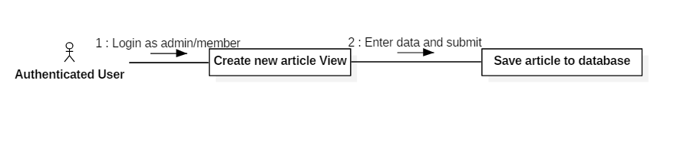

### 5.2. Web or Mobile Application Test case

#### 5.2.1. Manipulate crawling

|  |  |  |  |  |  |
| --- | --- | --- | --- | --- | --- |
| **ID** | **Test Case Description** | **Test Case Procedure** | **Expected output** | **Result** | **Test Date** |
| AMC1 | Start crawl | 1. Login with role “Admin” 2. Go to “Crawling” view. 3. Click CRAWL button. | Display log data with status “Crawling”  Display system is crawling message | Success | 2018-12-04  2:22 PM |
| AMC2 | Track crawling process | 1. Switch on icon “Track crawling process” | Counting crawl records and new records (which is saved to database after matching) | Success | 2018-12-04  2:22 PM |
| AMC3 | Review pending crawl records | 1. Go to pending crawl records page | Display records with status “crawlpending” | Success | 2018-12-04  2:22 PM |
| AMC4 | Approve pending crawl records | 1. Click approve button | Selected record’s status is changed available and display on user view | Success | 2018-12-04  2:22 PM |

#### 5.2.2. Search for model information

|  |  |  |  |  |  |
| --- | --- | --- | --- | --- | --- |
| **ID** | **Test Case Description** | **Test Case Procedure** | **Expected output** | **Result** | **Test Date** |
| SFM1 | Search for model information with filters | 1. Go to “Search Model” view. 2. Fill out the search form with filters 3. Click search button | List of matching records are shown with filters sort by and pagination | Success | 2018-12-04  2:45 PM |
| SFM2 | Choose filter sorts by and pagination | 1. Choose sort by options or pagination | Updated list records follow the filters and pagination | Success | 2018-12-04  2:45 PM |
| SFM3 | Show model detail information | 1. Click on a record’s “More information” button | The selected model detail page is shown | Success | 2018-12-04  2:45 PM |

#### 5.2.3. Manipulate trade post

|  |  |  |  |  |  |
| --- | --- | --- | --- | --- | --- |
| **ID** | **Test Case Description** | **Test Case Procedure** | **Expected output** | **Result** | **Test Date** |
| MTP1 | Post New Trade with valid data. | 1. Click “Post new trade” button. 2. Fills out form with valid data and submit 3. Click “Post your trade” button. | Go to My trade view. | Success | 2018-12-04  3:05 PM |
| MTP2 | Post New Trade with invalid data. | 1. Click “Post new trade” button. 2. Fills out form with invalid data and submit 3. Click “Post your trade” button. | Stay at Post new trade view and show error message for invalid data. | Success | 2018-12-04  3:05 PM |

#### 5.2.4. Order to trade post for exchange

|  |  |  |  |  |  |
| --- | --- | --- | --- | --- | --- |
| **ID** | **Test Case Description** | **Test Case Procedure** | **Expected output** | **Result** | **Test Date** |
| OTT1 | Send order with valid quantity | 1. Click “Send Order” button on trade post details view. 2. Enter valid quantity 3. fills out Trader information form 4. Click submit | Go to My order view | Success | 2018-12-04  3:05 PM |
| OTT2 | Send order with invalid quantity | 1. Click “Send Order” button on trade post details view. 2. Enter invalid quantity 3. fills out Trader information form 4. Click submit | Stay at send order modal view and show error message for invalid quantity.. | Success | 2018-12-04  3:05 PM |

#### 5.2.5. Register for event

|  |  |  |  |  |  |
| --- | --- | --- | --- | --- | --- |
| **ID** | **Test Case Description** | **Test Case Procedure** | **Expected output** | **Result** | **Test Date** |
| RE1 | Register with a valid card | 1. Enter card number and all required information 2. Click on “Register” | Save information to database and a Popup shows up saying “Registration complete” | Success | 2018-12-04  3:15 PM |
| RE2 | Register with a invalid card | 1. Enter card number and all required information 2. Click on “Register” | Popup shows saying “Card is invalid!” | Success | 2018-12-04  3:15 PM |
| RE3 | Register with the amount of tickets exceeding the remaining tickets available | 1. Enter all required information with the number of tickets higher than the amount of remaining tickets for that event 2. Click on “Register” | Popup shows saying “There aren’t enough tickets! Please reenter the amount of tickets.” | Success | 2018-12-04  3:15 PM |

#### 5.2.6. Create articles

|  |  |  |  |  |  |
| --- | --- | --- | --- | --- | --- |
| **ID** | **Test Case Description** | **Test Case Procedure** | **Expected output** | **Result** | **Test Date** |
| PA1 | Post an article | 1. Enter data in all fields 2. Click on “Submit” | Save information to database and a Popup shows up saying “Article submitted! Please wait for admin’s approval!” | Success | 2018-12-04  3:30 PM |

# F. Software User’s Manual

## 1. Installation Guide

### 1.1. Setting up environment at server side

**-** The specifications are based on the dependencies requirements and performance test result from previous section of this document.

#### 1.1.1. Hardware Requirement

**For Server**

|  |  |
| --- | --- |
| **Criteria** | **Minimum Requirements** |
| **Internet Connection** | Cable, Wi-Fi (8 Mbps) |
| **Computer Processor** | Intel® Core™ i3 @ 2.0Ghz |
| **Computer Memory** | 4 GB RAM |
| **Operating system** | Window 7 |

**For smartphone**

|  |  |
| --- | --- |
| **Criteria** | **Minimum Requirements** |
| **Operating System** | Android 4.0.3 Ice Cream Sandwich |
| **Processor** | CPU dual core 1.4 GHz |
| **Memory** | 1GB RAM |
| **Operating System** | Android 4.0.3 Ice Cream Sandwich |

#### 1.1.2. Software Requirement

|  |  |
| --- | --- |
| **Software** | **Name and version** |
| **Operating System** | Window 10 1803 |
| **Environment** | Java EE 8, Android SDK APIs level 15 or above |
| **Modeling Tool** | StarUML 2.8.1 |
| **IDE** | IntelliJ IDEA 2018.2.3, Android Studio 3.1.3 |
| **DBMS** | MySQL 5.7.20, MySQL Workbench 6.3.9 CE |
| **Source control** | SourceTree 2.6.10 |
| **Web browser** | Chrome 62 or above |

### 1.2. Web Application Deployment Process

Open IntelliJ IDEA application. Click on tab “Maven Projects”, then click “clean” option

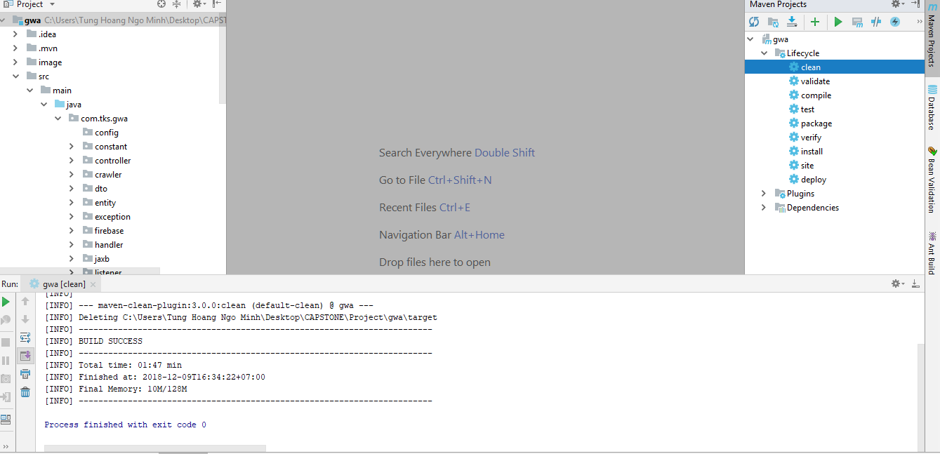

Continue to click on “install” option

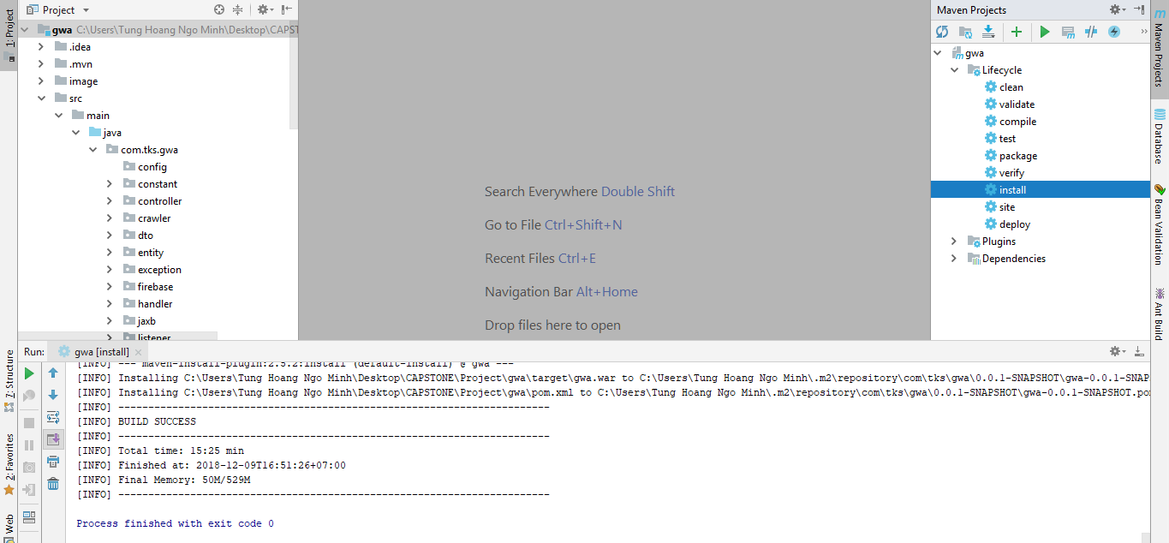

After that, go to directory follow this path



Copy file “gwa.war” to folder “webapps” of Tomcat

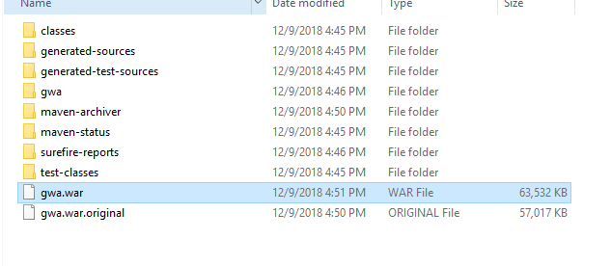

This is folder “webapps” of Tomcat 8.5.15

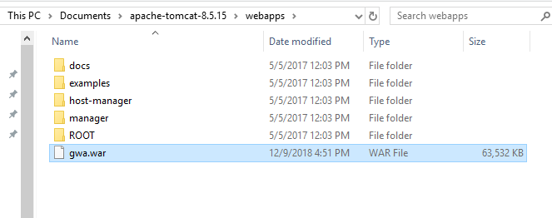

Then go to folder “bin” of Tomcat and click on “startup.bat” file

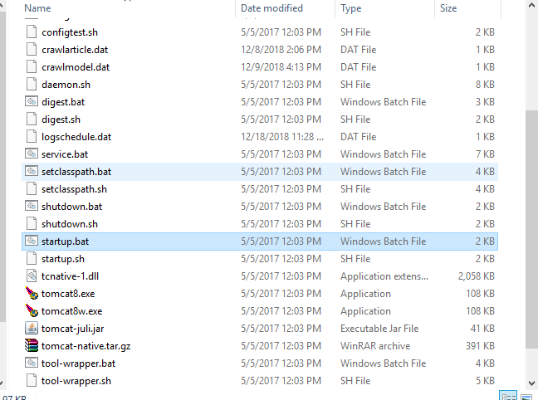

Web application is deployed on Tomcat standalone successfully

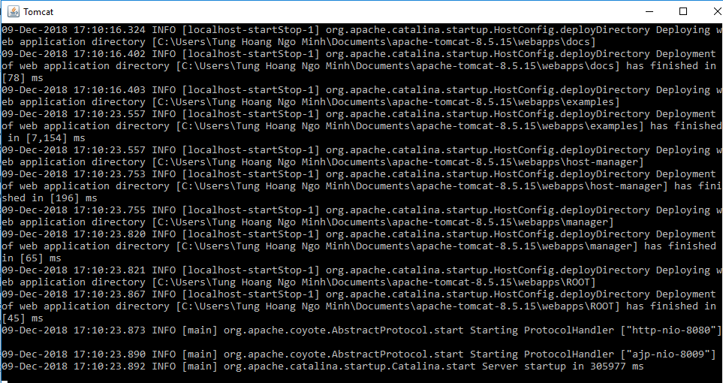

### 1.3. Mobile Application Deployment Process

Open Android Studio application. Click on “Run” tab, then choose “Run ‘app’”

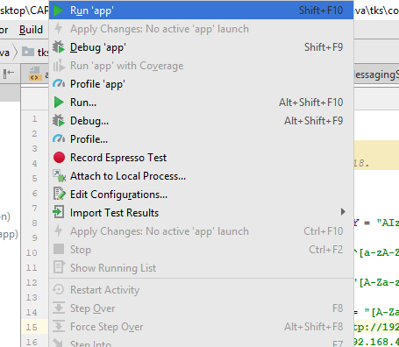

## 2. User Guide

### 2.1. Web Application

#### 2.1.1. Guest, Member and BuyerSeller

##### 2.1.1.1. Get user information, edit profile, get exchange evaluation

*Login to Web Application via* [*http://localhost:8080/gwa/login*](http://localhost:8080/gwa/login)*, then click on a username or own profile*

*This is for other user’s information*

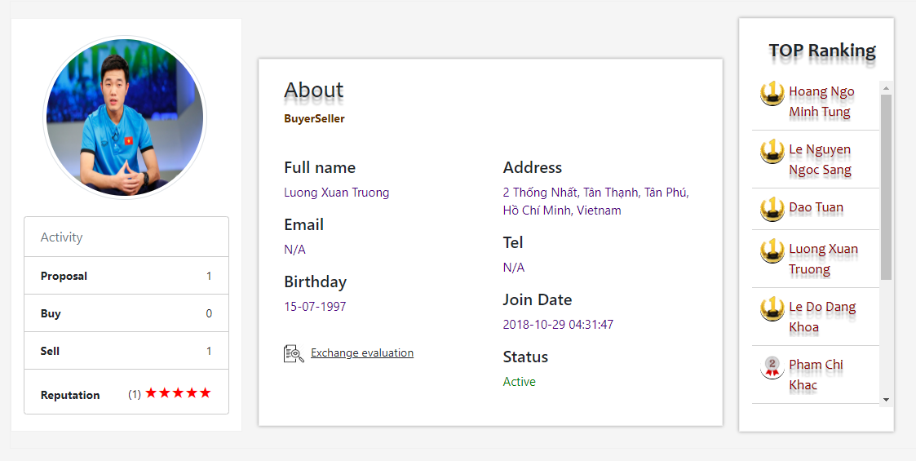

*This is for own profile*

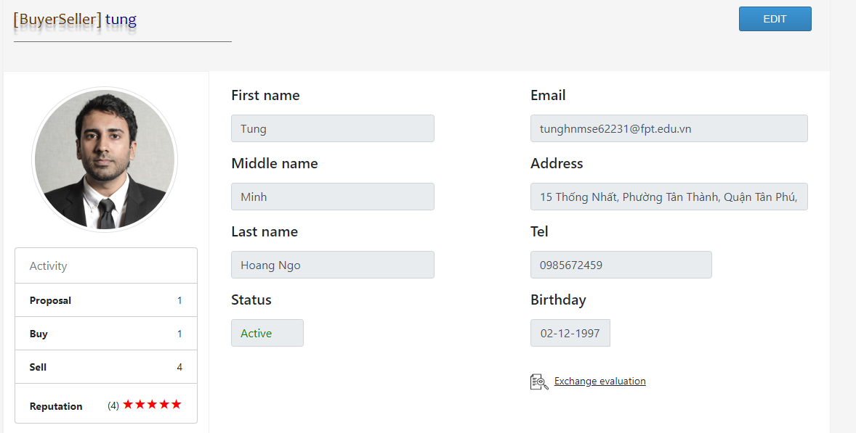

*This pop-up dialog show user’s exchange evaluation*

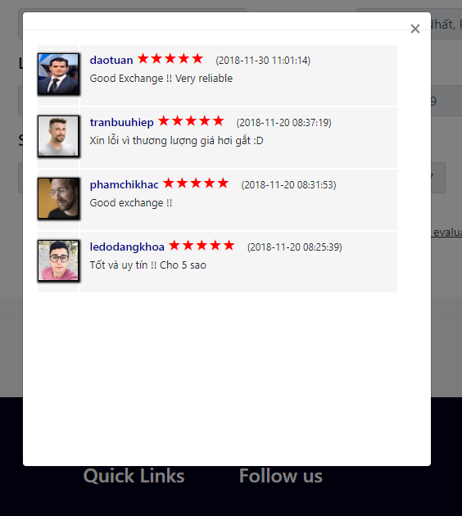

##### 2.1.1.2. Get gundam model information

*Click on “GUNDAM” option on the top menu, then type text in search input bar, this floating list shows instant matching models*

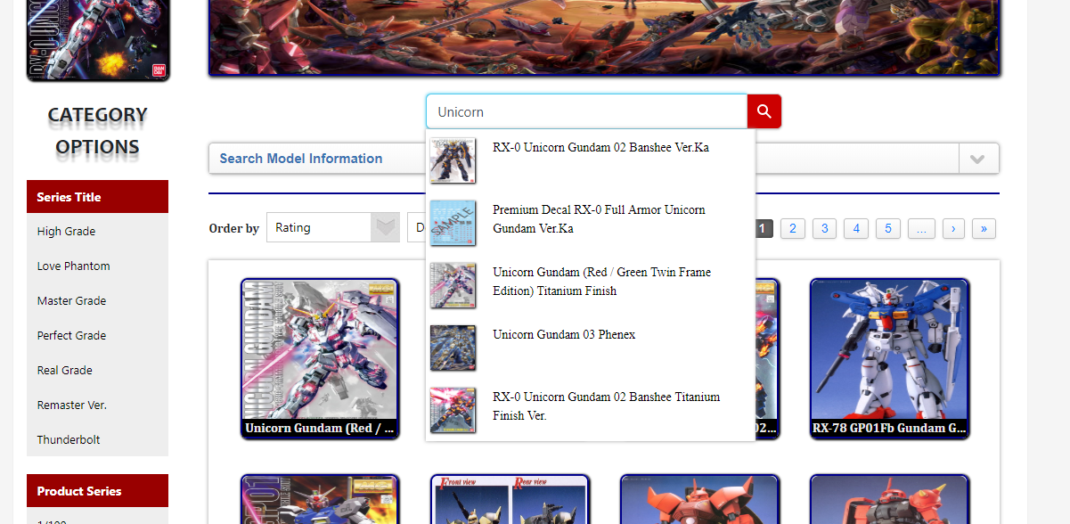

*Choose filter options and click on magnifier icon, choose order by options*

*Hover on a record and click on “More information” button*

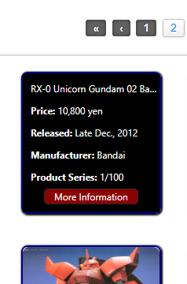

*This page shows model’s detail information with top 5 rating model, related exchange post and related article*

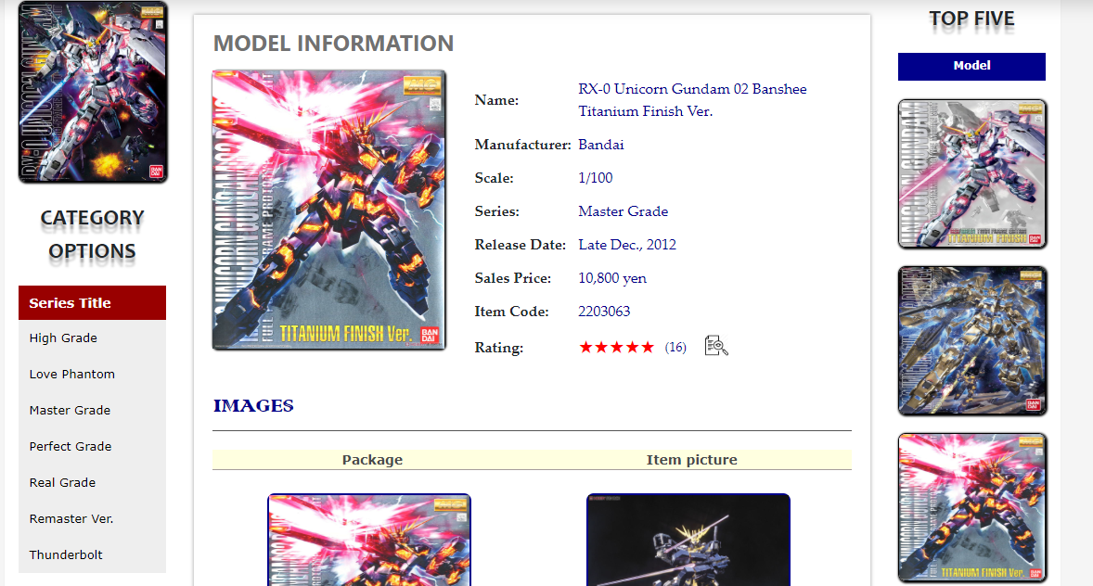

*This is model’s user review evaluation*

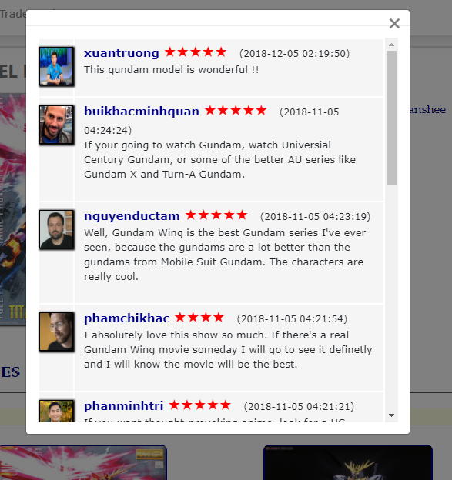

##### 2.1.1.3 Get article information

Search article by title and filters

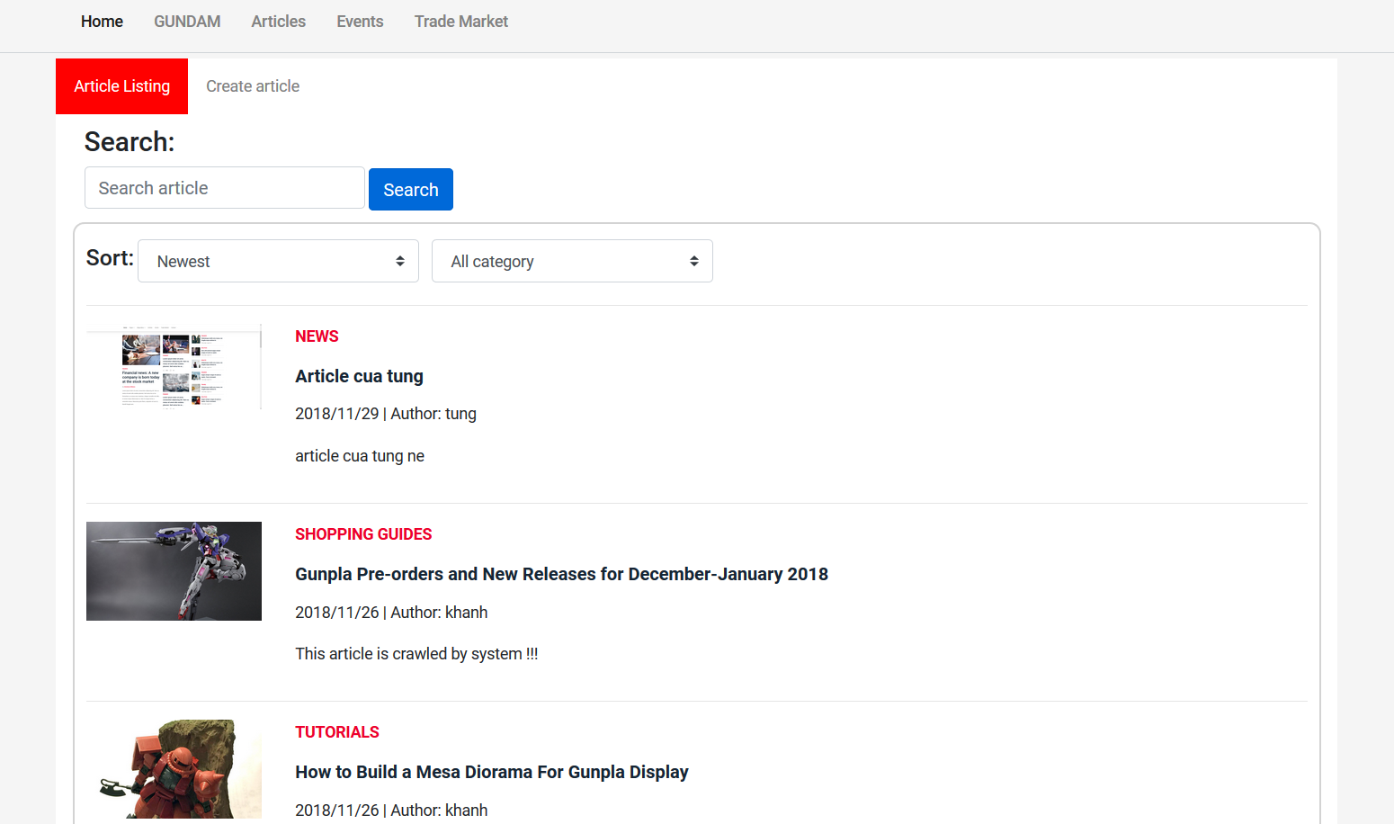

*This is search article page*

Create article by inputting all fields and submit

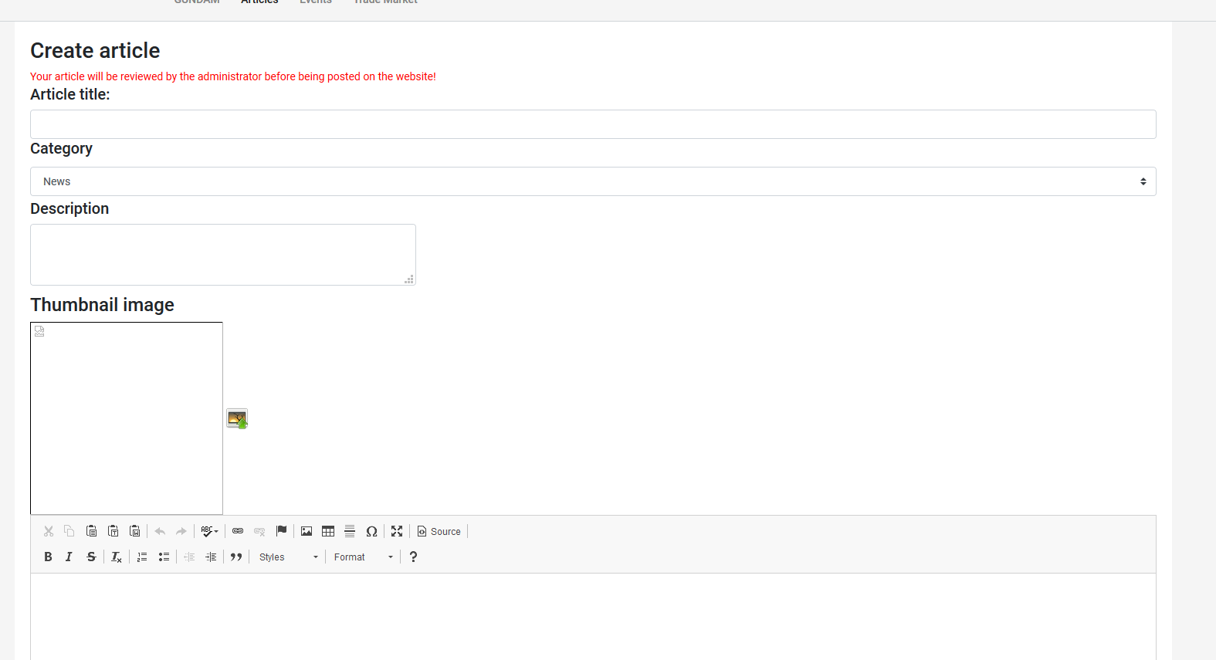

*Create article page*

##### 2.1.1.4 Get event information

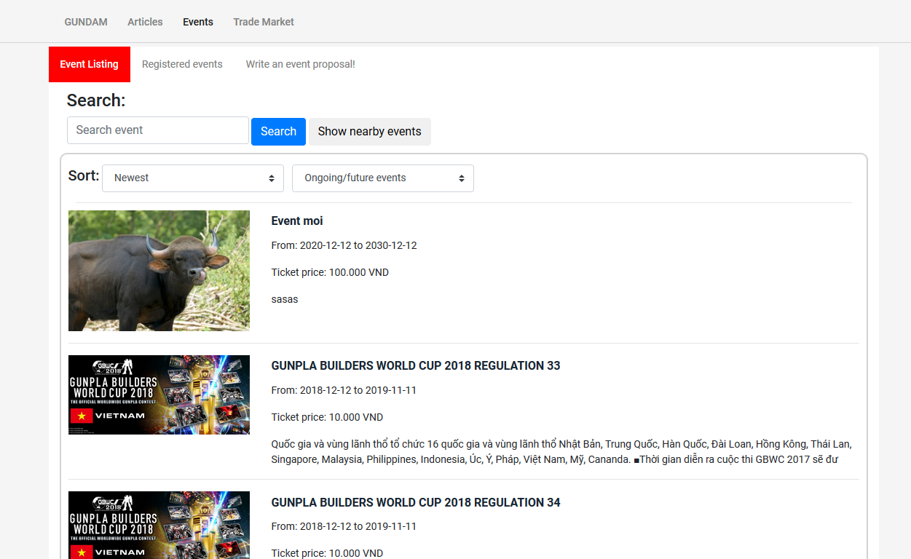

*Search event page*

Register event by entering your credit card number and tickets amount

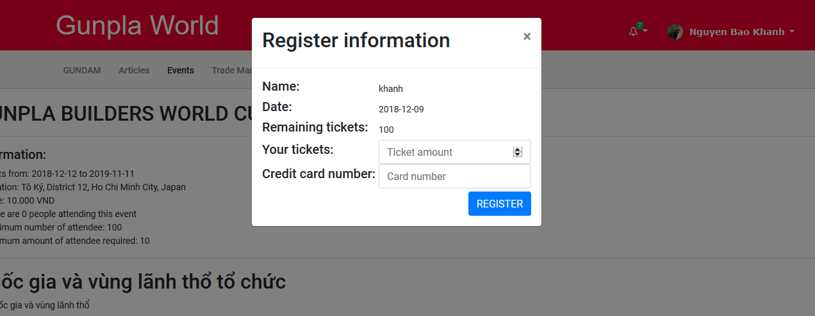

*Register event page*

#### 2.1.2. Administrator

*Login to Web Application via* [*http://localhost:8080/gwa/login*](http://localhost:8080/gwa/login) *with role “Admin”*

##### 2.1.2.1. Manipulate GUNDAM model

*Manage gundam models*

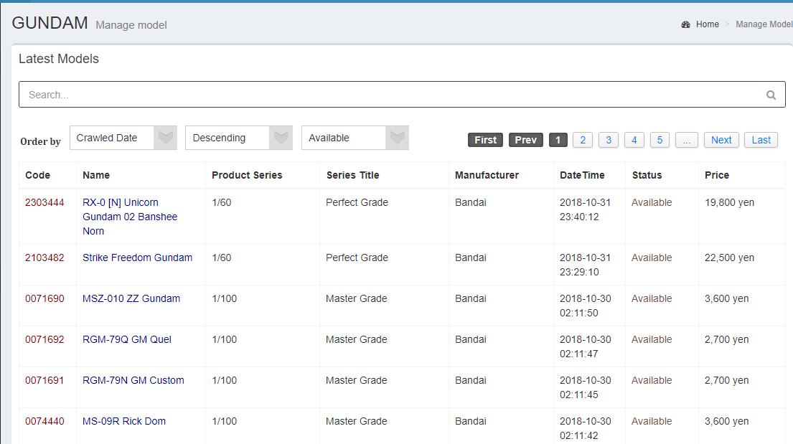

*Create new gundam model*

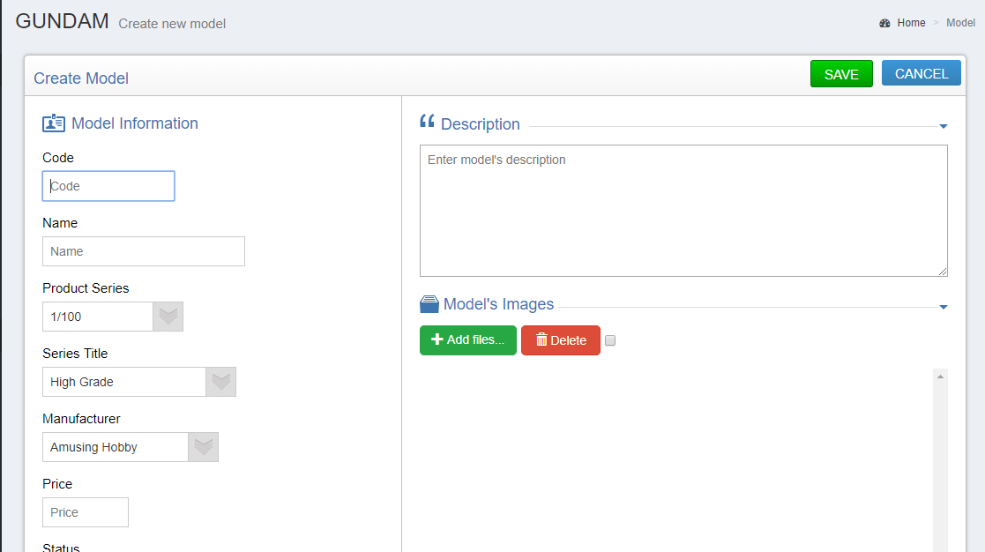

*Edit gundam model*

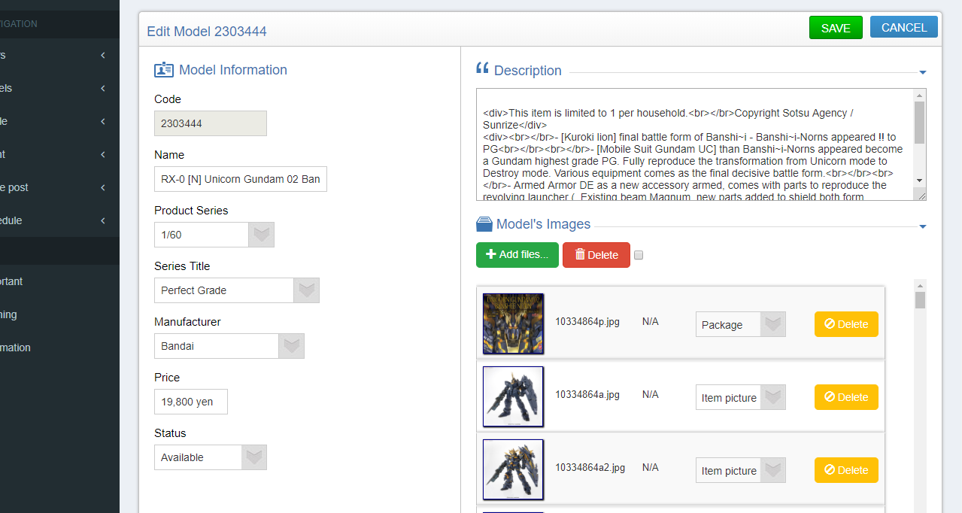

##### 2.1.2.2. Manipulate user

*Manage user*

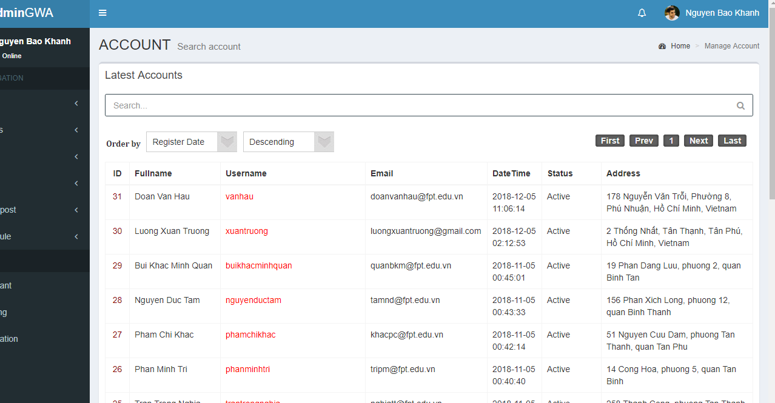

##### 2.1.2.3. Manipuate crawling

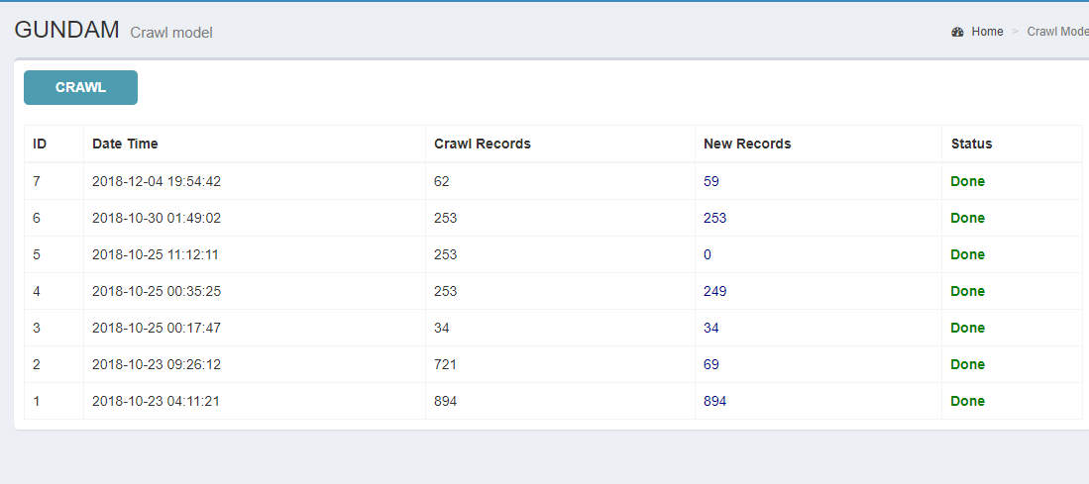

##### 2.1.2.4. Manipulate schedule

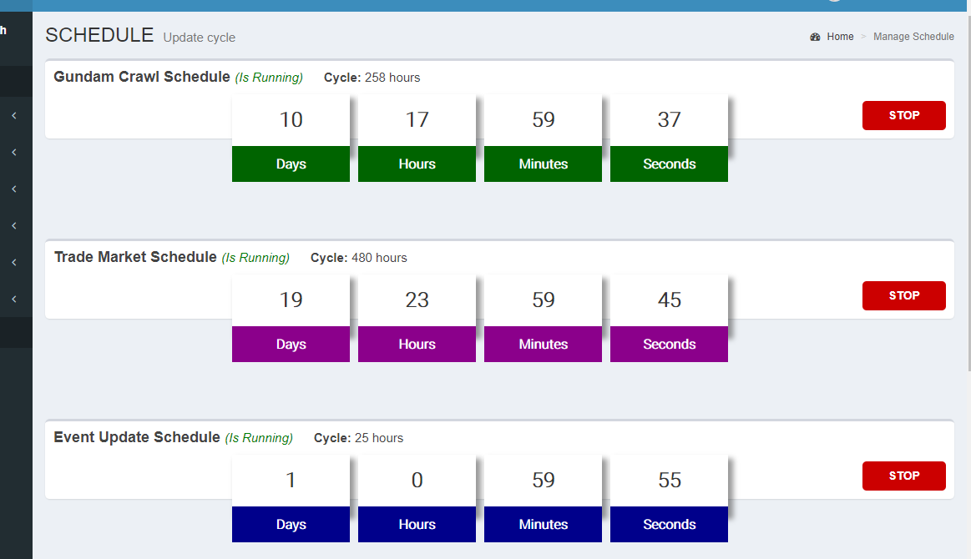

##### 2.1.2.5. Manipulate article

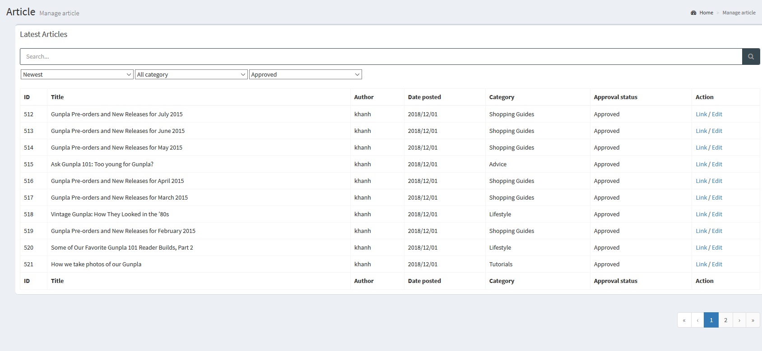

Manipulate article

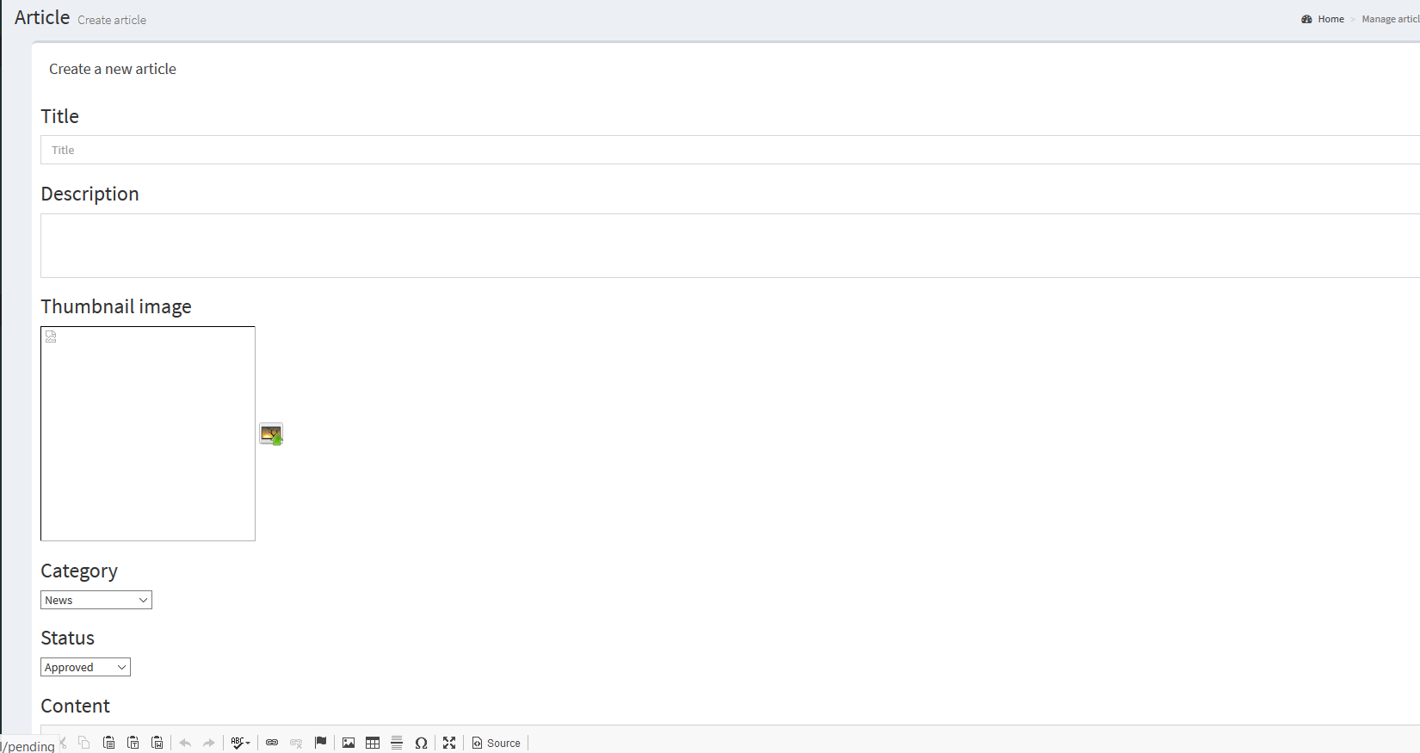

Create article by inputting all fields and submit

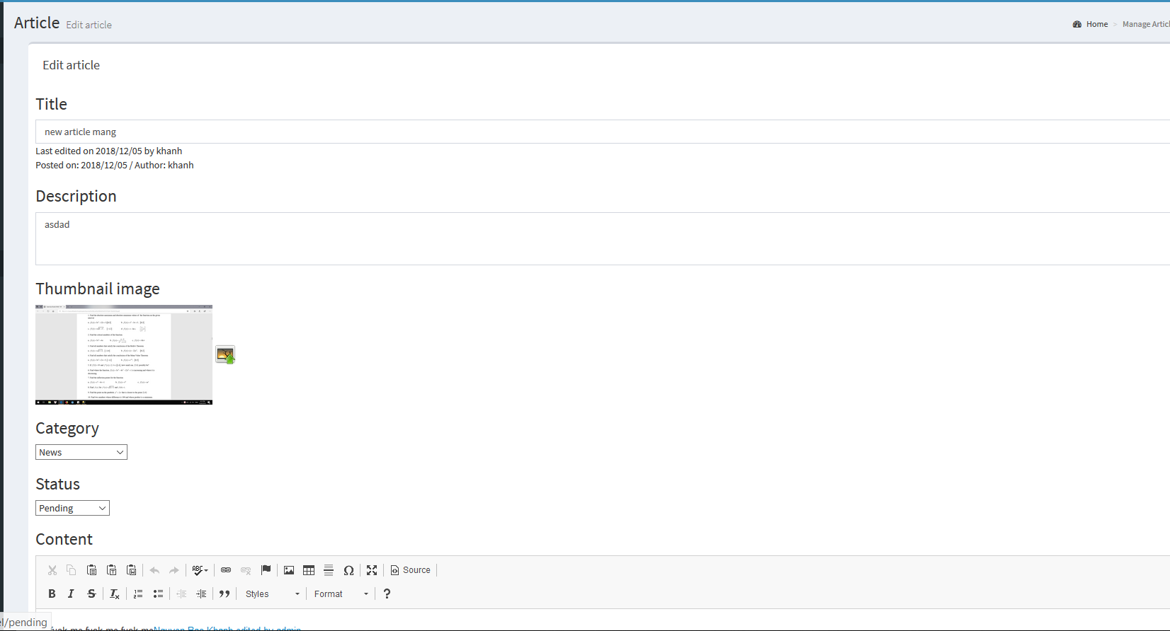

Edit article by inputting all fields and submit

##### 2.1.2.6 Manipulate event

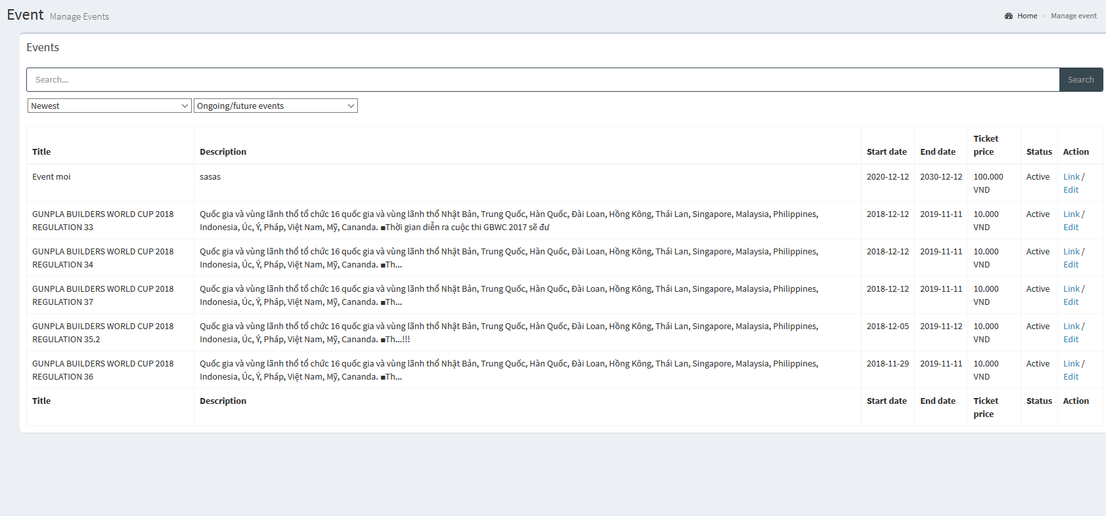

Manipulate events

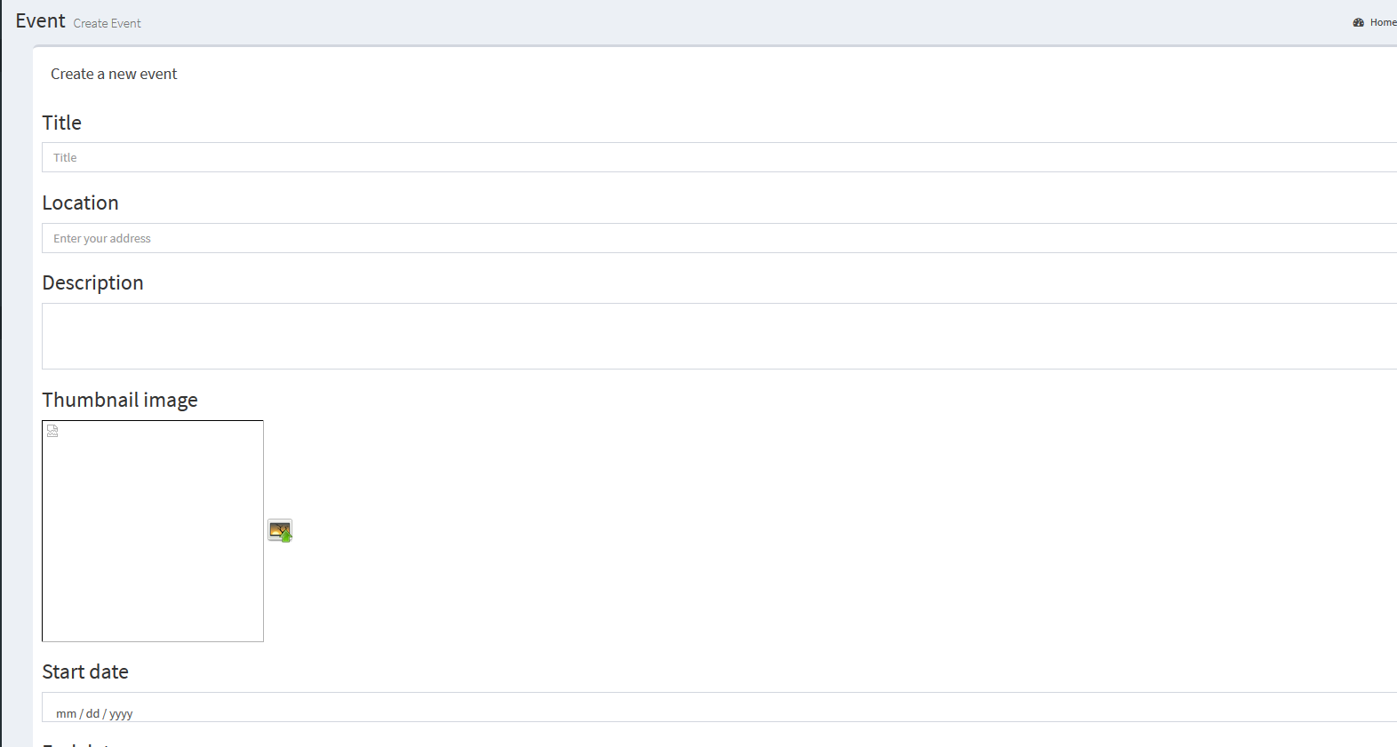

Create event by inputting all fields and submit

##### 2.1.2.7 Manipulate proposal

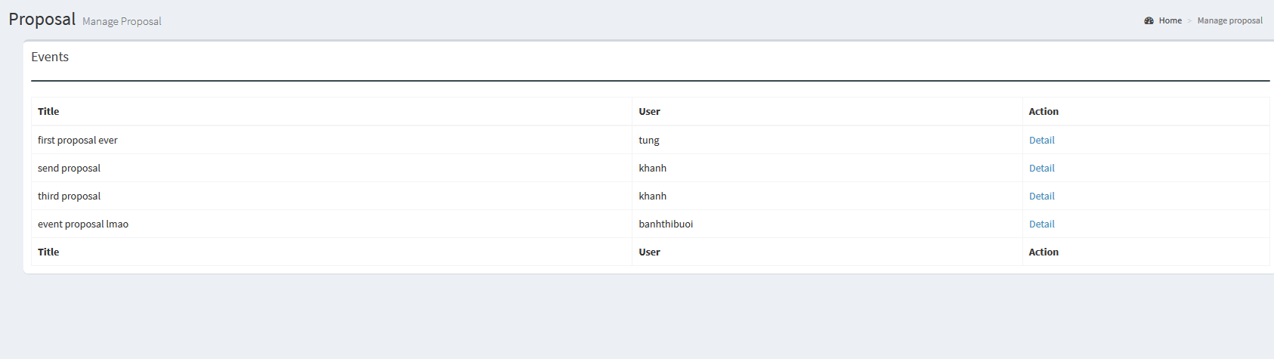

Manipulate proposal

### 2.2. Mobile Application

#### 2.2.1. Get user information

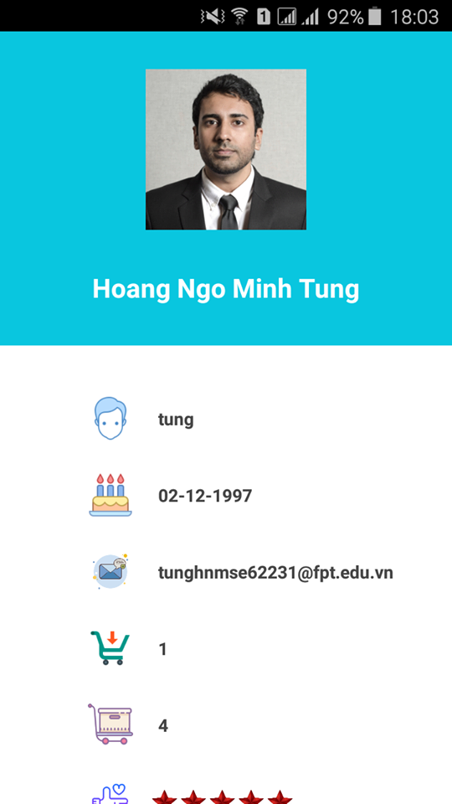

#### 2.2.2. Get model information

